|  |  |  |
| --- | --- | --- |
|  | **Using Printable Integrated Multimedia Maps for telling Islamic Heritage Sights in Al-Madinah Al-Monawarah**  FOUZIA ALZHRANI, KAWTHER SAEEDI, DANIA ALJEAID  Faculty of computing and information technology, King Abdulaziz University |  |
|  | **استخدام نموذج التفاعل المتكامل لسرد قصص التاريخ الإسلامي في المدينة المنورة** |  |
|  | فوزيه الزهراني، كوثر صعيدي، دانية الجعيد  كلية الحاسبات و تقنيه المعلومات, جامعه الملك عبد العزيز |  |

**ملخص البحث (Abstract):**

خريطة الوسائط المتعددة المدمجة (IMM) هي نموذج لسرد قصة يجمع بين صيغ الوسائط المتعددة المختلفة والمرتبطة بخريطة جغرافية بهدف إخبار قصة. في وقتنا الحالي، هناك عدد محدود من الحلول المتاحة لخريطة الوسائط المتعددة المدمجة التي تركز على تقديمها على الشاشات الإلكترونية مع خرائط قابلة للنقر. يقدم هذا المشروع نموذجًا تفاعليًا متكاملاً بين موقع المستخدم ورسائل خريطة الوسائط المتعددة المدمجة القابلة للطباعة ومحتويات الوسائط المتعددة المعروضة في تطبيق الجوّال. من خلال هذا الحل، يمكن للمستخدمين الاستمتاع بقصة تفاعلية مع خرائط مطبوعة باستخدام تطبيق الجوال المصاحب. تستهدف هذه الخرائط قطاعات السياحة والتعليم والصحافة، مع إمكانية استخدامها في مجالات أخرى أيضًا. توضح هذه الورقة استخدام نموذج خريطة الوسائط المتعددة المدمجة المقترح لسرد قصة حول مشاهد التراث الإسلامي في المدينة المنورة. يمكن الوصول إلى القصة من خلال خريطة قابلة للطباعة أو خاصية اكتشاف الموقع في الهاتف الذكي للزائر. يقوم تطبيق الجوّال بعرض قائمة بالخرائط ذات الصلة بالقصص. بمجرد أن يحدد الزائر قصة، يعرض التطبيق محتوى ذلك الموقع، ويستعرض أحداث أخرى ذات صلة أثناء الانتقال إلى مواقع مختلفة. علاوة على ذلك، تقدم خريطة القصة لمحة عامة عن الحدود الجغرافية للقصة، لإرشاد الزائرين خلال سيرهم داخل مواقع القصة، ويمكنهم من الاطلاع على علامات الخريطة إذا كانوا يقرأون القصة خارج الموقع. تستعرض هذه الورقة النظام المعمول به في نموذج التفاعل المقترح بالتفصيل، مما يسهل المرونة في إضافة قصص جديدة ببيانات الوسائط المتعددة وبيانات المواقع ذات الصلة.

An Integrated multimedia map (IMM) is a storytelling model that combines different multimedia formats associated with a geographical map to tell a story. Nowadays, there are a limited number of available IMM solutions and they focus on presenting IMMs on electronic screens with clickable maps. This project introduces an integrated interactivity paradigm between the user’s location, printable IMMs and multimedia contents displayed on a mobile application. Through this solution, users can enjoy an interactive story guided with printed maps using a companion mobile application. Printable IMMs is targeted at tourism, education and journalism sectors, though it can be used in other areas as well. This paper demonstrates the use of the proposed IMM paradigm to tell a story about Islamic Heritage Sights in Almadinah Almunawarah. The story can be accessed through a printable map or location detection feature in visitor smartphone. The mobile application will display a list of map related stories. Once a visitor selects a story, the application displays the content of that location. The application also notifies visitor with relevant events while moving to different locations. Furthermore, the story map provides an overview of the geographical borders of the story, to guide visitors during their walk within the story locations, as well as they can scan map markers if they are reading the story off-site. This paper will detail the system architected of proposed interactivity paradigm, which facilitates flexibility to add new stories with relevant multimedia and location data. Then presents the software system that has been successfully implemented which consists of two applications: one is the maps creation tool as a web application and the other is the content extractor as an Android App. For evaluation, the applicability of the proposed paradigm is demonstrated through a storytelling scenario about a story happened in Almadinah Almunawarah.

**Introduction:**

Maps are a powerful language that can be easily understood. The first known map of the world was a simple circular illustration dating to 550 BCE (Pontis, 2012). Traditionally, maps were based on paper and were hand drawn with limited applications and distribution. The main uses of maps were to aid in exploration and to guide in navigation. Otherwise, they were impractical. Nowadays, the power of maps has expanded to reveal, explore, and share information in an interactive way. The widespread use of location-aware applications familiarized users with interacting with maps and, consequently, users become enthusiastic to use these maps in creative ways. Together with technology advancements, the need to turn old-fashioned maps into interactive, content-rich maps have resulted in the development of integrated multimedia maps (IMMs), widely known as story maps. These IMMs can be generated using online story maps applications such as Story Maps by Esri (Environmental Systems Research Institute, 2016) and StoryMap JS by the Northwestern University Knight Lab (Wise, 2013). The role of IMM applications is expanding in numerous fields. For education, teachers and students can demonstrate compelling maps about subjects of interest. In critical fields, such as health and military, users can gather important data and present them on an interactive map in order to reveal interrelationships and examine causes and effects. Moreover, IMMs help businessmen track the progress of a sales or advertising campaign, for example. They can enrich maps with supplementary digital materials from different places to summarize, compare and contrast situations. Museums, as an instance of the tourism sector, can use IMMs to turn old-fashioned historical stories presentation into an attractive style. They can show changes over time in an interactive location-based demonstration, resulting in good experiences for visitors.

This project aimed to provide a new interactivity paradigm between users and IMMs by providing a software solution for generating and interacting with printable IMMs. The idea behind IMMs is to enrich maps with multimedia content, such as audio, video, and photos, within a single intuitive platform. The map is used for organizing multimedia elements. The purpose of this integration is to emphasize the message beyond the actual map. A web-based application is built to produce printable multimedia maps with hidden content accessed using Data Matrix codes (ISO/IEC, 2011). A companion mobile application is built to interact with the Data Matrix codes on the printed maps. The evaluation of the paradigm is conducted through a scenario in which an Islamic Heritage Sights in Madinah is visited through guidance of an IMM application. The historian collects multiple notes, videos, photos, and audio records from different Islamic Heritage Sights in Madinah. Afterward, he uploads these multimedia files to an online IMM application. The application allows him to assign every multimedia file to a location on the map. Then application displays a clickable map on the computer screen that contains markers for every location in the story. The generated code can be printed with or without a map in different printable format such as poster, flyer, brochure etc. On the mobile app once the code is scanned, full story with a clickable map on location marker is viewed and multimedia contents related to that location will appears on the screen.

The aim of this paper is to demonstrate the proposed interactivity paradigm through a story telling scenario about Islamic Heritage Sights in Almadinah Almunawarah. The scenario chosen to demonstrate the proposed paradigm is taken form (تاريخ طيبه في خير القرون) book (Alfaidi,2014). All the stories in this book or other sources can be added through graphical user interface of the proposed application. The paper starts with a background introduces the principles of IMMs and related technologies. Then the paper outlines the core functions of the application in two main parts: Adding story by an app administrator and navigating story by application users. Successful demonstration of the story on the app demonstrates the visibility of proposed paradigm. Then the paper concluded with suggestion and further recommendation for the developed application and plan for its operation.

**PRINCIPLES OF PRINTABLE IMM PARADIGM AND RELATED TECHNOLOGIES**

The IMM applications are similar in terms of the key input and output procedures. Its involve a user who creates a story must manually assign a location for every multimedia file even though such files are often already geotagged by modern photography devices. Additionally, the product of these solutions is a screen-only clickable map. This output mechanism limits the availability of IMMs to computer screens and thus constrains the usability of them, which may add additional setup and maintenance costs. For example, journalism publications can use IMM applications for only their online publications. Similarly, museums may have to attach wide screens on walls or distribute multiple screens around to allow IMMs to be accessible by visitors. Likewise, in education, the use of IMM applications during classes is restricted by the availability of computer labs. The printable IMM paradigm supports the current IMM applications with printable code, in the location map or any physical material, to allow access the relevant contents using smart phone. The following brief of the emerging technology encourage the development of such application.

**Encoding (Data Matrix):**

This allows multimedia content to be embedded within printed maps. A Data Matrix code is a two-dimensional symbol that can store binary, numeric, and alphanumeric characters in a square or rectangular symbol. Its square type has 24 symbol sizes ranging from 10x10 to 144x144 modules. Three factors make a square Data Matrix an optimal encoding technology for printable IMMs. First, its data capacity. A Data Matrix code has the ability to store 50 characters in a symbol that is 2 or 3 mm2, which is similar to the size of map markers. Second, its readability. Data Matrix codes are readable at a low contrast ratio, making them a favoured choice because different marker icons on maps may have different contrast ratios. Third, its reliability. The codes can be successfully read even if more than 20% of the symbol is damaged or poorly printed (ISO/IEC, 2011). Data matrix code shown in Figure1.



Figure 1: A Data Matrix code stores the text: “IMM”

**Mobile Augmented Reality (AR)**

AR refers to a real-time interaction between digital information and physical objects. For printable IMMs, AR allows a mobile device’s camera to be pointed at a map marker and display the hidden information on the mobile screen. Mobile AR takes digital information (e.g., photos and videos) and overlays it on a physical object (e.g., a printed map) through a mobile device’s screen when a user points the mobile device’s camera at specific map markers, which is a mechanism known as vision-based AR (raig, 2013).

**Web Map Service (WMS)**

A WMS adds the markers of the places in a story on top of a map generated by an online web map service, such as OpenStreetMap. WMS is a web-based platform aimed at producing georeferenced map images from a geospatial database and serving them over the Internet to clients. For printable IMM system, a map service was built using OpenLayers library and the mapping data was provided by OpenStreetMap (Open Geospatial Consortium, 2006).

**Multimedia**

Multimedia is a combination of different content forms within one digital element. It is made up of any combination of graphics, animation, photos, drawings, audio, text, and any other media forms. Multimedia elements are produced, stored, and represented on digital devices though some of them are printable as well. Multimedia can be embedded within the map markers of a story map. (Grimes & Potel, 1991).

**Geotagging**

Geotagging is the process of assigning geographical information as geospatial metadata to various digital media such as photos and videos. Usually, longitude and latitude coordinates are the main contents of the metadata. Further location information such as accuracy, distance, altitude, bearing, and place names may be included in addition. Multimedia files can be geotagged in different ways such as attaching the multimedia file to a map or at the time the photo or video is taken (Larson et al., 2011; Goldwasser, 2004). In printable IMMs, multimedia files are geotagged by assigning to them longitude and latitude coordinates when they are uploaded to the server.

**Interactivity**

Interactivity, in this context, comprises the request and response flow between the user and the system in a selective, intuitive, and associative way. These actions include a user’s request to play a video, click on a hyperlink, scroll through a text panel, change the zooming degree, and navigate through the map and the proper feedback from the system (Kiousis, 2002).

**Geovisualisation**

Geovisualisation refers to geographic visualisation, which is an interactive visualisation technique restricted to a spatial domain that contributes to knowledge construction about geographical phenomena (Dykes, MacEachren & Kraak, 2005; Nöllenburg, 2007). For example, maps can be overlaid with colour-coded temperature data. In printable IMMs, geovisualisation is the use of a map as an organiser for story elements and the content is presented as map markers

**Application description**

This paper consists of two applications: The first one is a web-based map-creation tool that acts as a story map writer, called Storymap Writer. This tool is accessed by a storyteller who writes and uploads relevant contents of the story. The second one is an Android application displays different forms of multimedia contents stored for the story through scanning the matrix code or location identification, called story map reader. The components of this application are illustrated in Figure 2.

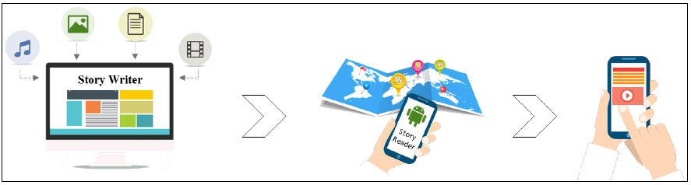

Figure 2: Components of IMM application

Using the Storymap Writer provides a login page to the storytellers where they can upload their multimedia files (MP3, MP4, JPEG, etc.) to the application’s server. As a part of the uploading process, they select the geographical location of these files and upload them on the server. Afterwards, the application generates a printable map with Data Matrix codes as location markers. Each code stores a string ID assigned to the related content. The Data Matrix code does not encode a URL in order to protect the access to the data; only the Storymap Reader app can extract the content of a printed story map. In other words, if any other barcode scanner is used to read the Data Matrix codes, it will not be able to access the multimedia content. Then, users can interact with the printed map by scanning the Data Matrix markers using the Storymap Reader application, which extracts the hidden content by firstly decoding the encoded string and then downloading the content from a standard web server. Then the content is displayed on the mobile screen via the application interface.

Publications can include multiple images for multiple locations in a single map image instead of spreading the images over pages. Furthermore, these publications can be enriched with non-printable contents such as videos and audios instead of distributing supplementary CDs or DVDs. Journalists can print attractive, location-based stories and support these stories by various multimedia content and allow users to uncover and explore additional information about the stories. For example, an article about the spread of coronavirus (Geller, Varbanov & Duval, 2012) may be supported by a story map that points to places affected by the virus, and the reader can explore additional information by scanning the map markers of those places. On the other side, Story map readers can interact with various printed story maps by using only one application that is able to extract the content from any map as long as this map is generated using the companion map creation tool.

**Demonstration of a storytelling senario**

The battle of the trench (Ghazwh al-Khandaq) is a battle between the Muslims, which led by the Prophet Muhammad peace be upon him, and the Confederacy (Ahzab): Quraish and his allies Kenana (Ahabeesh) and the tribe of Ghattafan al-Assad and Salim and others. The battle took place in Medina where Muslims dug a trench upon the suggestion of Salman al-Farsi to prevent Confederacy armies from entering Medina. When the Confederates reached the borders of Medina, they were unable to enter and forced three weeks of siege. This siege has caused harm to Muslims and starvation. The battle ended with withdrawal of the Confederates because of their exposure to extreme cold winds. The following illustrated steps show the main process of using the Printable IMM system through a process of generating a story map for the Battle of the Trench:

1. The user uploads the multimedia files and assign them a location on the map. The user can upload multiple multimedia files at a time if they are belonging to a single geographical location. Figures 3 and 4 present the process of uploading files. The map initially shows the globe view, and it then zooms in to focus the view on the selected location.

2. A story map can be generated in a single step by clicking [Create Storymap] link from the top menu. It displays a form contains a list of all the available files that have been uploaded by the user at any time. The story map can be generated by simply selecting the desired files from the list, and optionally adding a description for the story and captions for the selected files (see Figure 5). Then, the application generates a story map contains multiple encoded markers that indicate the important places of the Battle of the Trench.

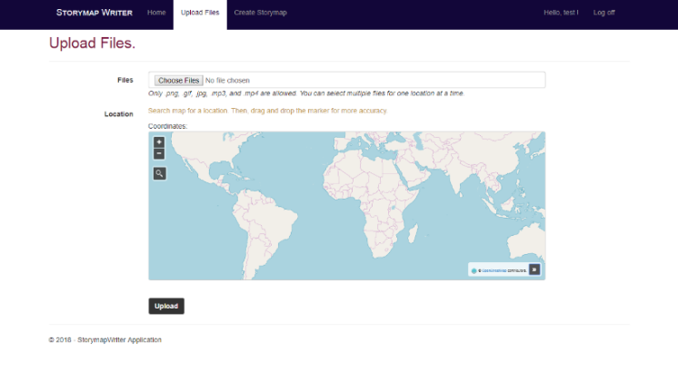

Figure 3: The initial view of the fie upload form.

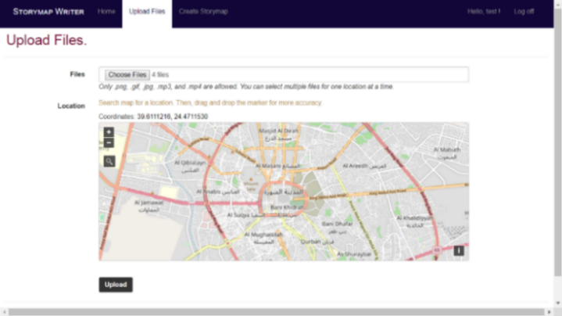

Figure 4: the map view is changed zooming in to focus on Almadinah Almonawarah region.

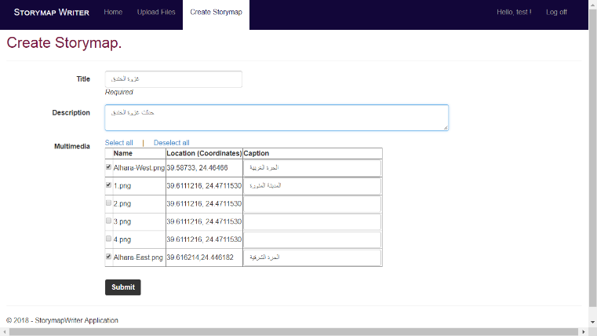

Figure 5: The form of creating a story in process. It displays all uploaded files by the user.

3. In order to read the Battle of the Trench story map, the Storymap Reader app is used. By clicking the app icon on the mobile Home screen, the app is opened and displays the home screen that contains the [Scan] button as shown in Figure6.

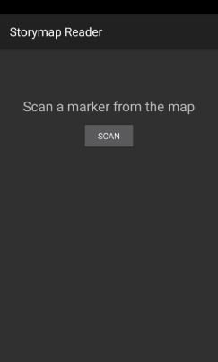

Figure 6: Home screen of StoryReader app

4. By scanning a valid Data Matrix code, the app displays the multimedia view screen.This screen contains dynamic tabs based on the retrieved multimedia count string. The [Photo] tab is displayed only if the count of image files is greater than zero. And the same is for [Video] and [Audio] tabs in relation to their counts, see Figure7.

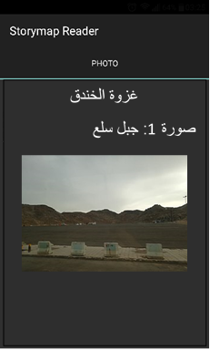

Figure 7: The view of an image after scanning a map marker

**Summary and cunclusion:**

The printable IMM solution provides a new way to tell and read stories with geographical maps. Unlike other currently available solutions, printable IMM provides a straightforward and single-step way to create a story map. In contrast with the available solutions, printable IMM provides an innovative way to read story maps. The solution relies on the encoding technology using Data Matrix codes, which is economical and feasible. It is suitable for any location-based topic linked to different locations. Such solution can be used in education, tourism, journalism and any other domain. This can enhance the grasping level of a story in an interactive and visual fashion. To demonstrate the usability of the solution, the paper proved how to write story of Muslim heritage in Madinah using Storymap Writer application and how to access the story through the location based mobile application using Storymap Reader mobile app. The story was chosen from (تاريخ طيبه في خير القرون) book (Alfaidi,2014), which includes a wide range of interesting stories related Islamic heritage in Almadinah Almunawarah with pictures and locations. The book was carefully selected as an example of trusted resource to Islamic heritage stories. However, the authors faced difficulties to allocate the accurate location due to new naming of the area.

**Recommendations:**

1. This solution provides the technological platform for storytelling and we recommend this platform to be the host of Islamic heritage in Saudi Arabia. The platform is devloped as a working prototype of the Printable IMM paradigms. In order to take the application into opration, a technological infrastruction and technical team support are needed.
2. A trusted historians and reliable histolical resourse are required to feed the solution with rich and interseting contents with different languages.
3. The multimedia contents have key role for attarct application users and help to enjoy the visiting experience. The solution entails talented and creative mulitmedia team to develop high quality contents for the application.

**References:**

* Alfaidi Tnidb, (2014). تاريخ طيبة في خير القرون
* E Craig, A. B. (2013). Understanding Augmented Reality: Concepts and Applications. Newnes.
* Dykes, J., MacEachren, A. M., & Kraak, M. J. (2005). Exploring geovisualization. Elsevier.
* Environmental Systems Research Institute. (2016). Story maps. Retrieved May 10, 2016, from https://storymaps.arcgis.com/en
* Geller, C., Varbanov, M. & Duval, R. (2012, November 12). Human Coronaviruses: Insights into Environmental Resistance and Its Influence on the Development of New Antiseptic Strategies. Retrieved from http://dx.doi.org/10.3390/v4113044
* Goldwasser, D. (2004). A Brief Introduction to GPS Photo Linking. Jun, 15, 1-5.
* Grimes, J., & Potel, M. (1991). What is multimedia?. IEEE Computer Graphics and Applications, 11(1), 49-52.
* ISO/IEC. (2011). Information technology – Automatic identification and data capture techniques – Data Matrix bar code symbology specification. Technical Report, International Standard ISO/IEC, Switzerland.
* Kiousis, S. (2002). Interactivity: a concept explication. new media & society,4(3), 355-383.
* Larson, M., Soleymani, M., Serdyukov, P., Rudinac, S., Wartena, C., Murdock, V., ... Jones, G. J. (2011, April). Automatic tagging and geotagging in video collections and communities. In Proceedings of the 1st ACM international conference on multimedia retrieval (p. 51). ACM.
* Nöllenburg, M. (2007). Geographic visualization. In Human-centered visualization environments (pp. 257-294). Springer Berlin Heidelberg.
* Open Geospatial Consortium. (2006). OpenGIS Web Map Service version 1.3. 0.
* Pontis, S. (2012, January 16). 20 Information Design Milestones. Retrieved February 23, 2016, from https://sheilapontis.wordpress.com/2012/01/16/20-information-design-milestones/
* Wise, Z. (2013). StoryMap JS - telling stories with maps. Retrieved September 23, 2016, from https://storymap.knightlab.com