|  |  |  |
| --- | --- | --- |
|  | **Applying game-based learning system to facilitate the Manasik of Hajj and Umrah**  **Marwa Atta Sultan**  **Department of Engineering and Applied Sciences (computer science),**Makkah **Community College, Umm Al Qura University** |  |
|  | **تطبيق نظام التعلم القائم على الألعاب لتسهيل مناسك الحج والعمرة** |  |
|  | مروة عطا أحمد سلطان  (قسم العلوم الهندسية والتطبيقية (علوم الحاسب) ,كلية المجتمع , جامعة أم القري |  |

**ملخص البحث (Abstract):**

نظام التعلم القائم علي الألعاب في التعلم يشمل عدة مميزات منها تحقيق مستوي عالي من التفكير والمهارات الأدراكية للحاج المستخدم لهذه الألعاب , وأيضا زيادة سعة ذاكرة الحاج حيث أن عليهم تذكر المناسك والأذكار من أجل حل اللعبة وحفظ التسلسلات المطلوب تأديتها للمناسك مما يساهم في تقليل الأخطاء أثناء الحج او العمرة. كما انها تساعد في التفكير الاستراتيجي السريع وحل المشكلات لأن معظم الألعاب تتطلب من الحاج أن يفكر بسرعة. علاوة على ذلك ، عليهم أن يستخدموا منطقهم لكي يفكروا في خطوات قادمة لحل المشاكل ومستويات اللعبة.

لذا تعد أنظمة التعلم المبنية على الألعاب تساعد في بناء المهارات للحجاج. كما تحتوي الكثير من الألعاب على جوانب فنية تساعد الحجاج ذوي المهارات الخاصة علي الاستيعاب بشكل أفضل للمناسك.

بالإضافه لذلك اضافه عنصر المرح والتشويق في عمليه التعليم للمناسك وبالتالي زيادة الارتباط بين الحاج واللعبة والاستفاده المثلي من محتوياتها.

يهدف البحث الي لتقديم نموذج متكامل مخصص لأي نظام قائم علي الألعاب يهدف الي تعليم مناسك الحج والعمرة وذلك عبر

دراسة تحليلية لأهم العناصر والعوامل التي يجب أن تتوفر في أي نظام تعلم قائم علي الألعاب خاص بهذا الغرض.

ويمكن استغلال هذا النموذج أيضا في انشاء تطبيقات ألعاب الكترونية تقوم بعرض التحذيرات والأرشادات المطلوبه علي الحجاج والمعتمرين مما يساهم أيضا في تفادي الوقوع في المشكلات التي يمكن أن تحدث أثناء الحج أو العمرة.

There are many benefits for using games in Manasik learning process, these games can enhance cognitive and mental skills of players as it makes them think about Manasik aspects and remember Manasik sequences to compelete playing the game. Also games motivate players for learning by the result this will make Manasik learning process is interseting.

Games help learners to think in a strategic way as it requires players to think fast and in logic order to can solve the game problem or complete game levels.

The research work aims to exploit the advantages of the game-based learning system on the comprehension of the Manasik of Hajj and Umrah. theses electronic game applications should simulate the Manasik electronically and offer warnings and guidance to pilgrims and Umrah in an interesting and effective way, which also helps avoiding problems that may occur during Hajj or Umrah caused by miss understanding or ignorance of such rules and Manasik.

The research introduces a theoretical model for game -based learning system that is specialized for all Manasik learning aspects. it introduce four main components that should be exist to develop a complete game for this purpose. These components are Cognitive,Motivation,Affect and Relgious.

**Introduction:**

In this section I will introduce the definition of game and game-based learning. Then I will dicuss some some reasons that help games effective learning environments.

Salen et al (2004 ) defined a game as “a system in which players engage in an artificial conflict, defined by rules, that results in a quantifiable outcome” .

Shaffer et al (2005) defined a Game-based learning as” it is a type of game play with defined learning outcomes”. As a result to this definition the design of a games for learning purpose should balance between the need to cover the content with the desired outcomes (Plass, Perlin, & Nordlinger, 2010).

Actually,There are a number of factors that affect on games and make it effective learning environments (motivation , player engagement and Adaptivity ) (Jan L. Plass ,Bruce D. Homer &Charles K. Kinzer 2015).

**1. Motiviation**: this means that the game will able to stick player over long periods on the game. To achieve this games should contain many features like stars, points, leaderboards, badges, and trophies. (Hidi & Renninger, 2006; Rotgans & Schmidt, 2011). Beside this features a reglious motivation will be added that makes pilgrim stay engaged to the game for Islamic purpose.

**2. Player engagement**: this factor is very close to motivation factor, player engagement means that the game has the ability to let the player continue palying and sticked to the game.

The type of engagement depends on the goal of learning and the characteristics of the learner.here the goal of learning is Islamic (i.e ,understanding the Manasik and all related issues )and the designed game should be suitable for pilgrims taking into consideration the age category , culture ,language and other characteristics .

I base my discussion of engagement on the” INTERACT” faremwork introduced by Jan L. Plass et al (2015.),this model differentiate among many types of player engagement which are cognitive engagement , affective engagement, behavioral engagement. The research added a new type of engagement, Religious engagement(i.e, Manasik interactions embedded within a religious context of quran and sunnah). Figure 1 shows the different types of engagement for the proposed game learning model. All these types of engagements will be discussed in later sections.

For example, a game can engage the pilgrim learner behaviorally by using gestures as input or inviting players to perform specific physical actions as part of play,and it can engage pilgrim cognitively by allowing the pilgrim think about all Manasik issues and how to complete them,. A Game can engage the pilgrim learner religiously by supporting Manasik guidelines and the matters that are prohipted during Hajj and Umrah referencing to the Quran and sunnah text.

The goal of all these types of engagement, is to relate cognitive engagement of the pilgrim learner with the learning process. Games that do not achieve cognitive engagement are not likely to be effective in helping the learner achieve their learning goal.

3. **Adaptivity:** is the capability of the game to engage each pilgrim learner in a way that reflects his or her specific characteristic. This can be related to the learners’ current level of knowledge, to cognitive abilities of pilgrim player, to the learners’ emotions, religious backgournd or to a range of other variables.

The first requirement of adaptive design is to assign the variables that the game is supposed to be adapted for, such as in our suitation if the pilgrim has prior knowledge of Manasik or the mental capability for the pilgrim In case of handicapped pilgrim or any type of handicap.

The next step is to provide an suitable response to the pilgrim learner. “This may involve a modification of the type and complexity of the problems and guidance presented to the learner” (Azevedo, Cromley, Moos, Greene, & Winters,2011; Koedinger, 2001) or the use of “guidance and feedback in a way that responds to the player’s ingame actions” (Steinkuehler & Duncan, 2008).

**Research aims:**

The aim of this research is to propose a simplified model of game-based learning dedicated for the purpose of Manasik learning. It will help game designers to develop an interactive ,effective and qualified learning digital games environments.

that digital games are able to engage pilgrim learners on an affective, behavioral,cognitive, sociocultural and religious level in ways few other learning environments are able to.which will make pilgrim motivated in the learning process .

**Research methodology:**

The methodology followed in this research is detailed study of previous game based learning systems and reviewing the elements ,arugments and components of game based learning systems.

Then introducing a new game based learning model more dedicated to Hajj and Umrah Manasik learning process.

The research adapted the types of engagement on the INTERACT model of learner activity(Jan L. Plass ,Bruce D. Homer &Charles K. Kinzer 2015) to be specialized for the purpose of Manasik learning or other Islamic rules learning purpose, the INTERACT model distinguishes among cognitive engagement , affective engagement , behavioral engagement . the current research adds a new engagement type , Religious engagement(i.e, Manasik within a religious context of quran and sunnah) see Figure 1.

**Results and discussion:**

In this section i will introduce the elements of game design and foundation of game based learning for the proposed model in Figure 2 .

**1.Elements of game design for learning:**

**1.1 Game Learning Mechanics**: it is a set of Manasik steps and activites repeated by the pilgrim player during the game. These activites considered learning mechanics.

**1.2 Visual Aesthetic Design:** it determines the way that tools ,feedback and cues of the game can be visualized**.** This may include cognitive beside asthetic function. (Jan L. Plass ,Bruce D. Homer &Charles K. Kinzer ,2015).

**1.3 Narrative Design**: The narrative of a game is the story that is introduced via dialogues, views, actions, and voice-overs.

**1.4 Reward System:**The Reward system of a game includes features that motivate and encourage players to continue playing. Reward system may include badges, scores, points, stars, power-ups, and many other rewards. (e.g., see Kinzer et al., 2012)

**1.5 Musical System:** is the background sounds and sound effects of the game , which used to pay the player’s attention to the important actions or warning in the game or the success or failure of a specific task during the game.

**1.6 Content and Skills:** The last element is the intended skills and subject content of the game. All the previous game elemetns (visual design , narrative design , reward system and musical system )depend on the content and the skills that the game supposed to teach. (Plass & Homer,2012).In case of Manasik learning the content will be all information and related to Hajj and Umrah process. (Plass, Perlin, et al., 2010) stated four functions of games that describe to what extent and with what learning goal this content is covered which are :” Preparation of future learning”,” Develop 21st-century skills”, “Teach new knowledge and skills” and “Practice and reinforce existing knowledge and skills”.

The proposed game model should Teach new knowledge and skills by introducing new knowledge to the pilgrim learners.

Also , the proposed model should reinforce existing knowledge by practicing existing knowledge for pilgrim about Manaski and basic cognitive skills in order to automate the game.

**2.Foundations Of Game-Based Learning**

The game desgin is affected by many foundations , thses foundations are cognitive ,motivaion, emotion and religious .

The extent to which these foundation affect the game design depends on the game’s content ,desired objective and game type.

I describe in Figure 2 a general game learning design patterns, that is, suitable solutions to the process of Manasik learning and also can be suitable for teaching any Islamic issue. Game design patterns describe solutions on an abstract level that will help game designer to develop complete game for Manasik learning .

**2.1 Cognitive Foundations Of Game-Based Learning**

The goal of cognitive foundation is to construct a mental model for learner. “(Mayer, 2005, 2014). There are many cognitive theories , one of them is introduced by (Mayer, 2014) in which the pilgrim learner will select information existed in the game , organize this information in working memory and then integrate the acquired knowledge with one another with the prior knowledge.

The designers should consider which game elements suitable for the cognitive processing of Manasik learning content. And should determine how these content represented to engage the pilgrim learner for reaching the intended outcomes.

Designers also have to take into consideration the cognitive processing of the meaning of the various game elements and relate them to Quran and Sunnah.

Next some factors facilitate cognitive processing will be discussed , which are dynamic assessment, information design, interaction design, and gestures and movement.

**Dynamic Assessment:**As the nature that Manasik consists of many steps and processes , the game design should have accurate dynamic assessment to know when pilgrim learner change to next step of Manasik. A first step for dynamic assessment is to clearly identify some factors to be assessed like Manasik learning goals, as well as other pilgrim’s individual-level variables that can affect learning outcomes (age, language,culture,..).

Evidence-Centered Design (Mislevy & Heartel, 2006) provides a useful framework for thinking about in game assessments (see Plass,Homer, et al., 2013, for more detail).

**Information Design:** it means visual representation of Manasik information , this visual design give games the strength in learning process.

The design of this visual information for purposes of learning can be based on research on” multimedia learning and its principles” presented by (Mayer, 2014), as well as on principles related to “cognitive load theory” presented by (Plass, Moreno, & Br€unken,2010).

**Learning Mechanics:** (Homer & Plass, 2014) defined it as is mapping process between game learning objectives and game strategies based on suitable learning theories. One of these theories is ” Evidence-Based Design” introduced by (Mislevy & Haertel, 2006). The effective learning mechanics should be suitable for the learning goals of the game.

**Gestures and Movement processing:** it consider how to map game gesture or movement to key features of the game content . this process has perceptual and cognitive effect on the player.

(Black, 2010) (Gibbs, 2006) (Kwah, Milne, Tsai, Goldman,& Plass, 2014).

**2.2 Motivational Foundation Of Game-Based Learning**

From motivational prespective , the game should be able to engage and motivate players to make them enjoyed and desire to continue playing the game. This will be achieved by providing different game features and taking into consideration the all reasons that make players want to play a game.

In case of Manasik learning the game designer should consider the Islamic motivator for the pilgrim player and trying to investigate how to enhance pilgrim learners’ motivation.

There are many theories of motivation can help inform the design of game features that enhance learners’ motivation.

In fact there are some factors that may affect on the motivation process , the main factor is the learning objectives of the game , which will be mainly facilitating Manasik process in an interesting way. Other factors may be considering the target population of of pilgrim players (i.e., their age, gender, educational level, etc.), and even the Islamic style of the game.

In game learnng motivation there are many theories organize player motivaiton. For example, Eccles et al. (1998) formulate thress questions which are ( “Can I do this?” “Do Iwant to do this, and why?” and “What do I need to do in order to succeed?”). these questions are related to any learning situation, including islamic educational games.

well-designed games are built in ways to ensure that pilgrim players know what to do and feel confident that they can succeed (which includes failing gracefully, and trying again). Jan L. Plass et al. (2017) suggest many factors of why players will be motivated to play a learning game such as intrinsic and extrinsic motivation of the learners, specific goals of the learners, and learners’ individual interest.

* 1. **Emotional Foundation Of Game-Based Learning**

An Emotional foundation of game-based learning interests on learners’ emotions, attitudes, and beliefs.

It fouces how the design of the game affect on learners’ affective through emotional engagement. It also fouces how it is related to cognitive, motivational, and religious aspects of learning.There are many models and theories that show the relation and mutual influence of cognition and emotion during learning ,these theories such as” the differential emotions theory” introduced by (Izard, 2007), “the control value theory of achievement emotions” introduced by (Pekrun, 2000), and “the integrated cognitive affective model of learning with multimedia” introduced by (Plass &Kaplan, 2015).

One way to integrate affect in games is by taking advantage of specific game elements, such as the aesthetic design, game mechanics, narrative, or musical score, to encourage emotions in players. When taking an affective perspective on game-based learning, emotional aspects of play and their impact on learner engagement are considered, whether they are facilitating or hindering learning process. This means that the goal of the design of a playful learning game is to maximize player engagement and stickiness of the game.

* 1. **Religious Foundation Of Game-Based Learning**

The religious foundation of game relate learning to Islamic context and use reglious influences as motivators for learning through Islamic design of game.Religious foundation of learning couldn’t separate from the other foundations discussed above, as cognitive and affective foundaitons interact with each other within religious contexts.

The religious aspects can affect on game desginers when they design their games ,for example we can’t find moslem designer use any content or internal design for other region eventhough its content is not for Islamic purpose.Designers should take into consideration while designing Islamic games some factors like the Islamic design patterns , motivation , cognitive contents from Quran and Sunnah and Islamic sound effects .

**Summary and conclusion:**

As my review has shown, many of the foundations that are important in the design of games in general and Islamic games in specific, such as motivation, have parts relating to each of the areas i discussed, and missing any one of

them would result in an incomplete desgin of games and will affect on their ability for learning.

Above, I have shown how all four different foundations of game learning framework should be integrated to form a complete design of game based learning that are able to engage learners , with the goal to enhance cognitive engagement with Manasik learning goals.

When talking about cognitive prespective of proposed game-based learning model ,we will find that it will help in building cognitive skills for pilgrims. For example, the proposed games will contain maps which pilgrims will have to read. This obviously helps their map reading skills and practical thinking, increasing pilgrims' memory capacity as they have to remember Manasik aspects in order to solve the game, memorize Manasik sequences ,and Finally, it helps with fast strategic thinking and problem solving because most games require pilgrim to think quickly.

When talking about the motivation prespective of proposed game-based learning model ,it will relate to the religious intersets for pilgrim. While the Affective prespective should introduce suitable Emotional design interaction and representation that makes Manasik learning done in an interseting way.All these prespective should be done whitin the religious context of Quran and sunnah.

**Recommendations:**

1. Based on the previous review i encourage a comprehensive focus of social, and cultural perspectives.

**Figures and Tables**:

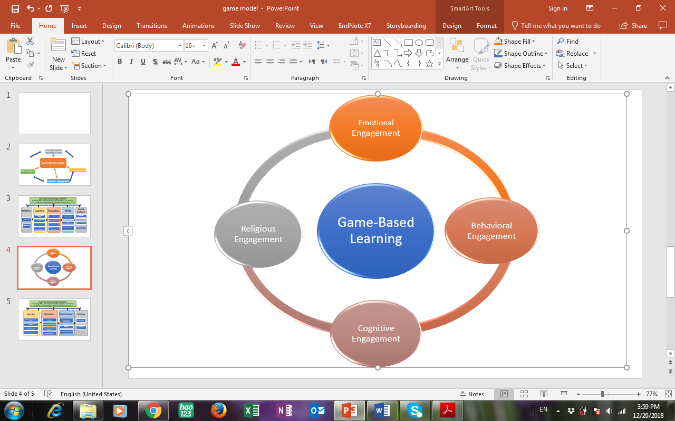

Figure 1:integrated design framework of game based learning

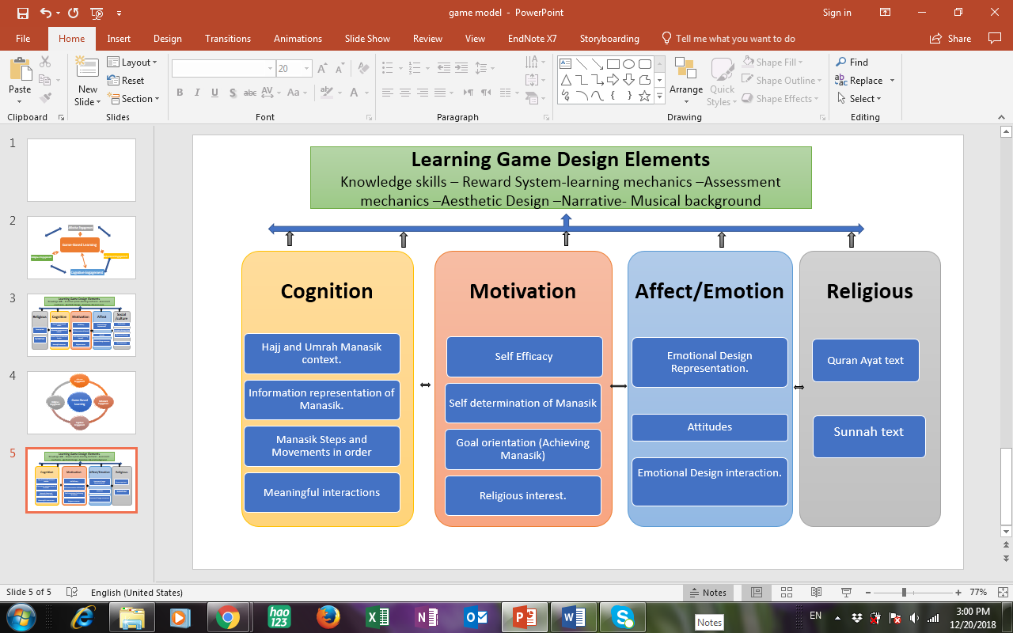

Figure 2: General game design pattern for Manasik learning

**References:**

* Azevedo, R., Cromley, J. G., Moos, D. C., Greene, J. A., & Winters, F. I.(2011). Adaptive content and process scaffolding: A key to facilitating students’ self-regulated learning with hypermedia. Psychological Testing and Assessment Modeling, 53, 106–140.
* Black, J. B. (2010). An embodied/grounded cognition perspective on educational technology. In M. S. Khine, & I. Saleh (Eds.), New science of learning: Cognition, computers and collaboration in education (pp. 45–52). New York, NY: Springer. <http://dx.doi.org/10.1007/978-1-4419-5716-0_3> .
* Eccles, J. S., Wigfield, A., & Schiefele, U. (1998). Motivation to succeed. In W. Damon, & N. Eisenberg (Eds.), Handbook of child psychology,5th ed.: Vol. 3. Social, emotional, and personality development (pp.1017–1095). Hoboken, NJ: Wiley & Sons.
* Gibbs, R. (2006). Embodiment and cognitive science. Cambridge, MA:Cambridge University Press.
* Hidi, S., & Renninger, K. A. (2006). The four-phase model of interest development. Educational Psychologist, 41, 111–127. <http://dx.doi.org/10.1207/s15326985ep4102_4>.
* Jan L. Plass ,Bruce D. Homer &Charles K. Kinzer (2015). Foundations of Game-Based Learning. EDUCATIONAL PSYCHOLOGIST, 50(4), 258–283, 2015 Copyright _ Division 15, American Psychological Association ISSN: 0046-1520 print / 1532-6985 online DOI: 10.1080/00461520.2015.1122533.
* Kinzer, C. K., Hoffman, D., Turkay, S., Gunbas, N., Chantes, P., Dvorkin,T., & Chaiwinij, A. (2012). The impact of choice and feedback on learning,motivation, and performance in an educational video game. In K.Squire, C. Martin, & A. Ochsner (Eds.), Proceedings of the games,learning, and society conference: Vol. 2 (pp. 175–181). Pittsburgh, PA:ETC Press.280 PLASS, HOMER, KINZER.
* Koedinger, K. (2001). Cognitive tutors as modeling tools and instructional models. In K. D. Forbus, & P. J. Feltovich (Eds.), Smart machines in education (pp. 145–167). Cambridge, MA: MIT Press.
* Kwah, H., Milne, C., Tsai, T., Goldman, R., & Plass, J. L. (2014).Emotional engagement, social interactions, and the development of an afterschool game design curriculum. Cultural Studies of Science Education. Advance online publication. doi:10.1007/s11422-014-9621-0 .
* Izard, C. E. (2007). Basic emotions, natural kinds, emotion schemas, and a new paradigm. Perspectives on Psychological Science, 2, 260–280. <http://dx.doi.org/10.1111/j.1745-6916.2007.00044.x> .
* Mayer, R. E. (2014). Computer games for learning. An evidence-based approach. Cambridge, MA: MIT Press.
* Mayer, R. E. (2005). Cognitive theory of multimedia learning. In R. Mayer (Ed.), The Cambridge handbook of multimedia learning (pp. 31–48). Mayer, R. E. (2014). Computer games for learning. An evidence-based approach. Cambridge, MA: MIT Press.
* Mislevy, R. J., & Haertel, G. D. (2006). Implications of evidence-centered design for educational testing. Educational Measurement: Issues and Practice, 25(4), 6–20. <http://dx.doi.org/10.1111/j.1745-3992.2006.00075.x> .
* Plass, J. L., & Kaplan, U. (2015). Emotional design in digital media for learning. In S. Tettegah, & M. Gartmeier (Eds.), Emotions, technology,design, and learning (pp. 131–162). New York, NY: Elsevier.
* Plass, J. L., Moreno, R., & Br€unken, R. (Eds.). (2010). Cognitive load theory.Cambridge, MA: Cambridge University Press. http://dx.doi.org/10.1017/CBO9780511844744 .
* Plass, J. L., Perlin, K., & Nordlinger, J. (2010, March). The games for learning institute: Research on design patterns for effective educational games. Paper presented at the Game Developers Conference, San Francisco,CA.
* Rotgans, J. I., & Schmidt, H. G. (2011). Situational interest and academic achievement in the active-learning classroom. Learning and Instruction,21, 58–67. <http://dx.doi.org/10.1016/j.learninstruc.2009.11.001>.
* Salen, K., & Zimmerman, E. (2004). Rules of play: Game design fundamentals.Cambridge, MA: MIT Press.
* Shaffer, D. W., Halverson, R., Squire, K. R., & Gee, J. P. (2005). Video games and the future of learning (WCER Working Paper No. 2005-4). Madison: University of Wisconsin–Madison, Wisconsin Center for Education Research (NJ1).
* Steinkuehler, C., & Duncan, S. (2008). Scientific habits of mind in virtual worlds. Journal of Science Education and Technology, 17, 530–543. <http://dx.doi.org/10.1007/s10956-008-9120-8> .