Using a multi-agent architecture to handle the negotiation between the Hajj authorities and the Hajj travel agents

Dr. Magdi Amer⁽¹⁾, Afnan Almatrafi⁽²⁾

⁽¹⁾ Department of Computer Science, College of Computer and Information Systems, Umm Al-Qura University

⁽²⁾ Department of Computer Science, Jamoum University College, Umm Al-Qura University

استخدام نظام متعدد الوكلاء (MAS) لتنظيم المفاوضات بين إدارات الحج ومنظمي الحملات لتفويج الحجاج خلال أوقات الذروة

د.مجدي عامر⁽¹⁾، ا. أفنان علي المطرفي⁽²⁾

⁽¹⁾ كلية الحاسب الآلي ونظم المعلومات- جامعة أم القرى

⁽²⁾ قسم الحاسب , الكلية الجامعية بالجموم - جامعة أم القرى

ملخص البحث (Abstract):
أحد أكبر المشاكل التي تواجه السلطات خلال الحج هي الاختناقات المرورية التي تحدث خلال انتقال الحجاج من عرفة إلى مزدلفة. في هذه الورقة يقترح المؤلفون استخدام الذكاء الاصطناعي (AI) لبناء الجدول الزمني الذي ينظم تفويج الحجاج خلال هذا الوقت. يتم ذلك باستخدام بنية نظام متعدد الوكلاء (MAS) لتنظيم التفاوض بين إدارات الحج ومنظمي الحملات. تقترح الورقة أيضًا استخدام بوابات RFID الآلية والتي بدورها ستكتشف تلقائيًا وتغرم أي حافلة لا تحترم الجدول الزمني المسند إليها. يتوقع من خلال استخدام نظام معلن يوزع الجدول الزمني بين منظمي الحملات بطريقة واضحة وعادلة، ستتمكن إدارات الحج من فرض الجدول الزمني مما يسمح بفرض غرامات على أولئك الذين لا يحترمون الجدول الزمني.

One of the biggest problems facing the Hajj Authorities is the traffic jams that occurs when pilgrims go from Arafah to Muzdalifah. In this paper the authors propose the use of Artificial Intelligent (AI) to build the schedule regulating the transport of pilgrims during this time. This is done using uses a Multi Agent System’s (MAS) architecture to regulate the negotiation. The paper proposes also the use of automated RFID gates that will automatically detect and fine any bus that does not respect the schedule. By using an open system that distributes the schedule between the hajj travel agents in a clear and fair way, the authorities will be able to enforce the schedule and will allow them to impose fines on those who do not respect the schedule.
Introduction:
Saudi Arabia, under the leadership of King Salman bin Abdulaziz, makes every effort to overcome the difficulties facing the pilgrims. This is aligned with the Kingdom’s Vision 2030, which includes plans to the improvement of services provided to pilgrims and plans to increase the number of Muslims performing Hajj with the highest standards of comfort and safety. Experts and researchers are encouraged in conducting research related to Hajj that helps achieve these goals.
One of the most difficult problems that the Hajj authorities face every year are the congestion and traffic jams that occurs during the transport of pilgrims from Arafah to Muzdalifah. This is due to the huge number of pilgrimers that aims to reach Muzdalifah at the earliest time, resulting in road congestions that elongate the time needed and that threatening the safety of the pilgrims as it reduces the ability to carry out safety procedures at the same time.
This motivated the research described in this paper that proposes the use of a solution based on Artificial Intelligent (AI) that regulates the flow of pilgrims during peak times. The proposed solution uses a Multi Agent System’s (MAS) architecture to regulate the negotiation between the Hajj authorities and the hajj travel agents to build a schedule for to transport pilgrims from Arafah to Muzdalifah. By using an open system that distributes the schedule between the hajj travel agents in a clear and fair way, the authorities will be able to enforce the schedule and will allow them to impose fines on those who do not respect the schedule.
The researchers will propose techniques to enforce buses to respect schedule and to allow the authorities to issue traffic fines to discourage attempts to disrespect the schedule. The use of AI will facilitate the implementation of the system and would allow each hajj travel agent to adapt the behavior of the system to his preferences and his financial constrains. The cost of the implementation will be covered with the revenue that the system will generate.
In the next section, research related to this topic will be described. Next, the overview of the MAS will be presented and the details of operation. The use of RFID to implement smart gateways for issuing fines will be explained in the section after that. Finally, the conclusion and future work will be presented.
State of the art
There is consensus that one of the biggest problems facing pilgrims is overcrowding during peak periods. In [1], the author prove that the problem of congestion is not the result of infrastructure’s limitations, but instead it is due to the difficulty of organizing the process of crowding and enforcing the pilgrims to respect the schedule allocated to them. Moreover, [2] also stressed the previous results, saying that if pilgrims were committed to pre-booking various activities during the Hajj season, this would ease congestion and suggested several alternatives to support the idea that people should not doing the same activities at the same time. This confirms the assumption made in this paper that regulating the schedule will have a clear impact in avoiding congestions during Hajj.
The first step for enforcing Hajj travel agents to abide to the schedule is create the schedule assigned to each travel agent through negotiation. The Hajj authorities need the schedule finalized long before the start of Hajj to prepare for the services needed to accommodate the large number of pilgrims. Direct human negotiation will not possible due to the large number of Hajj travel agents and due to the fact that many of them do not have a representative in the Kingdom. Hence, the negotiation between the Hajj authorities and the Hajj travel agents need to be automated.
Automated negotiation has been an active field of Artificial Intelligent research as a reliable approach for coordination between agents. Agents are software entities that act on behalf of a user to achieve the user’s goal within the constrains determined by the user [3]. Agents are distinguished from standard programs by many characteristics [4]. First of all, agents are expected to be autonomous, acting without human intervention. Agents should also be reactive, capable of sensing its environment and responding to changes that occur in it. Agents does not simply act in response to the environment instead, they control their actions to achieve their goals. Agents have often social abilities, allowing them to interact with other agents through collaboration and competition to achieve their goals within the constraints imposed by the user.
To simplify the architecture needed to implement the agent’s intelligence, many researchers were inspired by the insect world. In fact, an individual ant or bee has limited mental abilities, but when different simple ants or bees, each with a specific ability and goal, interact together, the resulting behavior of the group of insects is intelligent and the group is capable of solving complex problems. This inspired the research of Multi-agent Systems (MAS), which has proven its capability to resolve multiple complex real-life problems using limited resources [3, 4, 5]. A multi-agents system allows agents to work together to find answers to problems that are beyond the individual capabilities or knowledge of each agent [5].
Conflict may occur between multiple agents when their goals are at odds with each other. When this occurs, negotiation and arbitration are used to help resolve conflicts [6]. Negotiation can be purely competitive, purely cooperative or mixed depending on the behavior of the agents. Competitive negotiation is used when agents have independent goals that conflict with each other. Cooperative negotiation is used when agents have a common goal to achieve or a single task to execute. Most of cases contains element of both competitive and cooperative [7,8].
Auction is one of the forms of negotiation between agents. An auction is a procedure used for selling and buying items by offering them up for bid. Auction theory is important in both practical and theoretical terms, and is widely used in the economic fields of countries, companies and individuals [9]. Bidders are bidding to buy with the lowest prices and sell at the highest possible prices. Due to the widespread use of auctions in various fields, there has been growing interest in designing different forms of auctions to suit the diversity of deals and bidders [10].
There are three main types of auctions; the English auction, the Dutch auction and first price sealed. In the English auction, bidders compete to buy an item by raising the price. The bidder with the highest offer will be the one winning the auction. In the Dutch auction, the auctioneer starts at a very high price and then lowers the price periodically, the first bidder who accepts the current price proposed by the auctioneer wins the item. In the First-price sealed auction, each bidder independently submit a single bide without seeing others' bids and the item is sold to the bidder who makes the highest bid [10].
In the following section, the architecture used for negotiation between the Hajj authorities and the Hajj travel agents will be described.
Proposed Architecture
As discussed in the previous section, traffic congestion during Hajj is mainly due to the fact the most Hajj travel agents do not respect the time schedule assigned to them. In this paper, we propose the use of negotiation between the Hajj authorities and the Hajj travel agents so that the process of assigning the schedule to the Hajj travel agents is done in a fair and open way, allowing the Hajj travel agent to affect the schedule based on his needs and his financial limitations.
The use of Multi-Agent Systems (MAS) to automate the negotiation process is proposed as organizing an event were such negotiation can take place is not possible. In fact, the Hajj authorities need to finalize the schedule long before the start of the Hajj so it will have enough time to make the necessary preparation to provide the services and accommodations needed. Many of the Hajj travel agents will not be present at the Kingdom of Saudi Arabia so they cannot be present in such an event. Moreover, due to the large number of Hajj travel agents organizing such an event will not be possible even if they have representatives in KSA.
The time of travel of pilgrims from Arafah to Muzdalifah will be divided into several time slots. Let’s assume that each time slot represent an hour from 6 PM to 12 PM. The Hajj Authorities (HA) will create an Information Agent (IA) and a Request Processing Agent (RPA). The HA will conduct a Dutch auction for each time slot. At the beginning of each cycle, the IA will publish the cost of reserving a place for each time slot and the number of available places. Agents representing the Hajj travel agent may send requests to reserve places if the conditions announced by the IA satisfies the Hajj travel agent’s criteria. These request will be processed by the RPA. If the number of reservation requests is smaller than the number of available places for a given time slot, the HA will reserve these places for these travel agents for the agreed upon price. During the next iteration, the price of the time slot will be reduced by a predefined percentage and the IA will publish the new price and the number of available places for each time slot. On the other hand, if the number of reservation requests is bigger than the number of available places for a given time slot, no reservation will be made and the price of the time slot will be increased by a predefined percentage. Similarly, the IA will publish the new price and the number of available places for each time slot.
Each Hajj travel agents will have a Company Agent (CA) acting on his behalf. The agent is composed of an Arbitrator Agent, several Quality Agents (QA) and a database containing the Hajj travel agent’s preferences, rules and constrains. The travel agent will provide the maximum price his is willing to pay for each time slot, the time slot that he prefers and the flexibility of his preference, which indicates if he is willing to consider other time slots.
A QA will be created for each time slot and the preferences of the Hajj travel agent regarding the maximum price corresponding to the time slot. The QA will calculate the fuzzy parameter Price Satisfaction (PS) that reflects who much the price of this time slot satisfies the requirements of the Hajj travel agents. The QA will use the data of the place sales in the previous rounds to estimate the risk of running out of places after the current round of negotiation. Based on these two fuzzy variable, the QA will use the rules shown in Figure 1 to calculate the Proposal Criteria Satisfaction (PCS) that reflects the amount of necessity for the QA to request a reservation for this time slot with the current price for the time slot. The system uses the JFuzzyLogic [11] library to implement the fuzzy rule system shown in Figure 2.
The Arbitrator Agent (AA) will receive the PCSs sent by each QA. The AA will calculate the global risk of running out of acceptable place for all the time slots that the Hajj travel agentsmay accept based on his preferences. The AA will use fuzzy rules based on the global risk, the PCS of each QA and how much the corresponding time slot satisfies the preferences of the Hajj travel agent to evaluate the fuzzy variable Global Proposal Satisfaction (GPPS) for each QA. If one GPPS or more exceed the value of minimum acceptable GPPS as defined by the Hajj travel agent’s preferences, the AA will choose the GPPS with the highest value and will send it to the Hajj Authorities’ RPA. If no GPPS exceeds the minimum acceptable GPPS, the Hajj travel agent will not request any reservation in the current round.
This process is repeated for each round till all the Hajj travel agents have reserved the required places. An overview of the system shown in Figure 3.
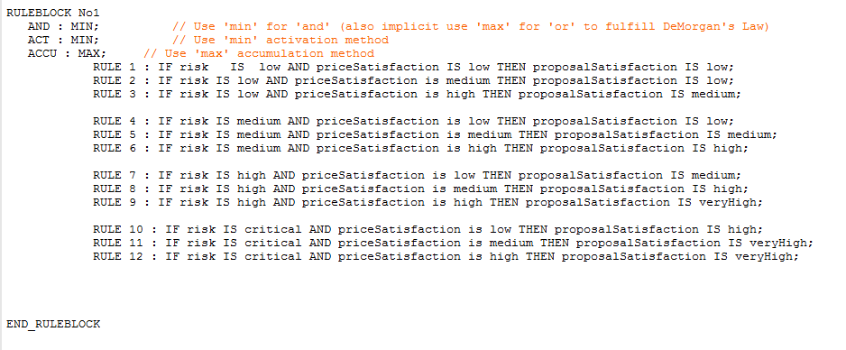
Figure 1: Sample of fuzzy rules used by QA to calculate PCS

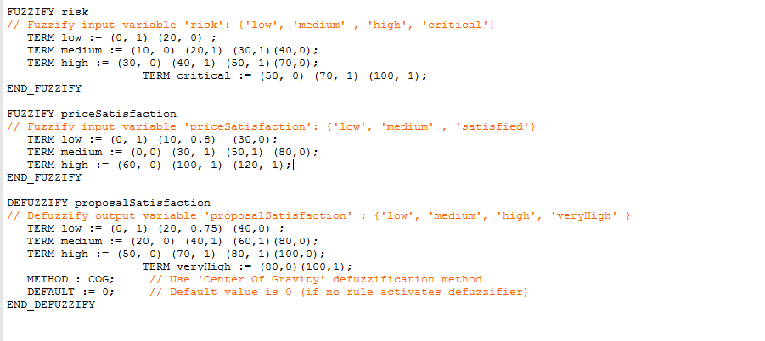
Figure 2: Sample of fuzzification and defuzzification of Fuzzy-Logic system
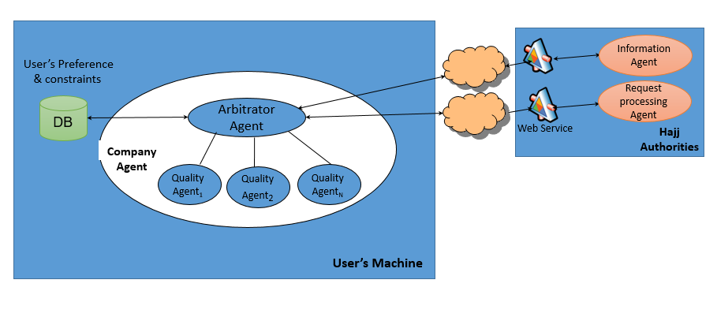
Figure 3: Overview of propsed system
After the automation of the negotiation, the next step is to implement a practical method to force the Hajj travel agents to abide to the assigned schedule. This paper proposes the use of Radio Frequency Identification (RFID) cards that is assigned to each bus. The RFID contains a key that uniquely identifies the Hajj travel agent that has participated in the automated negotiation and has reserved a place in the schedule. Automated gates will be placed at the entrance of Mecca to prevent any bus without a valid RFID to access the Holy city. During Hajj, automated gates can also be placed at the exit of Arafah that would only allow buses to pass if the time slot they have reserved have already started.
Any bus without a valid RFID for the current time slot will be fined. This fine should exceed the maximum possible value for any time slot. Using a fair and open system to distribute time slots and implementing a strict system that would penalize complain organizers that do not abide to the schedule is expected to resolve the problem of traffic congestions and improve the quality of the Hajj experience for all pilgrims.
Conclusion:
Traffic congestions that occurs during Hajj is not the result of insufficient infrastructure, instead it is due to the fact that the Hajj travel agents do not respect the schedule assigned to them.
In this paper, the authors propose to use a multi agent system to automate the negotiation between Hajj authorities and Hajj travel agents to make the process of schedule assignment open and fair. The use of automated RFID gates is also proposed to prevent buses without a valid card to access the holy city and to fine those buses without identification travelling during Hajj time.
It is expected that the use of such a system will be able to force Hajj travel agents to respect the assigned schedule, hence to resolve the problem of traffic congestions during Hajj.
Recommendations :
- Using the proposed multi agent system to automate the negotiation between Hajj authorities and Hajj travel agents to make the process of schedule assignment open and fair.
- Using automated RFID gates to prevent buses without a permission to access the holy city and to fine those buses without identification travelling during Hajj time.
References:
[1] M. Edrees, Location Based Scheduling to Jamarat Bridge, 16th Scientific Symposium for Hajj, Umrah & Madinah Visit – Scientific Portal for 1437AH
[2] F. M. Y. Othman, Practical Vision for Increasing the Capacity of the Hajj, In 16th Scientific Symposium for Hajj, Umrah & Madinah Visit – Scientific Portal for 1437AH
[3] M. Wooldridge, "An introduction to Multi-Agent systems". Wiley, 2009.
[4] S. Franklin, A. Graesser, Is it an agent, or just a program?: A taxonomy for autonomous agents, In Proceedings of the Third International Workshop on Agent Theories, Architectures and Languages, Springer Berlin Heidelberg, 1996. On-Line: http://www.msci.memphis.edu/ ~franklin/ AgentProg.html
[5] R. A. Flores-Mendez, "Towards a standardization of multi-agent system framework". In ACM Crossroads Student Magazine, Volume 5 issue 4, 1999.
[6] F. Lopes, "Negotiation and Argumentation in Multi-Agent Systems: Fundamentals, Theories, Systems and Applications", In Bentham Science Publishers.
[7] F. Bellifemine, G. Caire, D. Greenwood, "Developing Multi-Agent Systems with JADE", Wiley, 2009.
[8] F. Lopes, M. Wooldridge, A.Q. Novais, Negotiation among autonomous computational agents: principles, analysis and challenges, In Artificial Intelligence Review; Springer Netherlands, Dordrecht Vol. 29, Iss. 1, (Mar 2008): https://doi-org.sdl.idm.oclc.org/10.1007/s10462-009-9107-8
[9] McAfee, Dinesh Satam; McMillan, Dinesh (1987), "Auctions and Bidding" , Journal of Economic Literature, American Economic Association (published June 1987), 25 (2).
[10] Klemperer, P. 1999. Auction theory: A guide to the literature. Journal of Economic Surveys.
[11] Cingolani, P., & Alcala-Fdez, J. (2012, June)."jFuzzyLogic: a robust and flexible Fuzzy-Logic inference system language implementation", In Fuzzy Systems (FUZZ-IEEE), 2012 IEEE International Conference on (pp. 1-8). IEEE, https://doi.org/10.1109/FUZZ-IEEE.2012.6251215

