|  |  |  |
| --- | --- | --- |
|  | **A new proposed substance to resist ignition and fire for use in Hajj and Umrah seasons** Mohamed K. Hassan(1), Mohammed Y. Abdallah(1), Talal S. Mandourah(1),Ahmed F. Mohamed(1), Ibrahim Bushnaq(2), S. Azim(1)  (1) Mechanical Engineering Department, College of Engineering and Islamic Architecture, Umm Al-Qura University  (2) Volume Group Limited |  |
|  | **مادة جديدة مقترحة تقاوم الاشتعال والحرائق لاستخدامها في مواسم الحج والعمرة** |  |
|  | أ.د. محمد قرنى حسن( 1) د. طلال مندوره (1)، د. محمد يحيي عبد اللاه(1) د. أحمد فتحى محمد (1)  م. أبراهيم بوشناق (2)  م. سفيان أعظم(1)  (1) قسم الهندسة الميكانيكيةـ كلية ااهندسة والعمارة الاسلامية دامعة ام القرى  (2) فوليوم جروب ليمتد |  |

**ملخص البحث (Abstract):**

يتوافد الملايين من الحجاج والمعتمرين على مكة المكرمة والمدينة من مختلف الجنسيات والثقافات في مواسم الحج والعمرة. وهناك خدمات يحتاجها الحاج والمعتمر من وسائل نقل واعاشه واسكان وتنقل بين المشاعر المقدسة اثناء موسم الحج مما يؤدى الى زيادة فرص التعرض لمخاطر الحريق. و بالرغم من كون الخيام المتواجدة في المشاعر المقدسة مضادة للحريق الا ان وجود كميات هائلة من المواد القابلة للاشتعال خارج الاماكن المقدسة مثل الفرش في الفنادق ووسائل النقل وغيرها من مصادر الحريق مما يزيد من احتمالية حدوث حرائق. لذلك تهدف هذه الدراسة الى تقديم مادة سائله تقاوم الاشتعال بفعالية كبيرة كما ان هذه المادة آمنه على الانسان والبيئة وليس لها أي انبعاثات بالإضافة الى تكلفتها القليلة. علاوة على انه يمكن استخدام هذه المادة في كل الاماكن التى يتردد عليها الحجاج والزوار للاماكن المقدسة

Millions of pilgrims flock to Makkaha and Medina from different nationalities and cultures during the Hajj and Umrah seasons. There are services needed by Hajj and Umrah visitors from the means of transportation, accommodation, moving between sacred feelings and the end of the pilgrimage season, which leads to increased opportunities for exposure to fire risks. Although the tents in the holy sites are fireproof, the presence of huge quantities of flammable materials outside the holy places, such as mattresses in hotels, transportation and other sources of fire, increases the likelihood of fires.

Therefore, this study aims to provide a substance that is resistant to ignition very effectively, is safe for humans and the environment and has no emissions, in addition to the low cost. Moreover, this substance can be used in all places frequented by pilgrims and visitors to holy places.

**Introduction**

Fire safety is always a big concern wherever a huge number of people gather like in Hajj and Umrah season in Kingdom of Saudi Arabia; KSA. Governments spend a lot of money to prevent fire incidents including training, precautionary measures and using flame retardant and/or fire retardant materials and equipment. The flame retardants are the additives which delay ignition and fire retardants, on the other hand, are the additives which slow down combustion/flame propagation. Flame retardants are added substances, which when added to manufactured materials like plastics or textiles, during or after manufacture, restrain or suppress the burning process. In the presence of an ignition source, they meddle with combustion at different phases of the burning process, e.g. during heating, ignition or fire spread. The primary function of these additives is to suppress the spread of fires or slow down the flashover time so that people can escape from the premises. Flame retardant chemical additives have been used for several decades to reduce the flammability of resins and polymers found in commercial products such as furniture, mattresses, electronics (e.g., televisions, cell phones), and even children’s products such as car seats, strollers, and baby clothing [*1*-*4*]. These chemicals are designed to increase the time available to escape from fires by delaying the combustion of the treated materials. However, these flameretardants have been shown to leach or otherwise escape from these products over time and accumulate in both indoor and outdoor environments, raising concerns about human exposure and potential health effects [*5*-*7*]. Prior to 2004, polybrominated diphenyl ethers (PBDEs) were one of the most commonflameretardant mixtures used in furniture and electronic products. PBDEs were sold commercially as three different formulations referred to as PentaBDE, OctaBDE, and DecaBDE, each having different applications. However, due to their persistence, bioaccumulation, and potential health effects, PentaBDE and OctaBDE were banned or voluntarily phased out from use beginning in 2002 in many regions of the world, and will soon be added to the list of banned chemicals included in the Stockholm Convention on Persistent Organic Pollutants [*8*]. PentaBDE was historically used in the highest volumes in North America (primarily U.S. and Canada) to treat polyurethane foam in furniture [*9*]. The higher use of PentaBDE in North America led to elevated levels of the PentaBDE congeners in the U.S. population relative to European and Asian populations, likely due to a higher exposure from house dust [*10*-*17*]. Several studies have recently found associations between human body burdens of PBDEs (primarily PentaBDE) and health effects such as thyroid hormone and androgen abnormalities, cryptorchidism, and low birth weights [*18*-*21*]. The phase-out of PentaBDE has led to the development of alternate flame retardant formulations and the increased use of existing flame retardant chemicals to meet flammability standards for polyurethane foam [*22*]. We recently identified the brominated components of a PentaBDE replacement mixture suspected of high volume use in polyurethane foam [*23*]; however, for many flame retardants, basic information such as chemical identity and their consumer product applications is typically not available. Lack of information significantly restricts environmental and human health assessments for these chemicals, which is of considerable concern, particularly since the PentaBDE replacement chemicals recently identified were also detected in U.S. house dust [*23*]. Occurrence in house dust suggests thathumanexposure to theseflameretardants will also occur, and raises concerns regarding the potential for exposure to other PBDE replacements that have yet to be identified. Though several studies have reported the environmental fate and effects of PBDEs, very little information on the occurrence, fate, and toxicity of their replacement chemicals exists.

**Research aims**

The aim of this research is to develop a low cost higly flame retardant additive that can be used in liquid or powder form to suppress fire.

The characteristics of the proposed product are as follows:

**Cost Efficient**

The aim of the research is to provide an economical solution for energy efficiency and fire protection.

**Eco-friendly**

The developed product can be used to prevent forest wildfires and does not impact our habitat system.

**Highly insulate**

The proposed product has an effective isolation property. It can prevent heat transfer between surfaces.

**Water based/Anti-allergic**

The product does not contain harmful ingredients towards the human health. It is water-based and anti-allergic.

**Non-toxic Smoke/Less Smoke Pollution**

The smoke formation from materials coated or sprayed with the proposed material is significantly less under fire exposure.

**Validity Period**

Products and materials sprayed or applied with the additive material are infinitely protected so long as the end item is coated.

**Free from discoloration and fabric alterations**

After several tests it has been proved that the proposed material does not affect the original characteristics and conditions of fabric materials.

**Research methodology**

**Flame Retardants Definition.**

Flame retardants are added substances, which when added to manufactured materials like plastics or textiles, during or after manufacture, restrain or suppress the burning process. In the presence of an ignition source, they meddle with combustion at different phases of the burning process, e.g. during heating, ignition or fire spread. The primary function of these additives is to suppress the spread of fires or slow down the flashover time so that people can escape from the premises[24].

**Classes of Flame Retardants.**

Flame Retardants, both Reactive and Additive types, can be classified into the following classes [25]:

* Mineral compounds
* Organohalogen compounds
* Organophosphorus compounds

**Mineral compounds**

These compounds mainly consist of aluminum hydroxide (ATH), huntite, magnesium hydroxide (MDH), and hydromagnesite,[26][27][28][29], red phosphorus, and boron compounds, mostly borates.

**Organohalogen compounds**

Organochlorines (chlorendic acid derivatives and chlorinated paraffins), organobromines (decaBDE), decabromodiphenyl ethane, polymeric brominated compounds (brominated polystyrenes, brominated epoxy oligomers (BEOs), brominated carbonate oligomers (BCOs), tetrabromobisphenol A (TBBPA), tetrabromophthalic anyhydride and hexabromocyclododecane (HBCD) compounds fall in this class[30]. These compounds form the largest group of flame retardants used in printed circuit board (PCB) materials [31].

**Organophosphorus compounds**

Organophosphates (triphenyl phosphate), resorcinol bis(diphenylphosphate) (RDP), aluminium diethyl phosphinate, bisphenol A diphenyl phosphate (BADP), and tricresyl phosphate (TCP) and dimethyl methylphosphonate (DMMP) compounds are another class of flam retardants [32].

Proposed substance (BET200) works under a gas phase that interrupt chemical reactions that take place in the flame.

BET200 has three main forms. Depending on the materials, BET 200 can be either used as liquid, powder or jelly forms.

**Results and discussion**

**Mechanisms of Flame Retardancy**

Flame retardation mechanisms usually take place either physically or by chemical actions[31].

There are three modes for the physical flame retardant mechanisms. These are:

* Cooling
* Formation of Protective Layer
* Dilution

Under the cooling mode, an endothermic process is activated by added substances cooling the substrate to a temperature underneath that required for continuing the burning process. After cooling, a solid or gaseous protective layer shields the combustible layer from the gaseous phase. The heat exchange is obstructed by excluding the oxygen required for the combustion process. In dilution mode, to restrain the lower ignition limit of the gas mixture, fillers are incorporated that evolve inert gases on decomposition diluting the fuel in the solid and gaseous phase[33-36].

Chemical action flam retardant mechanisms can be subdivided into two modes:

* Reaction in the solid phase
* Reaction in the gas phase

In the solid phase, the flame retardant causes a layer of carbon to form on the polymer surface by dehydration of the flame retardant that forms a carbonaceous layer by cross linking. This layer acts as an insulation layer, preventing further decomposition of the material. Whereas, in the gas phase the free radical mechanism of the combustion process is interrupted. The exothermic processes are thus stopped, the system cools down and the supply of flammable gases is suppressed[37].The mechanism used by brominated flame retardants (BFRs) is shown in Fi. g. 1.0 At the first stage, bromine breaks down to form a bromine radical. After this HBr forms by the reaction of hydrocarbon with bromine radical. The high-energy H and OH radicals then removed by the reaction of HBr. The high-energy radicals are replaced with low-energy bromine radicals. The HBr consumed is then regenerated by reaction with the hydrocarbon.



Figure 1 Brominated flame retardants (BFRs) Mechanism [37]

In the category of non-halogenated flame retardants, the phosphorus containing compound is converted to phosphoric acid by thermal decomposition. The phosphoric acid then dehydrates the oxygen containing polymer and causes charring as shown in the Fig.1.2.

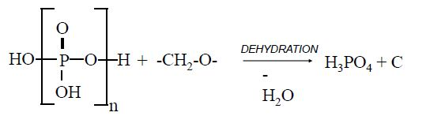

Figure 2 Non-halogenated flame retardants Mechanism[37]

Depending on the above mechanism and chemical reactions, a propsed subastance called BET200 is prepared. Table 1 contains the physical and chemicla properites of BET200. . The benefit of spraying BET200on wood and polyster foams are ilustrated in Fig 3 and Fig. 4. Fig. 3 shows that there is no decerease in wood thickness after ignition for 300 sec whereas

Thickness of wood piece without BET200 starts to decrease after only 5 sec. This means that BET200 slow the ignition of wood piece for 300 second. Similary, when spraying BET200 on polyster foam, the reuction in its thickness delyed to 2500 second. These results reveal clearly the benifts of using BET200 as afire retardancy substance.

**Summary and conclusion**

A new propsed subsatnce called BET200 is prepared and tested to get its chemical and physical properties. BET200 has been showed a significant possitive effect on retarding fire when sprying on wood and polyster foams. BET200i is safe as it is non-toxic smoke**/**less smoke pollution and is not harmful as it is eco-friendly..

**Recommendations**

1. From the above rsults, BET200 is recommended as a fire retardancy substance which might be used in holly sities during Haj and Ummarah seassons.

**Figures and Tables**

Table 1 Chemical and physical properties of BET200

|  |  |
| --- | --- |
| Property | Description |
| Appearance | Liquid |
| Boiling Point | 98 C |
| Freezing Point | -2 C |
| pH | 3 – 5 |
| Deflagrate | None |
| Flammability | None |
| Flash Point | None |
| Scent | None |
| Colour | Turbid |
| Solvents | Water |
| Density | 1.2 kg/m3 |
| Viscosity | 1.0 |

**Table 2 Results of spraying BET200 on foam door and polyster**

|  |  |  |  |
| --- | --- | --- | --- |
| **BET 200** | **Heat C°**  **Direct Torch**  **Flame** | **Sustain**  **Time** | **Material Thickness after Process** |
| Fire Retardant Fiber / Foam Door 5 cm Thickness | 1200 C° | 38 Second | 1.8 cm |
| Fire Retardant Fiber / Foam Door 5 cm Thickness  (with BET 200) | 1200 C° | 5 Minutes | 4.8 cm |
| Polyester 1.5 mm Thickness | 800 C° | 35 Second | 0 mm |
| Polyester 1.5 mm Thickness (with BET 200) | 800 C° | 35 Minutes | 1.2mm |

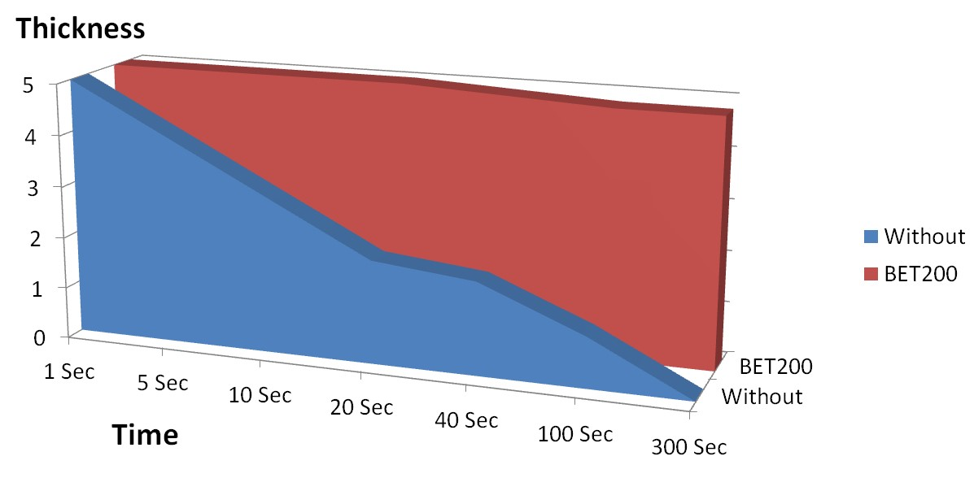

**Fig 3 Effect of spraying BET200 on ignition time of wood.**

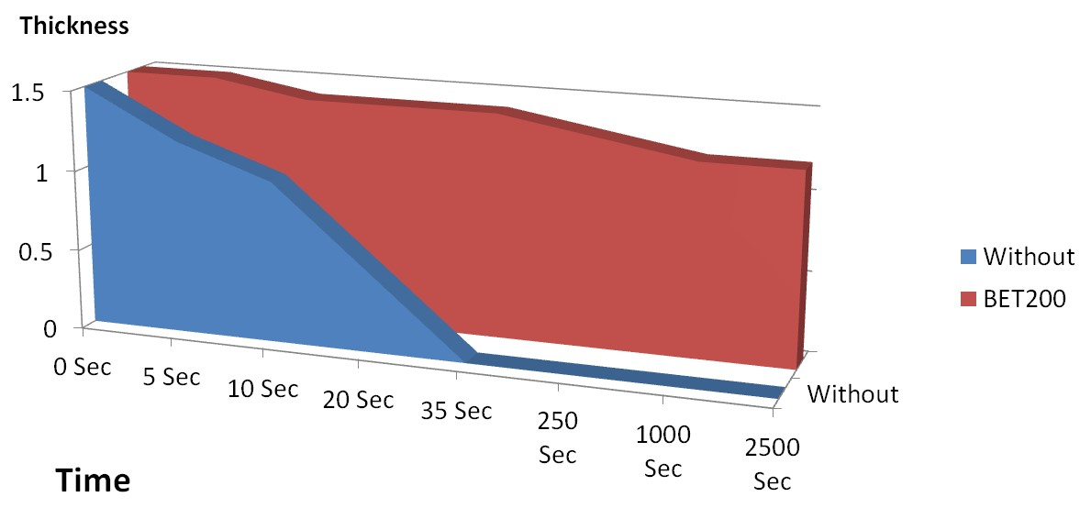

**Fig 4. Fig 3 Effect of spraying BET200 on ignition time of polyester (Foam)**

**Referamces:**

[1] Hale, R. C.; La Guardia, M. J.; Harvey, E.; Mainor, T. M. Potential role of fire retardant-treated polyurethane foam as a source of brominated diphenyl ethers to the US environment. *Chemosphere* 2002, *46* (5), 729–735.

[2] Blum, A.; Ames, B. N. Flame-Retardant Additives as Possible Cancer Hazards. Science 1977, 195 (4273), 17–23.

[3] Blum, A.; Gold, M. D.; Ames, B. N.; Kenyon, C.; Jones, F. R.; Hett, E. A.; Dougherty, R. C.; Horning, E. C.; Dzidic, I.; Carroll, D. I.; Stillwell, R. N.; Thenot, J. P. Children Absorb Tris-Bp Flame- Retardant from Sleepwear - Urine Contains Mutagenic Metabolite, 2,3-Dibromopropanol. Science 1978, 201 (4360), 1020– 1023.

[4]Alaee, M.; Arias, P.; Sjodin, A.; Bergman, A. An overview of commercially used brominated flame retardants, their applications, their use patterns in different countries/regions and possible modes of release. Environ. Int. 2003, 29 (6), 683–689.

[5] Allen, J. G.; McClean, M. D.; Stapleton, H. M.; Webstert, T. F. Linking PBDEs in house dust to consumer products using X-ray fluorescence. *Environ. Sci. Technol.* **2008**, *42* (11), 4222–4228

[6] Birnbaum, L. S.; Staskal, D. F. Brominated flame retardants: Cause for concern. *Environ. Health Perspect.* **2004**, *112* (1), 9– 17.

[7] Webster, T. F.; Harrad, S.; Millette, J. R.; Holbrook, R. D.; Davis, J. M.; Stapleton, H. M.; Allen, J. G.; McClean, M.; Ibarra, C.; Abdallah, M. A. E.; Covaci, A. Identifying Transfer Mechanisms and Sources of Decabromodiphenyl Ether (BDE 209) in Indoor Environments Using Environmental Forensic Microscopy. *Environ. Sci. Technol.* **2009**, *43* (9), 3067–3072.

[8] Stockholm Convention on Persistent Organic Pollutants. http://chm.pops.int/; accessed 2009.

[9] Hale, R. C.; Alaee, M.; Manchester-Neesvig, J. B.; Stapleton, H. M.;Ikonomou, M. G. Polybrominated diphenyl ether flame retardants in the North American environment. *Environ. Int.* **2003**, *29* (6), 771–779.

[10] Sjodin, A.; Papke, O.; McGahee, E.; Focant, J. F.; Jones, R. S.; Pless-Mulloli, T.; Toms, L. M. L.; Herrmann, T.; Muller, J.; Needham, L. L.; Patterson, D. G. Concentration of polybrominated diphenyl ethers (PBDEs) in household dust from various countries. *Chemosphere* **2008**, *73* (1), S131–S136.

[11] Stapleton, H. M.; Dodder, N. G.; Offenberg, J. H.; Schantz, M. M.; Wise, S. A. Polybrominated diphenyl ethers in house dust and clothes dryer lint. *Environ. Sci. Technol.* **2005**, *39* (4), 925–931.

[12] Wu, N.; Herrmann, T.; Paepke, O.; Tickner, J.; Hale, R.; Harvey, E.; La Guardia, M.; McClean, M. D.; Webster, T. F. Human exposure to PBDEs: Associations of PBDE body burdens with food consumption and house dust concentrations. *Environ. Sci. Technol.* **2007**, *41* (5), 1584–1589.

[13] Jones-Otazo, H. A.; Clarke, J. P.; Diamond, M. L.; Archbold, J. A.; Ferguson, G.; Harner, T.; Richardson, G. M.; Ryan, J. J.; Wilford, B. Is house dust the missing exposure pathway for PBDEs? An analysis of the urban fate and human exposure to PBDEs. *Environ. Sci. Technol.* **2005**, *39* (14), 5121–5130.

[14] Allen, J. G.; McClean, M.; Stapleton, H. M.; Webster, T. F. Critical Factors in Assessing Exposure toPBDEsviaHouseDust. *Environ. Int.* **2008**, *34*, 1085–1091.

[15] Hites, R. A. Polybrominated diphenyl ethers in the environment and in people: A meta-analysis of concentrations. *Environ. Sci. Technol.* **2004**, *38* (4), 945–956.

[16] Sjodin, A.; Patterson, D. G.; Bergman, A. A review on human exposure to brominated flame retardants - particularly polybrominated diphenyl ethers. *Environ. Int.* **2003**, *29* (6), 829– 839.

[17] Harrad, S.; Ibarra, C.; Diamond, M.; Melymuk, L.; Robson, M.; Douwes, J.; Roosens, L.; Dirtu, A. C.; Covaci, A. Polybrominated diphenyl ethers in domestic indoor dust from Canada, New Zealand, United Kingdom and United States. *Environ. Int.* **2008**, *34* (2), 232–238.

[18] Chao, H. R.; Wang, S. L.; Lee, W. J.; Wang, Y. F.; Papke, O. Levels of polybrominated diphenyl ethers (PBDEs) in breast milk from central Taiwan and their relation to infant birth outcome and maternal menstruation effects. *Environ. Int.* **2007**, *33* (2), 239–245.

[19] Turyk, M. E.; Persky, V. W.; Imm, P.; Knobeloch, L.; Chatterton, R.; Anderson, H. A. Hormone Disruption by PBDEs in AdultMale Sport Fish Consumers. *Environ. Health Perspect.* **2008**,*116* (12), 1635–1641.

[20] Meeker, J. D.; Johnson, P. I.; Camann, D.; Hauser, R. Polybrominated diphenyl ether (PBDE) concentrations in house dustare related to hormone levels in men. *Sci. Total Environ.* **2009**,*407* (10), 3425–3429.

[21] Main, K. M.; Kiviranta, H.; H.E., V.; E., S.; Tuomisto, J. T.;Tuomisto, J.; Vartiainen, T.; Skakkebaek, N. E.; Toppari, J. FlameRetardants in Placenta and Breast Milk and Cryptorchidism in Newborn Boys. *Environ. Health Perspect.* **2007**, *115* (10), 1519–1526.

[22] Babich, M. A. CPSC Staff Preliminary Risk Assessment of FlameRetardant (FR) Chemicals in Upholstered Furniture Foam; USCPSC: Bethesda, MD, 2006; www.cpsc.gov/library/foia/foia07/brief/ufurn2.pdf.

[23] Stapleton, H. M.; Allen, J. G.; Kelly, S. M.; Konstantinov, A.; Klosterhaus, S.; Watkins, D.; McClean, M. D.; Webster, T. F. Alternate and new brominated flame retardants detected in US house dust. *Environ. Sci. Technol.* **2008**, *42* (18), 6910–6916.

[24] U.S. Environmental Protection Agency (2005). Environmental Profiles of Chemical Flame-Retardant Alternatives for Low-Density Polyurethane Foam (Report). EPA 742-R-05-002A. Retrieved 4 April 2013.

[25] Hollingbery, LA; Hull TR (2010). "The Thermal Decomposition of Huntite and Hydromagnesite". Thermochimica Acta. 509 (1–2): 1–1. doi:10.1016/j.tca.2010.06.012.

[26] Hollingbery, LA; Hull TR (2010). "The Fire Retardant Behaviour of Huntite and Hydromagnesite - A Review". Polymer Degradation and Stability. 95 (12): 2213–2225. doi:10.1016/j.polymdegradstab.2010.08.019.

[27] Hollingbery, LA; Hull TR (2012). "The Fire Retardant Effects of Huntite in Natural Mixtures with Hydromagnesite". Polymer Degradation and Stability. 97 (4): 504–512. doi:10.1016/j.polymdegradstab.2012.01.024.

[28] Hollingbery, LA; Hull TR (2012). "The Thermal Decomposition of Natural Mixtures of Huntite and Hydromagnesite". Thermochimica Acta. 528: 45–52. doi:10.1016/j.tca.2011.11.002.

[29] Hull, TR; Witkowski A; Hollingbery LA (2011). "Fire Retardant Action of Mineral Fillers". Polymer Degradation and Stability. 96 (8): 1462–1469. doi:10.1016/j.polymdegradstab.2011.05.006.

[30] van der Veen, I; de Boer, J (2012). "Phosphorus flame retardants: Properties, production, environmental occurrence, toxicity and analysis". Chemosphere. 88 (10): 1119–1153. Bibcode:2012Chmsp..88.1119V.

[31] Dr. Oliver Töpfer, Nabaltec. “Boehmite as Halogen Free Flame Retardant Filler Utilized in Cost Effective Producton of Highly Reliable Base Laminates”, EIPC Summer Conference Milan, September 2012.

[32] Weil, ED; Levchik, SV (2015). Flame Retardants for Plastics and Textiles: Practical Applications. Munich: Carl Hanser Verlag. p. 97. ISBN 1569905789.

[33] International Electrotechnical Commision IEC 61249-2-21.

[34] Risks and Benefits in the Use of Flame Retardants in Consumer Products, G C Stevens & A H Mann, University of Surrey: DTI Reference URN 98/1026.

[35] Babrauskas, V.; Harris, R.; Gann, R.; Levin, B.; Lee, B.; Peacock, R.; Paabo, M.; Twilley, W.; Yoklavich, M.; Clark, H. (1988). NBS Special Publication 749: Fire hazard comparison of fire-retarded and non-fire-retarded products (Report). National Bureau of Standards, Center for Fire Research, Fire Measurement and Research Division. pp. 1–86.

[36] Schuhmann, J.; Hartzell, G. (1989). "Flaming combustion characteristics of upholstered furniture". Journal of Fire Sciences. 7 (6): 386–402. doi:10.1177/073490418900700602.

[37] Araki, A., Saito, I., Kanazawa, A., Morimoto, K., Nakayama, K., Shibata, E., . . . Kishi, R. (2014). Phosphorus flame retardants in indoor dust and their relation to asthma and allergies of inhabitants. Indoor Air, 24(1), 3-15. doi:10.1111/ina.12054.