|  |  |  |
| --- | --- | --- |
|  | **Trenchless Technology: The Right Method for Sustainable Construction & Maintenance of Urgent Infrastructure Projects within Crowded Vicinities**  Moustafa Kassab(1)(2), Omar Alruwaythi(1)  (1) Civil Engineering Department, Faculty of Engineering, Taibah University Al-Madina Al-Munawara, Saudi Arabia  (2) Systems Design Engineering, University of Waterloo, Canada |  |
|  | **تقنية عدم حفر الخنادق: الطريقة الأمثل للبناء المستدام وصيانة مشاريع البنية التحتية العاجلة في المناطق المزدحمة** |  |
|  | مصطفى محمد كساب(1)(2)، عمر الرويثي(1)  (1) جامعة طيبة- كلية الهندسة- قسم الهندسة المدنية  (2)كلية الهندسة – جامعة واترلوا – كندا |  |

**ملخص البحث (Abstract):**

في مشاريع البنية التحتية العاجلة في المناطق والشوارع المزدحمة بالمشاة و العربات، فإن إيجاد طرق أسرع وأكثر أمانًا لاستكمال مشاريع البناء والصيانة مع مرعاة الحد الأدنى من التأثير على المشاة وحركة المرور والبيئة هو محور اساسي لمعظم مديري المشاريع وصناع القرار. تعد تقنية عدم حفر الخنادق المكشوفة "Trenchless Technology" والتي تم تطويرها مؤخرًا واحدة من أكثر التقنيات الحديثة اهمية وعملية. حيث تسمح لنا بالتشييد والصيانة الطارئة لخطوط أنابيب المياة والصرف الصحي والطاقة والاتصالات من خلال استخدام تقينة الحفر تحت سطح الارض ومن دون الحاجة الى استخدام طرق الحفر التقليدية للخنادق المكشوفة للسطح والمسببة لاغلاق الشوارع وازعاج المارة والمركبات والتي تستغرق وقتا طويلا ، مثل: عبور الشوارع المزدحمة ، ممرات المشاة ، والسكك الحديدية لتركيب وصيانة المرافق ؛ على وجه الخصوص في الأوقات المزدحمة للحج والعمرة والزيارة، حيث يصبح التقليل من (ازعاج المارة وحركة المرور وتلوث البيئة نتيجة الحفر اللمكشوف) هي من أهم أولويات صانعي القرار في الجهات المسؤولة. ان تقنية الحفر الغير مكشوف أساسًا هي طرق مبتكرة حديثة في بناء أنفاق تحت سطح الارض او الشارع بهدف تركيب وصيانة خطوط خدمات البنية التحتية مثل المياه ومياه الصرف الصحي، وأنابيب الغاز، والكابلات الكهربائية، والاتصالات السلكية واللاسلكية من دون أن يلاحظ او تتأثر حركة مرور المارة والمركبات على السطح. وعلى الرغم من ازدياد الاعتماد المفيد والاستخدامات الناجحة لهذه التقنية في كثير من بلديات الدول المتقدمة التي تبنت هذه التقنية في التشييد والصيانة لشبكات البنية التحتية، وخاصة في شوارع المدن المزدحمة، والمواقع الهامة، لكن لاتزال هذه التقنية المستخدمة في الإنشاءات والصيانة العاجلة او الطارئة نادرة الاُستخدام في الدول العربية. هذه الورقة تقدم عرضا عاما لهذه التقنية الناشئة لمشاريع البنية التحتية الحيوية من (بناء ، وصيانة ، وإعادة التأهيل)، كما تتعرض لانواع وأساليب استخدامها, كما تعرض مزاياها وبعض تحديات استعمالاتها مع أمثلة لاستخدامات ناجحة في البلاد المتقدمة. ان ميزة واهمية هذه التقنية في التشييد والصيانة العاجلة والطارئة تلاخظ بوضوح في مواقع المرور المزدحمة بالمارة والمركبات من خلال القضاء على الازعاجات العامة والاحتقان المروري وتسهيل حياة العامة، كما يسرع من وقت اكمال المشروع والصيانة الطارئة ويقلل من تكاليفها، هذا بالاضافة الى الفوائد الاقتصادية والبيئية الاخرى في مناطق الحشود والمدن المزدحمة.

For urgent infrastructure projects in the crowded areas and busy streets, finding faster and safer methods to complete the construction and maintenance projects with minimum impact on public, traffic, and environment is the focus for most project managers and decision makers. Recently evolved “Trenchless Technology” is one of the most interesting and practical technologies that let us install and perform urgent repair to pipelines, sewer, water mains, power and telecom through steerable trenchless method where conventional excavation of open-cut techniques are not feasible, disturbing, and time consuming, such as: crossing the busy streets, pedestrian walkways, and railways for utility installation and maintenance; particularly, in at the crowded times of Haj, Omra, and visits seasons where minimizing public, traffic, and environment impacts are the top priorities of the decision-makers. Trenchless technology (TT) is basically a tunneling construction methods below the surface to install and maintenance infrastructure service-lines like water/wastewater, gas pipes, electric, or telecommunication cables, without anyone noticing on the surface. Despite the successful uses and its beneficial acceptance by more Municipalities in western and developed countries who adopt this method of construction and maintenance, especially in the crowded cites, and critical sites. Yet, this technology for urgent construction and maintenance are hardly ever used in the Arab countries. This paper presents an overview of this emerging Trenchless technology for critical Infrastructure Projects (Construction, Maintenance, and Rehabilitation), its methods-types, advantages and limitation with examples of successful case-studies in north America and Europe. The advantage of this method are Cleary noticeable in the crowded locations and busy streets by eliminating public disturbance and traffic congestion, reducing construction and maintenance cost, reducing project completion time, with overall benefits to the economy and environment in the crowded vicinities.

**Introduction**

In today’s modern society, the continuous availability of the basic infrastructure services are essential part of daily life. No communities could be considered inhabitant without the availability of fresh water and wastewater networks, power and telecommunication. The necessity to provide these services and keep it in updated functioning condition is so crucial to the municipality in such away it make creating an emergency department and highly skilled emergency crew to repair urgent and damaged utility on the 24 hrs. basis are available. This task becomes big burdens and heavy task when it comes to service and maintain old and damaged infrastructure facilities in the crowded and critical locations of big cities and communities affected by events such as Haj, Omra, and other seasonal times in Makkah, Medina, and the surroundings. For Infrastructure construction, rehabilitation, and maintenance, local municipalities and Infrastructure Contractors in these dense- pedestrian and traffic are faced with challenging tasks of installing and maintaining underground infrastructure utilities in the crowded vicinities. This includes installation, inspection, repair, and replacement of underground service facilities such as water and waste water pipelines, power, and telecommunication networks.

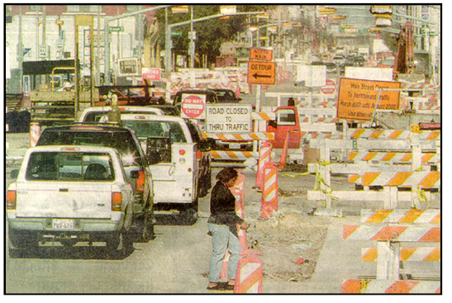

Figure 1: Traditional Open cut excavation: Disturbance for pedestrian, traffic, and environment [8]

Traditionally, construction and maintenance of underground utilities involve open trenching method methods. Such operations methods are proven expensive, particularly in congested urban areas of crowded cities and critical locations. Contractors have to close roads, divert traffic and create chaos and frustration for vehicles, commuters, and business in the operation vicinity, in addition, they must cautiously dig and operate carefully around other existing critical utilities to achieve the required depth and proper location, which in turn slows down the whole operation and delay the projects. Additional costs in open trenching construction are incurred by the process of restoring the existing original surfaces including pavements, sidewalks, and other disturbed facilities, as well as, landscaping. Open cut trenching operations often result in high user and social costs due to the disruption to vehicles and pedestrian traffic, as well as its adverse impact on nearby businesses [1,2,3,8], let alone the danger of possible collapse of trenches walls on the working personnel, and close by pedestrians. Furthermore, the increases in the population of crowded cities, and urgent need to rehabilitate, replace aging infrastructure utilities systems, as well as, repairing damaged utilities, together with the increased emphasis on user and social costs, have pushed municipalities and contractors to seek alternative methods for repairing and replacing underground utilities [4]. Accordingly, in many western countries, under-pressured municipalities found the solution for this problem by utilizing the Trenchless technology in construction. Trenchless technology (TT) is an emerging area of construction involving innovative methods, materials, and equipment used for the installation of new, and the rehabilitation, or replacement and maintenance of existing underground infrastructure with minimal or no need for open cut excavation (Figure 2) [3].

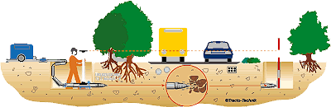

Figure 2: Sustainable Trenchless technology: No disturbance for traffic, and environment [8]

Despite the fact that trenchless construction methods have not been used in the Arab countries, as often as they have been used in the developed western world [5], it is obvious that the development, selection, and utilization of trenchless technology in the infrastructure projects have expanded rapidly over the past 15 years worldwide. The reason for this exceptional growth is the desire to install, rehabilitate and maintain underground infrastructure services - like water or gas pipes, electric or telecommunication cables, and other networks utilities systems- in the crowded and critical locations fast and with minimum impact on society and the environment. In the literature review, publications show the many benefits of trenchless technology are apparent when compared to the conventional open-cut process [1,3,4,6,7].

In the Arab Countries very little efforts have been done to recognize and encourage the importance of using trenchless technology in the crowded Arab cities as an effective and economic alternative to existing traditional methods of utility cuts with less disruptions to traffic, commerce, and community [1, 3, 6, 9, 14]. This paper, presents an overview for the concepts of Trenchless technology as the right method that could be utilized by municipalities for underground infrastructure construction and maintenance, especially in the vicinity of critical locations and crowded areas, next it presents the most common methods that are used and successfully proof its practicality and efficiency in the western world, and finally, advantages and disadvantages of the trenchless technology will be presented as well.

**Trenchless technology**

Trenchless construction technology can be defined as “a family of methods, materials, and equipment capable of being used for the installation of new or replacement or rehabilitation of existing underground infrastructure with minimal disruption to surface traffic, business, and other activities” [1, 6,7]. Based on location, type of infrastructure utility, soil type, and the project urgent needs, different trenchless construction-techniques are available such as Horizontal directional drilling, pipe jacking, micro tunneling, auger boring, and pipe bursting. Other trenchless rehabilitation techniques include lining of pipe, pipe scanning and evaluation, and robotic spot repair. Even though, the extensive use of trenchless construction in the installation, repair, and replacement of underground infrastructure utilities are relatively recent-development; yet, the idea and uses of trenchless techniques dates back to the 1860s, by Northern Pacific Railroad Company pioneer the use of pipe jacking techniques. Then by the 1930s, reinforced concrete pipes had been installed using this technique. Thereafter, other methods of trenchless construction began to emerge and utilized including: boring (1940), impact moling (1962), horizontal directional drilling (1971), microtunneling (1973), and pipe bursting (1980). [3, 6,7,10]. Subsequently, many developed countries have successfully started to adopt various trenchless technologies in one form or another as shown in Tabale 1.

Table. 1: Historical implementation of the trench technology time line developments [16]

|  |  |  |
| --- | --- | --- |
| **Technology** | **Year Introduced** | **Country Invented** |
| Pipe Jacking | 1860 | United States |
| Auger Boring | 1940 | United States |
| Impact Mole | 1962 | Germany |
| Horizontal Directional Drilling | 1971 | United States |
| Cured in Place Pipe (CIPP) | 1971 | United Kingdom |
| Microtunneling | 1973 | Japan |
| Pipe Bursting | 1981 | United Kingdom |
| Pipe Ramming | 1980’s | United States |
| Guided Moles | 1990’s | Germany |
| Pilot Tube Microtunneling | 1995 | Germany |
| Axis Vacuum Guided Boring System | 2008 | Australia/United States |

**Trenchless Technology Methods**

There are various methods of trenchless technologies that may be utilized (Figure 3) depend on the utility type, location, the ground-soil condition, the pipe-size that needs to installed, the depth it needs to be installed to, and the overall cost of the method and urgent need of the project. The most popular methods have been outlined in Figure 3 (Michigan Department of Transportation 2006) [10, 11, 12].

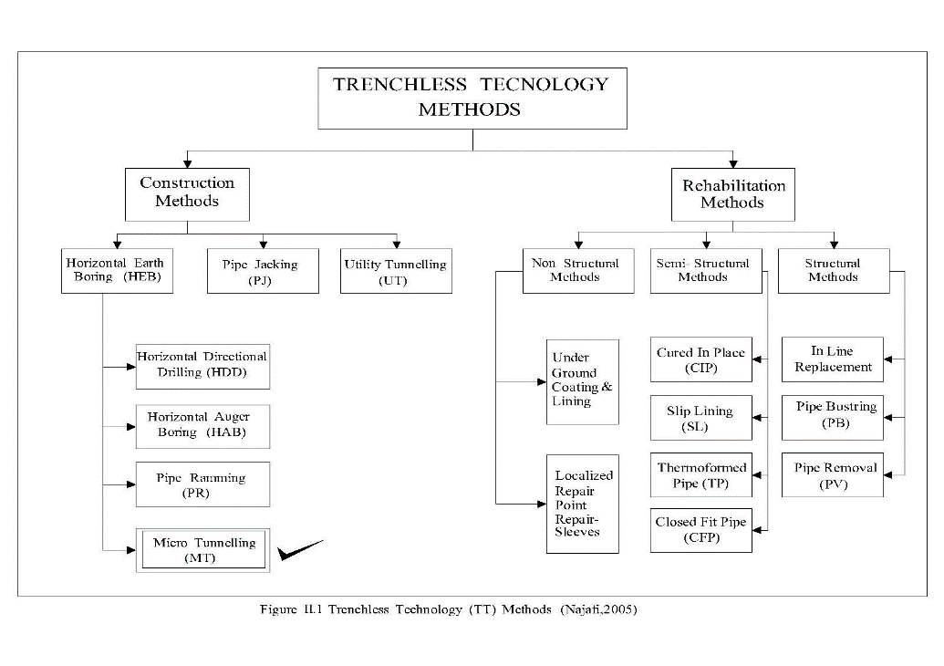

Figure 3: Popular Trenchless technology (TT) Methods

**Horizontal auger boring:** A technique for forming a bore from a drive pit to a reception pit, by means of a rotating cutting head. Spoil is removed back to the drive shaft by helically wound auger flights rotating in a steel casing. The equipment may have limited steering capability.

**Pipe jacking:** A system of directly installing pipes behind a shield machine by hydraulic jacking from a drive shaft such that the pipes form a continuous string in the ground. Usually personnel are required inside the pipe to perform the excavation or spoil removal process. The excavation can be performed manually or mechanically (Figure 4).

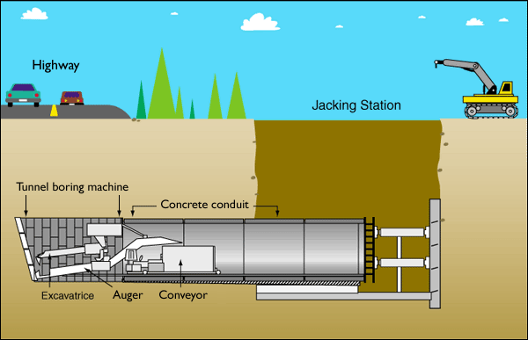

Figure 4: Pipe Jacking

**Pipe bursting:** A technique for breaking existing pipe by brittle fracture, using force from within, applied mechanically. Pipe remains are forced into the surrounding soil. At the same time a new pipe, of the same or larger diameter, is drawn behind the bursting tool (Figure 5).

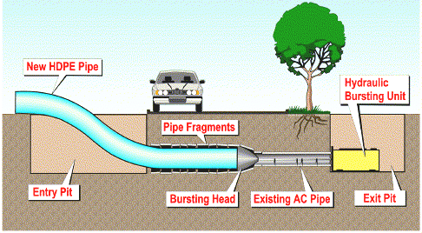

Figure 5: Pipe Bursting

**Horizontal directional drilling:** A steerable system for the installation of pipes, conduits, and cables in a shallow arc using a surface launched drilling rig. Traditionally HDD is applied to large scale crossings such as rivers in which a fluid filled pilot bore is drilled without rotating the drill string, and this is then enlarged by a wash over pipe and back reamer to the size required for the product pipe (Figure 6).



Figure 6: Horizontal Directional Drilling (Opening of the guide hole, expanding the hole and pulling the Pipe) [10]

**Pipe ramming:** A technique for installing steel casing from a drive shaft to a reception shaft utilizing the dynamic energy from a percussion hammer attached to the end of the pipe. A continuous casing support is provided and over-excavation or water is not required. This is a 2- stage process (Figure 7).

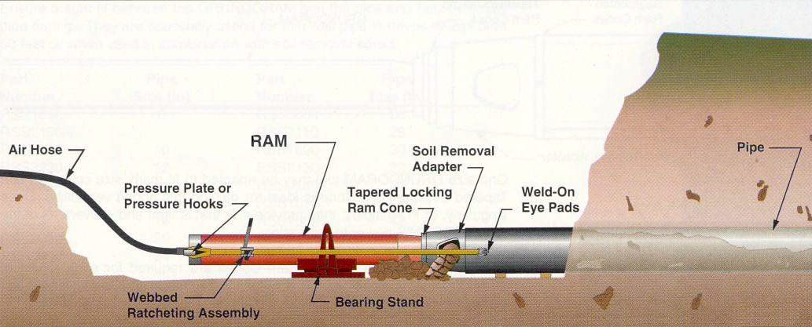

Figure 7: Pipe Ramming

**Microtunneling:** TT construction method for installing pipelines with the following features (Figure 8):

* Remote Controlled – The Micro Tunnel Boring Machine (MTBM) is operated form a control panel, normally located on the surface. It simultaneously installs pipe as spoil being excavated and removed.
* Guided – The guidance system usually refers to a laser beam projected onto a target in the MTBM, capable of installing gravity sewers or other types of pipeline to the required tolerance for line and grade.
* Jacking Pipe – The process of constructing a pipeline by consecutively pushing the MTBM through the ground using a jacking system.
* Face Support – Continuous pressure is provided to the face of the excavation to balance groundwater and earth pressure.

**Trenchless Technology vs. Open-Cut Trench Methods**

Researches and piratical experiences show many advantages for the innovative-methods of Trench-technology that overcome the traditional method of open-trench in many important aspects such as [10, 11, 12, 14, 15]:

* Less disturbing: Open-cut method disturbs local properties, agricultural land, or disturbing local highways. Butby using Trenchless technology, one will come out from these problems.
* Less time: Open-cut method is time consuming method. In this method time is required for the excavation and refilling of trenches. In addition to the time is taken in site restoration, spoils storage and traffic control.
* Enhanced safety: in Open-cut method, steep excavation Landslides can be occurred. Where the mud is likely to subside due to steep walls or water aggravation, protection needs to be taken with specialist equipment. While with Trenchless technology safety are provided to the workers as there are no steep trenches involved in this work.
* Save time and cost related to survey and design: Open-cut method consist of preliminary survey, detailed survey consists of the depth of the cut, the ground conditions where the trenches will run, and also how much dewatering will need to take place, and ensuring continuous and alert safe conditions to workers. But in Trenchless technique time and cost related to these tasks will be saved.
* Encountering fewer unknowns in the ground: in Open cut method, approximately 70% of the cost required for excavating and replacing the ground during the process due to the possible unknowns that come in the excavation, and or the digging cost of excavation will further increases. By use of Trenchless technology reduced this problem.
* Minimize chance of disturbing existing utilities: at the time of open cut most important problem come in front of is disruption to above surface activities, as well as at the time of digging has to avoid existing utilities. Trenchless technology comes with the ability to install new pipelines and rehabilitate and maintain existing pipelines with limited disturbance to pedestrian, traffic and business activities; reduce damage to above existing paved surfaces.
* Less Problems to the public such as noise and air pollution – The indirect social costs of Open cut projects consist of unhealthy conditions, and noise pollution. These problems can be overcome with trenchless technology without the need for road closures, noise pollution.
* CO2 Emission: Researches shows that Trenchless technology is more friendly to the environment in many ways. For example, a conducted research study for identical projects shows that using open cut exaction will safe 80% of carbon emission to the atmosphere [6,14, ariatren 2003]. In addition, less dust and no trees or green landscape areas will be disturb or removed. As shown in Figure 8
* Choosing the right excavation method, trenchless technology could save up to ½ total cost of the similar operation [16]



Figure 8: Sample Comparison for average reduction in gas emission between open cut and TT

**Examples of Successful case studies**

Trench technology for infrastructure projects (Construction, Maintenance, and Rehabilitation) in the crowded cities and critical sites are still rarely used in the Arab countries despite its successful usage and wide acceptance in western and developed countries who adopt this method of construction and maintenance, especially in the crowded cites, and critical sites. Every year, hundreds of trench less technology projects were successfully completed. Trenchless technology magazine and website list regularly stories and projects completed using this technology around the world particularly in North America and Europe. For example [17] [Kezdi](https://trenchlesstechnology.com/author/mike/) listed 50 projects which readers can access them through that reference.

***Dubai Water Canal project, UAE***

UAE was among the early few pioneers that utilized the Trenchless technology among the Arab countries. In its project, Dubai Water Canal project which includes the construction of a 3-km long waterway in the vicinity of its highly crowded central business district. Al Naboodah Construction Group (ANCG) was hired to divert utilities on a section of the project. The company accomplished that task by utilizing two trenchless technologies methods of Horizontal directional drilling (HDD) for power and telecommunication cables and irrigation lines; and the method of Microtunneling for water mains. For the HDD work, ANCG completed 24 bores, totaling approximately 7,315 m, “The project was a tight corridor with multiple crossings next to busy roads,” says general manager for ANCG. The project has 24 crossings averaging 305 m in four busy locations. Their work was vital for the timeline of the overall project because installations at two of the locations had to occur before bridges, which were important to relieve traffic congestion issues, could be built. “Bridges were planned on top of the HDD route. Those locations were completed as soon as possible”. In addition Reclaimers were used on all the HDD projects to reduce cost and environmental impact,” [18].

***Crossing under the River of Texas’s Rio- Grande using HDD, USA***

In Webb County, Texas, near Laredo, nine-member directional drilling crews with PUMPCO Inc. have successfully crossed under the river of Rio Grande. The project involved boring and pulling back 2,200 ft of 36-in. pipe approximately 80 ft under the river’s bed using Trenchless technology of Horizontal Directional Drilling (HDD). It was the last leg of the 17-mile long Pipeline that has to cross the river. “Using the proper method and equipments of trenchless technology, the construction process was as easily and quickly as it could” said by the project manager. On average, the crew drilled around 500 ft a day and took them around four and a half days to complete without disturbance to the river and the environment, and the project completed on time and budget [19].

***Frankfurt Airport, Germany***

With nearly 65 Million passengers using its services each year, Frankfurt Airport, in Germany, can’t just shut down for maintenance. However, after 40 years of heavy usage, the airport’s vast system of sanitation infrastructure was in danger of falling into a critical state. The system exacerbated normal wear and tear, leading to cracks, pipe offsets, corrosion and multiple un-flushable deposits. With the clock ticking down, the airport authority led a charge to repair or replace the wastewater network at Frankfurt Terminal 1 and contracted Germany’s ANT GmbH to manage the project. ANT sought support from [Trelleborg Pipe Seals](http://www.trelleborg.com/en/pipe-seals), a provider of pipe renovation systems with coverage across Europe and the United States. With a vast spiderweb of pipes lying directly beneath the terminal’s buildings, this would be no simple project for either firm. Using a combination of several trenches less technology methods, the project team had managed to successfully repair almost two and a half miles of pipes without a single trench being dug. By working at night and using compact, portable equipment, the team was able to minimize disruption to the day-to-day running of Frankfurt Airport. Crucially, the solutions that are now in place are expected to last at least 50 years, helping Frankfurt’s 1970s old sanitation system to last well into the second half of the 21st century [20].

***Installing Sustainable Stormwater System at Krakow Airport, Poland***

In this airport, the nearby stream into which the rainwater had previously been discharged could no longer handle the growing amounts. It was therefore decided to extend the storm water sewer system by new pressure lines which should lead the water over a distance of 3 km into the Rudawa River (Table 2). 5.85 km of drainage pipes will be installed with many stretches underneath roads and Aircrafts’ taxi-ways using trenchless technology of Microtunneling. The works at the airport started in November 2017 and are expected to be completed ahead of schedule at the beginning of 2019. The installation of this new drainage network will lay the foundation for future expansions of the airport, among others a new runway and aircraft hangars. This will allow for the number of flight operations to increase and further strengthen Krakow airport’s international importance [21].

Table 2: Sustainable Storm water System at Krakow Airport, Poland

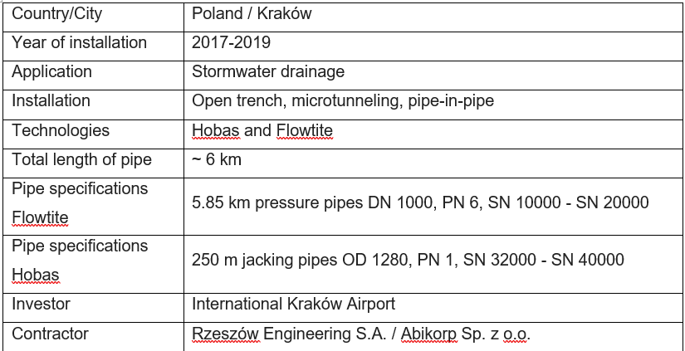

As can been observed , and from the literature and the many successful stories around the world, The advantages of Trenchless technology in newly installed, maintenance, and rehabilitation of underground infrastructure services are clearly noticeable in the crowded locations, busy streets, and critical locations. It eliminates public disturbance and traffic congestion, reduces construction and maintenance cost, reduces project completion time, with overall benefits to the sustainable economy and environment in the crowded vicinities.

**Recommendations:**

Despite its many advantages, yet the decision to use the trench less technology should have careful pre-planning and thoughtful investigation for the type of project, location, soil type and cost. Michigan Department of Transportation [10] recommendation for engineers and decision-makers should recognize that there are conditions where trenchless applications are not appropriate, such as fast emergencies, where immediate excavation of the pavement is necessary, and advanced pre-planning simply cannot be done. In other cases, conditions such as the nature of the soils and rocks below the surface, or the presence and/or uncertain location of existing utilities rule out the use of trenchless technology. Table 1 shows examples of some trenchless technology methods that suite the construction and utility type in case of new installation. In addition, Engineers and decision-makers should corporate with city and municipalities for more specific information and guidelines for trench less technology at the pre-plan stages for other rehabilitation and maintenance projects.

Table 3: Recommended Appropriate Techniques for Trenchless New Installation [10].

|  |  |  |  |  |  |
| --- | --- | --- | --- | --- | --- |
| TECHNIQUE | Water | Sanitary and Storm Sewers | G  as | Electricity | Telecommunications |
| Horizontal Auger Boring | √ |  | √ | √ | √ |
| Pipe Ramming | √ | √ | √ | √ | √ |
| Pipe Jacking |  | √ |  |  |  |
| Directional Drilling | √ | √ | √ | √ | √ |
| Microtunneling |  | √ |  |  |  |
| Pipe Bursting | √ | √ | √ |  |  |

**Conclusions**

In today modern society, having proper underground infrastructure utilities such as, service lines of water wastewater or gas pipes, electric or telecommunication cables, becomes an essential part of the our daily life and inhabitant communities, installing new utilities and maintaining the existing old, or damaged sections are becoming costly and disturbing for the society (traffic and pedestrian delays, business disruption) and environment (safe trees, landscape, less gases emission, and less pollution to water and soils). This problem is especially magnified and tedious in crowded cities, and critical locations. Trenchless technology is a new technology successfully utilized in many developed countries. Yet, it is not commonly adopted by the majority of the crowded cites in the Arab countries. With the increasing popularity of the Trenchless technologies, many innovative methods have been developed to suit different types of utilities, soil conditions and locations. Many benefits could be gain by introducing these sustainable technology solutions in the region such as lowering construction cost, less traffic and pedestrian congestion and headache, and many others advantages that demonstrate the merits of adopting trenchless technologies for sustainable development of underground infrastructure systems.

**References**

[1] McKim, R., (1997). Bidding strategies for conventional and trenchless technologies considering social costs. *Canadian Journal of Civil Engineering* 24 (5), 819–827.

[2] Arends, G., Bielecki, R., Castle, J., Drabek, S., Haack, A., Nedbal, F., Nordmark, A., Sterling, R., (2004). Risk budget management in progressing underground works. *Tunneling and Underground Space Technology* .19 (1), 29–33.

[3] E.K. Zaneldin. (2006).Trenchless construction: An emerging technology in United Arab Emirates. *Tunneling and underground space technology*. 22(2007) 96-105.

[4] Russell, D.E., Davies, A.T., (1997). New tools for water main asset management. *No-Dig Engineering* 4 (4), 2–6.

[5] Schreyer, J., (1998). GSTT investigation: guidelines for selecting construction methods for earth-laid lines. *Tunnelling and Underground Space Technology* 13 (2), 129–130.

[6] Ariaratnam, S.T., Lueke, J.S., Allouche, E.N., (1999). Utilization of trenchless construction methods by Canadian municipalities. *Journal of Construction Engineering and Management* 125 (2), 76–86.

[7] <http://www.hms-it.co.uk/trenchless_technology.htm>

[8] Bauhan, T., Fowler, D., Haas, C., (1997). Performance testing of trenchless wastewater line spot repairs. *Journal of Infrastructure Systems 3 (1), 40–48.*

[9] Committee on Construction Equipment Techniques, (1991). Trenchless excavation construction methods: classification and evaluation. *Journal of Construction Engineering and Management* 117 (3), 521–536.

[10] Michigan Department of Transportation Trenchless Guidelines. *Michigan*, USA. 3701(11/06). USA

[11] Mohammad Najafi, Brett Gunnink,(2005), " Preparation of Construction Specifications, Contract Documents, Field Testing, Educational Materials, and Course Offerings for Trenchless Construction", *Missouri Department of Transportation Organizational Results Division*, Pg.No.4-13.

[12] Onkar K. Chothe 1 , V.S. Kadam.(2016) Comparative Study of traditional method and innovative method for Trenchless Technology: A Review. *International Research Journal of Engineering and Technology*. V: 03 Issue: 05

[13] Sherif M. Hafez1, Remon F. Aziz1, A., Attia. (2015)Exploring Critical Factors Affecting upon Micro-tunnelling Equipment Productivity. *International Journal of Education and Research.* Vol. 3 No. 8

[14] Ariaratnam, S.T. (1999). Sustainable development through innovative underground infrastructure construction practices. *Arizona State University*, Tempe, AZ USA. <http://dl.lib.mrt.ac.lk/handle/123/9383>

[15] <http://www.istt.com/why-trenchless-no-dig>.

[16] Samuel T. Ariaratnam. (2003). “Sustainable Development through Innovative Underground Infrastructure Construction Practices’ *Arizona state University*, USA.

[17] <https://trenchlesstechnology.com/the-top-10-in-trenchless-engineering-for-2018-projects/> (Accessed 20-1-2019)

[18] <https://trenchlesstechnology.com/hdd-dubais-next-big-project/> (Accessed 20-1-2019)

[19] <https://trenchlesstechnology.com/crossing-under-rio-grande-impulsora-pipeline/> (Accessed 20-1-2019)

[20] <https://trenchlesstechnology.com/when-trenchless-kept-frankfurt-flying/> (Accessed 20-1-2019)

[21] <https://trenchlesstechnology.com/flowtite-hobas-pipes-create-sustainable-stormwater-system-at-krakow-airport/>