Evaluation of water quality supplied in pilgrims and Umrah visitors buildings
Omar B Ahmed⁽¹⁾, Atif A Asghar⁽¹⁾, Ibrahim H Abdel-Rahim⁽¹⁾, Mahmoud Y Lubbad⁽²⁾, Abeer A Barhameen⁽³⁾, Ali A Saygal⁽⁴⁾, Mahir H Mashat⁽¹⁾, Ahmed Alsihli⁽¹⁾,
1- The Custodian of the Two Holy Mosques Institute of Hajj and Umrah Research, Umm Al-Qura University 2- Ministry of Health 3- Faculty of Medicine 4- Faculty of Applied Science

Abstract
The present study was undertaken in order to determine the chemical and microbial quality of water supplied in pilgrims’ and Umrah visitors’ buildings. Faucets in 73 hotels at Makkah during Ramadan and Hajj seasons 1438 h (2017) have been examined. The samples were chemically analyzed for free chlorine, pH, TDS while microbiological analysis were coliform count, E. coli count, heterotrophilic Plate count (HPC) and Legionella using advanced microbiologic and molecular methods. The result showed that of the 73 samples tested, the PH was ranged between (5.15-7.3), the TDS were ranged between (84-195) PPM while chlorine was not adequate in all samples. The fecal coliform count was detected in 5 (6.8%) water samples, the MPN was very high in three of them. The Pseudomonas aeruginosa was not detected in any sample. The HPC was detected in 7 samples (9.6%), three of them were very high. Neither Legionella nor E.coli was detected in water supplies in pilgrims and Umra visitors buildings. It was concluded that the water supplied in pilgrims buildings were of good chemical quality, free of contamination with: legionella, Pseudomonas aeruginosa and fecal E.coli while few of them were contaminated with fecal coliforms. Efforts to enforce effective water treatment, periodic inspection and testing of the water in hotels’ or pilgrims and Umra visitors buildings are recommended.
- Introduction:
The World Water Day (22nd March ) is an international annually held day which was recommended at the 1992 United Nations Conference on Environment and Development (UNCED) (1). The day aims to focus attention on the importance of freshwater and advocating for the sustainable management of freshwater resources. In Makkah the main sources of drinking water are the desalination plants, the average consumption per capita of potable water about 260 L per day (2). The pilgrims buildings should be comfortable, convenient and have all necessary safety equipment and in a continuous challenge to protect pilgrims from water illness. Water has to be clean, clear and meet regulatory standards and/or WHO guidelines (2006) (3). ‘Water quality’ is a term used here to express the suitability of water to sustain various uses or processes and involves the routine testing of water quality to ensure compliance with national standards. Health risks for unhealthy water include physical, chemical and microbial. The pH and total dissolved solids (TDS) are two ways to measure water quality and are two very important aspects of buildings. TDS is made up of inorganic salts, as well as a small amount of organic matter. The pH value of a water source is a measure of its acidity or alkalinity. Pure water would have a pH of 7.0, but water sources and precipitation tends to be slightly acidic, due to contaminants that are in the water (4). Chlorination, one of water treatment processes, creates water that is safe for public consumption. A large amount of research and many studies have been conducted to ensure success in new treatment plants using chlorine as a disinfectant. A large variety of bacterial, viral and protozoan pathogens are capable of initiating waterborne infections. The enteric bacterial pathogens include Salmonella spp., Shigella spp., Campylobacter jejuni, enterohaemorrhagic Escherichia coli. Environmental pathogens include Legionella, Mycobacterium spp and Pseudomonas aeruginosa. (5). In addition, viruses such as Hepatitis A and E viruses, rotavirus, calicivirus and enteric protozoa associated with waterborne disease such as Giardia lamblia emerging as opportunistic pathogens (6). After disinfection, numbers would be expected to be low; In some cases chemical hazards may also be introduced from water delivered to buildings from external sources. Chemicals from environmental and industrial sources, agriculture, water treatment, and materials in contact with water can contaminate building systems. The impacts on health of inadequate management of water in buildings is considerable and has in turn significant direct and indirect economic and social impacts. WHO has identified that the benefits of all interventions to reduce risks from unsafe water outweigh costs by substantial margins (7). The most basic test for bacterial contamination of a water supply is the test for total coliform bacteria. Total coliform counts give a general indication of the sanitary condition of a water supply. Total coliforms include bacteria that are found in the soil, in water that has been influenced by surface water, and in human or animal waste. Fecal coliforms are the group of the total coliforms that are considered to be present specifically in the gut and feces of warm-blooded animals. Because the origins of fecal coliforms are more specific than the origins of the more general total coliform group of bacteria, fecal coliforms are considered a more accurate indication of animal or human waste than the total coliforms (8). E. coli is considered to be the species of coliform bacteria that is the best indicator of fecal pollution and the possible presence of pathogens (5). The present study was undertaken in order to determine the chemical and microbial quality of water supplied in pilgrims buildings.
- Research aims:
The present study was undertaken in order to determine the chemical and microbial quality of water supplied in pilgrim’s buildings.
- Research Methodology:
Seventy-three bottles representing 73 buildings from randomly selected hotels and pilgrims’ buildings in Makkah during Ramdan season 1438 (2017), and were tested for chemical and bacteriological quality. Samples were collected in 1-litre sterile bottles directly from the outlet. Collected samples were transferred in an ice box to the Microbiology Laboratory in Department of Environmental and Health Research the Custodian of the Two Holy Mosques Institute of Hajj and Umrah Research, Umm Al Qura University. Samples were stored at 4°C till further investigation of water-quality parameters to be carried out. The pH is measured by advanced electrochemical meter orion thermo scientific wide range of TDS/conductivity meters, which gives direct value of pH and EC according to manufacturer's instructions. The heterotrophic plate count (HPC) Sampler (EMD Millipore), consisting of a removable dip paddle contained in a plastic sampler. (According to manufacturer instructions). Escherichia coli (E. coli) and Coliforms count were determined in the samples, in additional to most probable number (MPN) of coliform bacteria. The number of Total coliforms and E. coli per 100 ml, based on the number of positive wells counted, was determined by referring to a 97-well MPN table (IDEXX) (according to manufacturer instructions). Identification of Pseudomonas aeruginosa (P. aeruginosa) was done using standard methods. All other growths on MacConkey agar were also subjected to identification. For Legionella identification, One liter of samples was filtered through 0.22 μm mixed cellulose ester membrane filters (Schleicher & Schuell) in a stainless-steel filter holder with a water aspirator. Total DNA was extracted from concentrated water samples using two classic manual methods: freeze & thaw and phenol-chloroform. Amplification reactions were preformed according to what has been described earlier by Hsu et al., 2006; Rafiee M, et al 2014 (9,10). The PCR primers LEG 225 (5'AAGATTAGCCTGCGTCCGAT-3') and LEG 858 (5' GTCAACTTATCGCGTTTGCT-3') were used to amplify a 650 bp fragment of the 16SrRNA gene of Legionella species. Fifty μl PCR mixture containing 8 μl of DNA template, 1 μl (100 pmol) of each primer and a 25 μl of Taq PCR Master (Promega Company) was prepared. Amplification was performed using Mastercycler PCR machine (Eppendorf, Germany). The thermal cycling conditions were as follows: an initial denaturation step at 94ºC for 5 min, followed by 35cycles of denaturation at 95ºC for 30 s, annealing at 64 ºC for 30 s and extension at 74ºC for 20 s. 1 cycle of 72ºC for 5 min. The PCR products were analyzed by electrophoresis in 1.5% agarose gels, 100 bp DNA ladder was included in each run and DNA bands were viewed under UVP BioDoct It Imaging System after staining with ethidium bromide (2 g/ml). Data was presented as average of replicates. In order to determine the significance relationships between variables Chi-square and Wilcoxon test were used and P-values less than 0.05 were considered statistically significant. All the available data were analyzed by a computer program (IBM SPSS statistics 20).
- Results and discussion:
The result showed that in the tested 73 samples, the PH was ranged between (5.15-7.3), the TDS were ranged between (84-195) PPM and adequate chlorine in all samples (table1). The fecal coliform count was detected in 5 (6.8%) water samples, the MPN was very high (135.5) in three of them while the other two samples showed very low MPN of 2 and 4 values (table 2, figures1,3,4). The HPC was detected in 7 samples (9.6%), three of them were very high, two are moderate, two were very low (table3 and figure2). No P. aeruginosa was detected in the samples. Neither Legionella nor E. coli was detected in water supplies in pilgrims and Umra visitors buildings (figures 5,6). There was significant correlation between coliform with heterotrophic bacteria (P ≤ 0.05) as in table 4. In Makkah, the water supply system functions with water supplied after treatment with rapid filtration and chlorine disinfection. Following that, the tap water passes through the building’s internal water supply system and is distributed to users. All water supply systems of the hotels investigated in this study used an elevated water tank system. According to the previous studies (2) with design businesses, the majority utilize the elevated water tank system. According to legislation on water systems in Saudi Arabia, the residual active chlorine concentration of water supplied from the faucet is required to be above 0.1 mg/L. A leading advantage of chlorination is that it has proven effective against bacteria and viruses; however, it cannot inactivate all microbes. In the United States, pH is, like TDS, a secondary standard; the Secondary Maximum Contaminant Level for pH is between 6.5 and 8.5. A large variety of bacterial pathogens are capable of initiating waterborne infections. For legionella, no band was detected using PCR technique i.e. the water samples were free for Legionella species (figure 3). Travel and hotel stays are recognized as risk factors for legionellosis (11). In Europe, approximately 20% of detected legionellosis cases are considered to be travel associated (11,12). In most countries like Japan, measures against Legionella are taken so as to reduce the risk of disease from Legionella for the whole of society (13). Legionella bacteria cannot grow in temperatures above 55 ºC. the extensive-piping systems may result in variability of temperature and encourage biofilm accumulation, such factors may favour the growth and proliferation of Legionella spp. (14,15). Different studies have shown that large buildings provide a rich environment for Legionella than small facilities. (15, 16). The negative results may be attributed to different factors such as the water supply system functions treatment with chlorine disinfectant. However, significant particulate contamination of the water was observed in one sample. Microbial pathogens represent the greatest risk associated with building water supplies. Recent surveillance data indicate that a substantial proportion of outbreaks in recreational water and drinking water were associated with buildings and hotels and other places such as hospital and schools. HPC serves as an indicator of general microbial population and thereby as indirect indicators of water safety. Clark et al., reported that the common bacterial species occurring in all types of water samples were E. coli, Enterobacter aerogenes, Aeromonas hydrophila, Klebsiella pneumoniae, and Citrobacter freundii (17). Total coliforms are not useful as an indicator of faecal pathogens, but they can be used to assess the cleanliness and integrity of distribution systems and the potential presence of biofilms. It has been proposed that total coliforms could be used as a disinfection indicator. However, the test for total coliforms is far slower and less reliable than direct measurement of disinfectant residual. In addition, total coliforms are far more sensitive to disinfection than are enteric viruses and protozoa. HPC measurements detect a wider range of microorganisms and are generally considered a better indicator of distribution system integrity and cleanliness (18). However, in the present study, coliforms bacteria were detected in (9.6%) of the samples. Water pollution caused by fecal contamination is a serious problem due to the potential for contracting diseases from pathogens (disease causing organisms). Proportion of water-borne disease is associated with contamination within buildings. This arises from direct contamination through faults in water systems (e.g. bird and small animal droppings into storage tanks) (5). Water in pilgrims building should be monitored so as to protect them from infections or other health problems due to unhealthy water. It can be concluded that the water supplied in pilgrims buildings were of good chemical quality, free of legionella, P. aeruginosa and fecal E. coli contamination while few of them were contaminated with fecal coliforms. Efforts to enforce effective water treatment in pilgrims and Umra visitors’ buildings by the are recommended. There should be periodic inspection and testing of hotels’ water systems.
- Summary:
It can be concluded that the water supplied in the pilgrims’ buildings were of good chemical quality, free of legionella, P. aeruginosa and fecal E. coli contamination while few of them were contaminated with fecal coliforms.
- Recommendations:
Efforts to enforce effective water treatment in pilgrims and Umrah visitors’ buildings by the are recommended. There should be periodic inspection and testing of hotels’ water systems.
- References:
1-http://www.greenhotelier.org/know-how-guides/water-management-and-responsibility-in-hotels/
2- امل صلاح جمبي :مصادر مياه الشرب ومشكلاتها في مدينة مكة المكرمة دراسة في جغرافية الموارد المائية" رسالة ماجستير جامعة م القرى , كلیة العلوم الاجتماعیة قسم الجغرافیا 1432-1433
3-World Health Organization (WHO) (2006) Guidelines for the safe use of wastewater, excreta and greywater. World Health Organization, Geneva.
4-SDWF (2008) TDS & pH. Safe Drinking Water Foundation: 6 pp.
5-World Health Organization (WHO) (2010) Water safety in buildings. World Health Organization, Geneva
6-H. Leclerc, Relationships between common water bacteria and pathogens in drinking-water in" Heterotrophic Plate Counts and Drinking-water Safety. Edited by J. Bartram, J. Cotruvo, M. Exner, C. Fricker, A. Glasmacher. Published by IWA Publishing, London, UK. ISBN: 1 84339 025 6.2003 World Health Organization (WHO).
7- Hutton G, and Haller L. (2004). Evaluation of the Costs and Benefits of Water and Sanitation Improvements at the Global Level. World Health Organization, Geneva
http://www.who.int/water_sanitation_health/wsh0404.pdf.
8- x- Pandey PK, Kass PH, Soupir ML, Biswas S, Singh VP. (2014). Contamination of water resources by pathogenic bacteria. AMB Express.;4:51. doi:10.1186/s13568-014-0051-x.
9- Hsu et al. (2006) Legionella prevalence in hot spring recreation areas of Taiwan. Water Res, 40(17):3267–3273.
10- Rafiee M, et al. Detection and identification of Legionella species in hospital water supplies through Polymerase Chain Reaction (16S rRNA). Journal of Environmental Health Science & Engineering 2014, 12:83.
11-Bartram J, Chartier Y, Lee JV, Pond K and Surman-Lee S (Eds) (2007) Legionella and the prevention of legionellosis. World Health Organization, Geneva.
12-Joseph C (2002) The risk of suffering from Legionnaires’ disease whilst abroad. Journal of the Royal Society of Health 122: 6-7
13-Toyosada K, Otani T, Shimizu Y, Managi S. (2017) Water Quality Study on the Hot and ColdWater Supply Systems at Vietnamese Hotels. Water, 9, 251; doi:10.3390/w9040251
14-Yu, V.L. (2002) Legionella surveillance: political and social implications – a little knowledge is a dangerous thing. J Infect Dis 185, 259–261.
15- Borella, P., Montagna, M.T., Stampi, S., Stancanelli, G., Romano-Spica, V., Triassi, M., Marchesi, I., Barghellini, A. et al. (2005) Legionella contamination in hot water of Italian hotels. Appl Environ Microbiol 61, 5805–5813.
16-Leoni, E. and Legnani, P.P. (2001) Comparison of selective procedures for isolation and enumeration of Legionella
species from hot water systems. J Appl Microbiol 90, 27–33.
17-Clark, J.A., Burger, C.A. and Sabanatinos, L.E. (1982) Characterization of indicator bacteria in municipal raw water, drinking water and new main water supplies. Can. J. Microbiol. 28, 1002–1013.
18-WHO (2017) Guidelines for drinking-water quality: 4th edition. Geneva. World Health Organization, , ISBN 978-92-4-154995-0.

Table1: chemical analysis of the water
 | N | Minimum | Maximum | Mean | Std. Deviation
PH | 73 | 5.15 | 7.30 | 6.3499 | .36337
TDS(ppm) | 73 | 84.60 | 195.00 | 112.4808 | 28.58775

Table2: coliform count of the water
MPN/100 ml |  | Frequency | Percent
Low | 2.00 | 1 | 1.4
 | 4.00 | 1 | 1.4
High | 135.50 | 3 | 4.1
Negative | NEG | 68 | 93.2
 | Total | 73 | 100.0

Table3: HPC of the water
 |  | CFM/ 100 ml | Frequency | Percent
low | 200.00 |  | 1 | 1.4
 | 300.00 |  | 1 | 1.4
Intermediate | 2500.00 |  | 1 | 1.4
 | 14500.00 |  | 1 | 1.4
High | 285400.00 |  | 1 | 1.4
 | 314500.00 |  | 1 | 1.4
 | 325200.00 |  | 1 | 1.4
Negative | NEG |  | 66 | 90.4
 | Total |  | 73 | 100.0

Table4: Correlation between heterotrophic bacteria and fecal coliforms.
 | Variable | P value (Pearson Chi-Square) | P value (Wilcoxon)
HPC bacteria | Fecal coliform | 0.000 | 0.018

Figure2: HPC of the water | Figure1: coliform count of the water

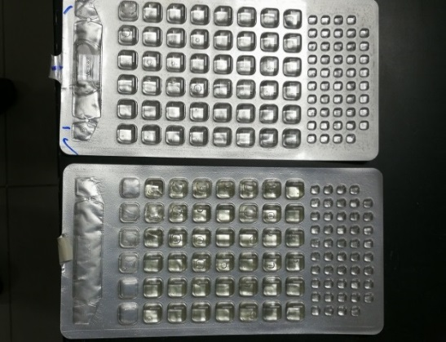  Figure3: Negative coli form result by Colilert | 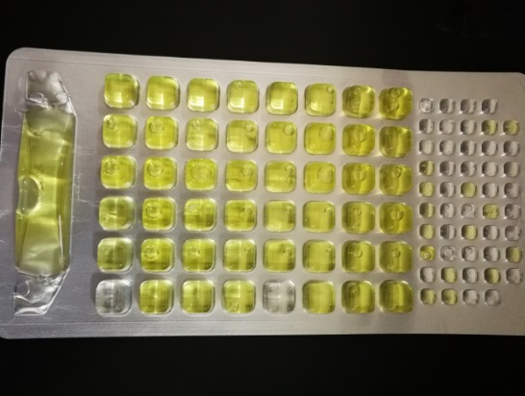  Figure4: Positive coli form result by Colilert
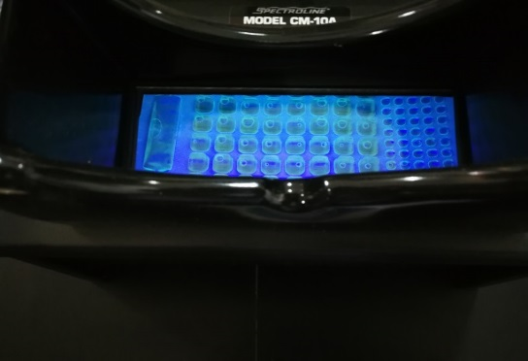  Figure5: Negative E. coli result by Colilert (UV) | 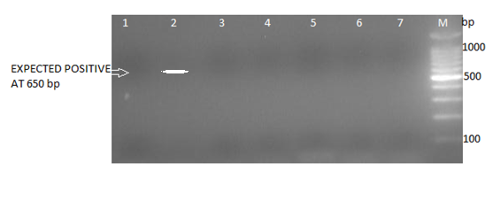  Figure 6. No band detected in 1% agarose gel electrophoresis after PCR reaction, Band 2: positive control

