|  |  |  |
| --- | --- | --- |
|  | محاكاة دخول وخروج الزوار من المرافق العامة (دورات المياه) في مسجد النبوي الشريف |  |
|  | **Simulation of people entering and exiting the public Utilities (Washrooms) at Al-Masjid An-Nabawi**  Yaser Alginahi1 , Omar Tayan2 , Mohammed Kabir3  1 Department of Computer Science, Deanship of Academic Services - Taibah University  2 Dept. of Computer Engineering, College of Computer Science and Engineering - Taibah University  3 Faculty of Computer Systems and Software Engineering - University Malaysia Pahang |  |

**المستخلص**:

الملخص:

الملايين من المسلمين يقومون بزيارة المسجد النبوي الشريف خلال السنة وخصوصا في شهر رمضان وموسم الحج والعمرة. وخلال الزيارة يقوم المسلمين بزيارة قبر الرسول صلى الله عليه وسلم وأداء الصلوات الخمس في المسجد. وتشترط الطهارة للصلاة عن طريق ممارسة الوضوء لهذا فإن المرافق العامة مثل دورات المياه تعتبر مهمة جدا بالنسبة لزوار المسجد النبوي الشريف. نظرا للعدد الهائل من الزوار في كل صلاة، وكثرة الازدحام في دورات المياه في أوقات الصلوات الخمسة بسبب أداء فريضة الوضوء. لذا فإن أعداد الزوار الداخلين إلى والخارجين من إحدى وحدات دورات المياه (بأدوارها الأربعة) تم رصدها لنمذجة تدفق الزوار من وإلى دورات المياه. والهدف من هذا المشروع هو تقييم حركة الزوار داخل دورات المياه بحسب الوضع العادي والطوارئ باستخدام برمجيات محاكاة الحشود (برنامج buildingEXODUS). واخيرا يمكن استخدام النتائج من المشروع للتطوير المستقبلي في ضوء التوسعة الجديدة للمسجد النبوي الشريف.

Abstract

Millions of Muslims visit Al-Masjid An-Nabawi throughout the year especially during the seasons of Ummrah and Hajj. The main purpose of their visit is to visit the graveyard of the Prophet Mohammed peace be upon him and pray the five daily prayers at this specific mosque due to the special rewards. The prayers require Muslims to be in a clean (ablution) state. Hence, the washroom (public utility) is essential beside the mosque. Many visitors require using these facilities before the prayer. Given the huge number of visitors, the washroom units are extremely congested with people performing ablution. Real data of the number of people entering and exiting the four level washroom units are gathered to model the flow of people in and out of the washroom units. The purpose of this work is to assess the circulation of people within the washroom units during normal and emergency situations using crowd simulation software *buildingEXODUS*. Finally, the results from this work provide recommendations for the new expansion of the mosque.

Introduction

Developing accurate representations of crowd-dynamics and behavior analysis presents one of the most challenging research issues in crowd management today. Crowd simulation is a powerful technique for analyzing crowds and observing (anticipated) human behavior and interaction in order to replicate the collective crowd-behavior [1] for a given population, environment and under various hazard scenarios. From the literature, three approaches are used to simulate crowds: fluids, cellular automata and particles. A brief literature survey on crowd simulation is presented in Table 1.

Table 1: Literature Survey on Crowd Management and Simulation

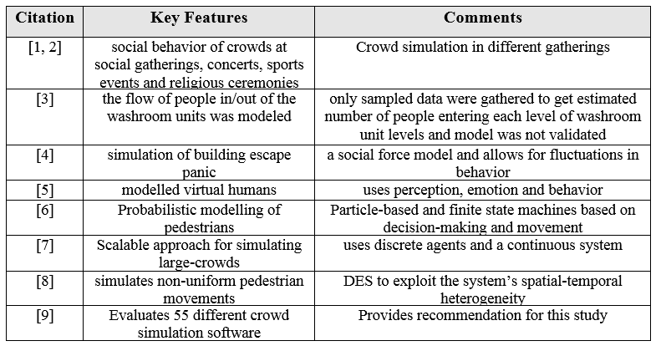

The system being modeled in this study relates to the washroom/ablution units located in the underground area of the piazza surrounding the grand mosque of the Prophet Muhammad, Al-Masjid An-Nabawi. Real data is used to support the simulation, and commercial software is used to simulate the crowds using the washroom units. The crowds/worshippers usage of the washroom/ablution facilities needs to be efficiently and safely controlled and managed during daily prayers. Hence, a model for the flow of people in and out of the washroom areas is proposed and simulated using MATLAB. Therefore, the main objectives of this work are:

Provide an estimation of the number of people entering and exiting the washroom units.

Propose solutions/scenarios for dealing with the crowd situation in the washroom areas.

Estimate the capacity of the washrooms during peak times.

Provide recommendations on crowd management for the underground washroom areas.

The rest of the paper is organized as follows: section 2 presents the system description; section 3 explains the methodology; section 4 provides the data collection and analysis; section 5 presents the proposed crowd flow behavior model; section 6 provides a case study of an evacuation simulation using buildingEXODUS, section 7 states the recommendations and concludes this paper.

2- System Description

This paper is concerned with crowd study and simulation for the underground washroom units of Al-Masjid An-Nabawi. The washroom/ablution units are all located below the open piazza surrounding the mosque. Each unit occupies four underground levels below the mosque, each of which can be accessed using the staircases, while only two levels can be accessed using escalators. Escalators tend to be more appealing to users due to the less effort required during use. On the contrary, stairs are preferred when escalators are heavily crowded. Worshippers from the car-parks at each side of the washroom areas serve as a second input feeding into the system from two levels which generate less flow than those entering from the mosque. The percentage of people arriving from the parking areas that use the washroom/ablution facilities is very low since most people come from their homes ready for the prayers.

Traffic within the washroom/ablution areas at each level is bidirectional and can become very crowded due to the lack of a traffic-flow policy/discipline. Traffic congestion is particularly problematic at the more-easily accessible higher levels. The flow of crowd is noticed to increase before the prayer time until the Athan (call for prayers) after which the number of people in the washroom units starts to decrease gradually to almost zero at the end of the prayer. Additionally, during the seasons of Umrrah and Hajj the significant buildup of crowds is observed in these facilities. People who use the washrooms must make the ablution. The rest of the people only use ablution area. On an average, a person requires 3-5 minutes to use washroom and 2 minutes to perform ablution. Ideally, after entering the unit, a person tends to look for the empty washroom (ablution seat) first or the one with the shortest queue. After performing ablution, the person leaves the unit using either the staircases or the escalators depending on the level and the crowd. Generally, it was noted that more people wait for washrooms than for the ablution areas since the number of water taps for ablution is significantly larger than the number of available washrooms. This shows that the number of people performing ablution is usually higher than those who use the toilets before making ablution. Peak time is determined to be during evening prayers due to the fact that this time allows locals to join the prayers together with the other mosque visitors.

Methodology

The methodology of modeling and simulation of crowds at Al-Masjid An-Nabawi’s washroom units was carried out using to the following steps:

1. Data Collection: Ten students helped in the process of collecting data, from the busiest washroom unit, no. 9, closest to King Fahd door. Using handheld counters, the number of people at different entry/exit points in the washroom unit was counted.

2. Model Construction: A mathematical model is proposed and constructed providing a practical solution to the real problem.

3. Parameter Tuning and Model Validation: The model parameters are fine-tuned such that the deviation between the sampled output and the model output is minimized. The correctness of the model and the accuracy of the parameters are evaluated based on the model fit with the experimental data and physical ranges of parameters.

The simulation of this model was carried out using MATLAB. This was done to validate the proposed model and compare the results. In addition, buildingEXODUS was used to simulate a scenario of crowd evacuation. Finally, simulation results of the flow of people in the washroom units can be used to investigate the safety aspects of the nature of exits/entrances and provide recommendations for better arrangements.

Data collection and Analysis

The data collection process was planned by deciding on the dates to collect the data needed. A data collection form was designed. The data collection dates were decided to be few days before and after Hajj days. Four days before Hajj were 1 – 4 of Thul-Hijjah, 1434H and two days after Hajj on 18-19 Thul-Hijjah. This was done for the Isha prayer only. The data analysis is explained below for the two days after Hajj. Fig. 1 shows the 12 points at which data was collected.

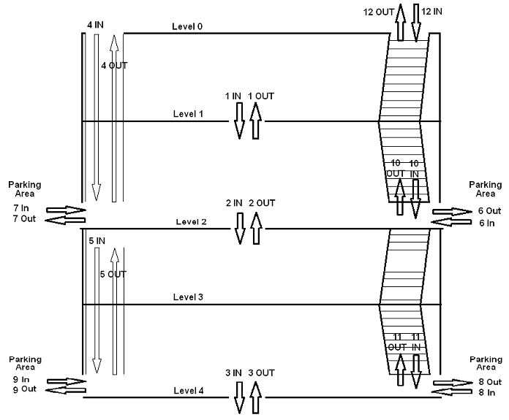

Fig. 1: Washroom Unit Elevation diagram

The graphs in Fig. 2 show the flow of people going into the washroom area and out to the piazza (points 4 and 12 of Fig. 1). Fig. 2 replicates the cumulative crowd flow behavior from all the levels below, since these are the entry/exit points to the washroom unit. It can be concluded that more people use escalators than staircases.

|  |  |
| --- | --- |
| (a) | (b) |

Fig. 2: The flow of people in and out of the washroom unit (point 4 and 12 of Fig. 1)

Proposed model and simulation results

To build the model of the flow behaviour of the people at all the levels of a washroom unit, we need to consider the access characteristics of all levels. People entering the washrooms prefer to choose the closest and easily accessed levels, i.e., levels 1 and 2. Level 1 is connected by stairs and is the closest to the ground level. Since level 2 is connected by escalators with the ground level, it is most preferred by people. Level 4 which is connected by escalators with level 2 and connected by stairs with level 3 experiences less crowd-flow than level 1 and 2. level 3 is closed and it is only connected by stairs with level 2.

Since we consider a measurement time of period T during which people are entering washroom and aim to develop the discrete event model, T is discretized in n uniform grid of time steps {0, h, 2h, ..., nh} with a step size h for a corresponding set of iteration steps {0, 1, ..., n} as shown in Figure 13.

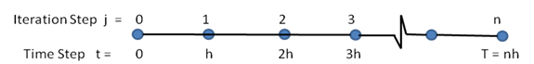

Fig. 3: Uniform grid of time steps for corresponding iteration steps

Suppose that Pi(t) indicates the number of people entering Level unit i at time t, which is in the small interval [t1 , t2]. For discrete event, we consider that tj = jh is the time step in that j ∈ {0, 1, , n} is an iteration step. Then, we compute Pi(t) for any t ∈ [0, T] by interpolating the nearest data points Pi(t1) and Pi(t2) where t is in the time interval [t1 , t2].

Now, we consider that the washroom Level has limited capacity which restricts the people to get in the washroom Level making the rest of the people queue. People who enter a Level to use toilets or to make ablution are chosen randomly. People are assumed to use the nearest available toilet and ablution seat. The subscript v is used to denote the toilets and w to denote ablution places. We assume that a person requires tV minutes in toilet and tW minutes in ablution. Toilet users must use ablution places, where ablution is required before performing prayers. Toilet users will be queued if toilets are occupied. Assume that a maximum of qV people can stay in the queue for toilets. Similarly, a maximum of qW people can stand in the queue for ablution. Once the system is full, they start lining up in front of these places and use it in a systematic manner (first come, first in). When all places along with queue are filled, then the remaining people ei wait to get in the queue. However, a number of people go to the next Level to find less crowded areas.

The number of people ei waiting to get in the queue at time step jh can be calculated by equation (1):

, (1)

where

.

Note that Gi(jh) is the number of people exiting the facility. This is calculated by checking whether a person completes his/her required time in the facility. Suppose that a person wants to use the toilet then he/she will check whether any toilet is free. If there is none available then the person is required to stay in queue until a toilet is available for use; the toilet use requires, tV minutes. After the use of toilet the person must look for an ablution place. If none is available, he/she must stand in queue. When a seat is available, the person takes tW minutes to perform ablution then he/she exits the facility. Now we summarize the above discrete event model in the form of an algorithm in Algorithm 1. This algorithm requires the numerical values of step size h, number of time steps, n. This algorithm provides the numbers of people Pi staying at all levels i = 1 to 3 at time steps 0, h, ..., nh. First the queue ei of the people remaining outside each Level i is set to zero. Then for each iteration step the following operations are performed.

Algorithm 1: Discrete event algorithm for computing inflow and outflow of the washroom

**Input:** Step size *h*, number of time steps *n*.

**Output:** Number of people *P*i staying at level *i* at time steps 0, *h*, ..., *nh* for *i* = 1 to 3.

1. Initialization*; ei* (0):*=*0, *for i =* 1 to 3

2. **for *j* = 1 to *n***

Calculate *P1* at time step *jh* from measurement data

Distribute *P1* to toilet/ablution places randomly. Set the people in the queue of the toilet/ablution places according to the availability. If a person has spent the required time in the toilet/ ablution, the person can get out and is added to *G1*(*jh*).

Calculate *e1*(*jh*) using equation (1)

Calculate *P2* at time step *jh* from measurement data

Distribute *P2* to toilet/ablution places randomly. Set the people in the queue of the toilet/ablution places according to the availability. If a person has spent the required time in the toilet/ ablution, the person can get out and is added to *G2*(*jh*).

Calculate *e2* using equation (1)

Estimate *P3* at *jh* from measurement data

Distribute *P3* to toilet/ablution places randomly. Set the people in the queue of the toilet/ablution places according to the availability. If a person has spent the required time in the toilet/ ablution, the person can get out and is added to *G3*(*jh*).

Calculate (*e3*) using equation (1)

**end (For).**

The number of people Pi is computed sequentially for all levels i = 1 to 3 from measurement data. Whether a person uses a toilet or ablution place is determined randomly for all levels i = 1 to 3. The people in the queue of the toilet/ablution places are set according to the availability of the places in the queues which are limited in sizes as qV, qW, respectively. If a person has spent the required time in the toilet/ ablution, the person can get out and is added to G1(jh). Then ei is updated using equation (1).

Algorithm 1 is used to simulate the flow of people in and out of the washroom areas and the movement of people from different levels. The next section presents the experimental results using the proposed model above.

Our objective is to simulate the crowd scenario in the unique structure of the washroom units. To achieve this objective, a multi-queue model is constructed and Discrete Event Simulation (DES) algorithm is used to compute the flow of people. Furthermore, the model provides the flow behavior of people at all the levels of a washroom unit. It considers the actual inflow of people inside each level of washroom unit and the interflow between each level. The queuing system inside each level has a complex pattern due to the many toilets and ablution places available in each level of the washroom units. To the best knowledge of the authors, such model or algorithm has not been explored in the literature which deals with such a unique problem with different levels, access characteristics and the multi-queues.

The total number of toilets is 42 and the number of ablution places is 128. The following values/assumptions are used for our simulation: The inflow/outflow of people in/from the washroom unit was measured. The measurement time is T = 120 minutes. The step size h = 1 minute. Hence, the number of steps n = 120. The time to move from a level to the next is 1 minute using either the stairs or the escalators. A person requires tV = 5 minutes in toilet and tW = 2 minutes in ablution. The size of the queue for toilet qV = 4, and for ablution qW = 2.

Fig. 4 shows the measured number of people entering the washroom levels 1, 2 and 4 during time T = 120 minutes. Note that the flow of people is increasing from the initial time t=0. Visitors increase until t = 45 to 55 min when the prayer starts. After the prayer completes at t = 75, the number of people increases showing that people tend to use washrooms after the prayer. Observe that more people use the washroom Level 2 since it is connected by escalator making the level more convenient to reach. This level is also connected by staircases with Level 1.

|  |  |
| --- | --- |
| entrace | entrace2 |
| Day 1 | Day 2 |

Fig. 4: Measured number of the people entering the washroom levels 1, 2 and 4 during the experiment time T = 120 minutes

The simulation of the model was carried out using the number of people over the period T. The simulated results of the number of visitors staying inside the washroom units during T = 120 minutes are shown In Fig. 5. Notice that the behaviour of the plots is the same as that in Fig. 6. The graphs in Fig. 5 follow the trajectory of the plots in Fig.4.

|  |  |
| --- | --- |
| inside | inside2 |
| Day 1 | Day 2 |

Fig. 5: Simulated result of the number of people staying inside the washroom units during the experiment time

The simulation of the model provides the outflow of the people from each washroom unit (Fig. 6). The measured number of people is also combined in the plots for comparison. Observe that the difference between the inflow and outflow of visitors occurred due to the short stay of visitors inside washrooms. Hence, the outflow tends to follow the inflow trajectory with some delay. This delay is due to the waiting time inside the unit.

|  |  |
| --- | --- |
| in_out | in_out2 |
| Day 1 | Day 2 |

Fig. 6: Measured number of people entering each washroom level and the simulated result of the number of people exiting the washroom level during the experiment time

The total inflow and outflow of the people must be the same. This can be noticed in Fig. 7 where the total number of visitors getting in and out is plotted over period t =140 minutes. Note that after t > T, the total inflow and outflow are the same. Fig. 7 provides the total number of visitors served using all 3 levels. At time t = 55 when the prayer starts, it is interesting to note that the total number of visitors who used the washroom units is 4014 with the data of Day 1, where unit 1 serves 1580 persons, unit 2, 1822 persons and unit 3, 612 persons. At time t > 120 min, the number of visitors using level 1 is 2215 persons, by level 2, 2756 persons and by level 4, 1082 persons, with a total of 6053 persons served by all 3 levels.

|  |  |
| --- | --- |
| total_in_out | total_in_out2 |
| Day 1 | Day 2 |

Fig. 7: Measured total number of people entered the washroom and the simulated result of total number of people exited from the washroom units

Case study: Evacuation simulation using buildingEXODUS

The following are required in order to carry the simulation using buildingEXODUS: CAD diagram for the washroom layout (Fig.8), response time, speed and approximate distribution of people according to age. In addition to the data collection carried out, the authors realized the need for statistics of people according to their age and since this information is not available from the Saudi Dept. of Statistics and information or other organization such as the General Agency of the presidency of Al-Masjid An-Nabawi Affairs. The project team members decided to randomly select different groups of people in the mosque and estimate their age range. From this study, the authors estimated the rough percentage for different age groups to be as follows, with a ±10% error:

Males’ ages: 5 – 15 🡪 10%

Males’ ages: 16 – 30 🡪 20%

Males’ ages: 31 – 55 🡪 50%

Males’ ages: 56 – 80 🡪 20%

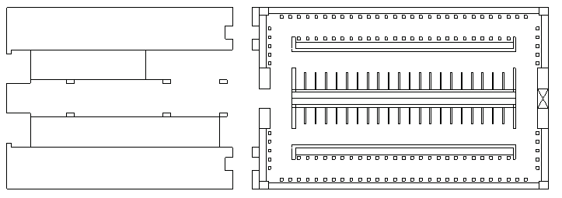

Fig.8: Washroom Layout Designed in AUTOCAD.

The estimated response time ranges are given in Table 2 below.

Table 2: Estimated Response time

|  |  |
| --- | --- |
| Age (years) | Estimated Response Time Range (sec) |
| 5 – 15 | 100 – 225 |
| 16 – 30 | 110 – 275 |
| 31- 55 | 120 – 300 |
| 56 – 80 | 175 – 355 |

For the travel speed, the standard travel speeds provided by buildingEXODUS were used: Fast walk = 1.2 m/s – 1.5 m/s, Walk speed = 1.08 m/s – 1.35 m/s, Stairs up = 0.510, and Escalators up = 0.320 – 1.510. From the data collection process, the total number of people in each level was estimated to be between (770 ~ 850), which does not include the people close to the staircases and escalators. This number was estimated according the following distribution, assuming that all washrooms and ablution seats are occupied: 42 people using toilets, 128 are performing ablution, (3 – 5) people queuing for toilets ~ (4 x 50) = 200 people, and (2 – 3) people queuing for ablution ~ (2 x 128) = 248. In addition to about (180 – 210) people distributed mainly at the entrance of the washroom/ablution area at each washroom level, from which few people are moving around the washroom area looking for a smaller queue or moving around in the system. Then, according to the above calculations and estimations, the number of people in each level except level 3 were estimated at 770 – 800, while the number of people in Level 3 is zero.

6.1 Evacuation simulation results for all levels connected:

Fig. 9 shows the initial distribution of people in the system. Fig. 10 shows the status of the system time = 1 min, with the number of people exiting the system being 48. Fig. 11 shows the status of the system at time 5 mins, and the number of people exiting the system equals 856.

|  |  |
| --- | --- |
|  |  |
| Level 0 | Level 1 |
|  |  |
| Level 2 | Level 3 |
|  | |
| Level 4 | |

Fig.9: Simulation status at time = 0.

|  |  |
| --- | --- |
|  |  |
| Level 0 | Level 1 |
|  |  |
| Level 2 | Level 3 |
|  | |
| Level 4 | |

Fig.10: Simulation status at 1 min.

|  |  |
| --- | --- |
|  |  |
| Level 0 | Level 1 |
|  |  |
| Level 2 | Level 3 |
|  | |
| Level 4 | |

Fig. 11: Simulation status at 5 mins.

Fig. 12 shows the status of the system at time 7 mins, where the total number of people exiting the system equals 1290. Level 3 is not shown since no people were moving through this level.

|  |  |
| --- | --- |
|  |  |
| Level l | Level 2 |
|  | |
| Level 4 | |

Fig.12: Simulation status at 7 mins

Progressing through the simulation, at 8 mins and 55 secs, Level 1 was vacant and the total number of people evacuated was 1660 people. Additionally, at time 10 mins. and 10 secs., the total number of people exiting the system was 1798 people where all toilets/ablutions areas in all levels were vacant and the only people left in the system are those on the escalators or waiting to get on the escalators with no queues seen at the staircases since all people in level 1 had already evacuated. Fig. 13 shows the simulation status at time 10 mins. and 10 secs.

|  |  |
| --- | --- |
|  |  |
| Level 1 | Level 2 |
|  | |
| Level 4 | |

Fig. 13: Simulation status at 10 min and 10 sec

At time 12 minutes and 23 seconds, Level 4 was evacuated and the lower escalator delivered the last person to Level 2 since no people were noticed to use the staircases between levels 4 and level 3. Thus, the total number of visitors who left the system was 2029 people. At this point only Level 2 is noticed to have people queuing at the escalator to exit the washroom system Fig. 14.

|  |  |
| --- | --- |
|  |  |
| Level 2 (time = 12 minutes and 23 seconds) | Level 2 (at time = 15 minutes) |

Fig. 14: Simulation status for Level 2

At 15 minutes, the simulation results show that less people are queuing at the bottom of the escalator on Level 2, and the total number of people who evacuated the system was 2308. Finally, at 17 mins. and 6 secs., the washroom units were completely empty and the number of people out of the system was 2529 with an average of 833 people on each level except Level 3 which had no one using the washrooms. Fig. 15 shows the graphs of visitors exiting with time for each exit and Fig. 16 shows 3D views of the washroom unit.

|  |  |  |
| --- | --- | --- |
|  |  |  |
| Stairs | Escalator | Both |

Fig. 15: No. of people vs. time for the whole washroom unit.

|  |  |
| --- | --- |
|  |  |

Fig. 16: Simulation Results: 3D view showing the connection of the four levels.

Conclusion

From the data collection, observations and simulations, this study provides the following recommendations:

Use signage to warn and direct people away from overcrowded areas.

Provide emergency exits.

Reduce capacity to guarantee the safety of people during crowded and emergency situations.

Train staff during emergencies in the underground washroom facilities, which is essential in accordance to an evacuation plan.

Support the development of standards, such as building standards. The multicultural and diversity of people provides a fertile area of research especially in the development of standard, such as building, social … etc.

In conclusion, a proposed model for the flow of people in and out of washroom unit 9 at Al-Masjid An-Nabawi was implemented and simulated. The simulation provides the nature of flow of the people in and out of the washroom unit during peak times. The proposed model was simulated using MATLAB and validated against the data collected. The model provided a close resemblance to the real data collected. In addition, a case study for simulating an evacuation scenario was done using buildingEXODUS simulation software. From the evacuation simulation results, it is observed that more investigation is needed for an evacuation plan to guarantee the safety of crowds and to provide recommendations for better layout arrangements. Future work on simulating different scenarios must be done in order to provide an optimized toilet/ablution layout for the washroom units. Finally, this work recommends the need for an evacuation plan of crowded washroom units as well suggests rearrangement of toilets/ablutions areas in order to avoid any catastrophe for any unexpected situation.

References

[1] G. Santos and B.E. Aguirre, "A Critical Review of Emergency Evacuation Simulation Models", Proceedings of the NIST Workshop on Building Occupant Movement during Fire Emergencies, 2004.

[2] Haron, Fazilah, et al. "Software Evaluation for Crowd Evacuation- Case Study: Al-Masjid An-Nabawi." *International Journal of Computer Science Issues (IJCSI)* 9. 6 (2012).

[3] Alginahi, Yasser M., Muhammad N. Kabir, and Ali I. Mohamed. "Optimization of High-Crowd-Density Facilities Based on Discrete Event Simulation." *Malaysian Journal of Computer Science* 26 (2013): 4.

[4] D. Helbing et al., “Simulating Dynamical Features of Escape Panic,” Nature, 407, 2000, pp. 487-490.

[5] D. Thalmann, S. Musse, M. Kallmann, “Virtual Humans’ Behaviour: Individuals, Groups and Crowds,” Proc. International Conference on Digital Media Futures, British Computer Society, Bradford, UK, 1999, pp. 13 – 15.

[6] M. Sung, M. Gleicher, S. Chenney, “Scalable Behaviours for Crowd imulation,” Computer Graphics Forum, (Proc. of the Eurographics Conference) vol. 23, no. 3, 2004, pp 519-528.

[7] R. Narain, “Aggregate Dynamics for Dense Crowd Simulation,” http://gamma.cs.unc.edu/DenseCrowds/, 2009.

[8] F. Qiu and X. Hu, “Exploiting Spatial-temporal Heterogeneity for Agent-based Simulation of Pedestrian Crowd Behavior,” Activity-Based Modeling and Simulation, 2010, pp. 107 – 127.

[9] Galea E.R. and Perez Galparsoro J.M. 1993. “EXODUS: An Evacuation Model for Mass Transport Vehicles”. UK CAA Paper 93 006, ISBN 086039543X. <http://fseg.gre.ac.uk/exodus>