|  |  |  |
| --- | --- | --- |
|  | تطوير بنية تحتية للبيانات المكانية لحركة الحجاج وتنقلهم خلال أيام الحج في المشاعر المقدسة |  |
|  | Developing a Spatial Data Infrastructure (SDI) for Pilgrims’ Movement and Transportation during Hajj days in Holy Places  Riza Al-Yaqubi  King Abdulaziz University |  |

الملخص :

تعتبر سلامة الحجاج من اهم أولويات السلطات التي تسهر على مرور مناسك الحج في أفضل الظروف. ولا يخفى ان إدارة حشود الحجاج و تنقلهم داخل المشاعر المقدسة خلال ايام الحج يعتبران جانبان أساسيان يجب أخذهما بعين الاعتبار لضمان سلامة  حجاج بيت الله الحرام. ان إدارة حشود الحجاج و مراقبتها بالاضافة الى اقتراح أفضل و أسلم مسارات التنقل، تحتاج الى تطويربُنية تحتية للبيانات المكانية. في هذه الورقة العلمية، سوف نعرض بنية تحتية للبيانات المكانية تهدف الى توفير معلومات و تحليلات مكانية مفيدة و ذات أهمية من اجل مساندة اتخاذ القرارات المناسبة لتفويج الحجاج ومراقبة تنقلاتهم و محاكاة خطط الطوارئ. لتحقيق هذا الهدف، قمنا بتصميم قاعدة بيانات مكانية من اجل نمذجة الالية المتبعة في تفويج الحجاج وتنقلاتهم داخل المشاعر المقدسة (منى، عرفات و مزدلفة) خلال ايام الحج. بالاضافة الى ذلك، قمنا بتطوير شبكة نقل متعددة الوسائط تتألف من اهم وسائل التنقل المستعملة خلال ايام الحج التي تتمثل أساسا في؛ خطوط الحافلات، شبكة القطار و مسارات المشاة. كما تحتوي شبكة النقل المتعددة الوسائط المطورة على نقاط تجمع الحجاج داخل المخيمات بمنى و عرفات. تسمح قاعدة البيانات المكانية وشبكة النقل المتعددة الوسائط اللتان تم تطويرهما بإنشاء بنية تحتية فعالة للبيانات المكانية توفر مساندة قوية لكافة جوانب إدارة حشود الحجاج. كذلك، يمكن استخدام هذه البنية في تقديم الخدمات المعتمدة على الموقع بطريقة فعالة لحجاج بيت الله الحرام اثناء اداء مناسك الحج. في نهاية هذه الورقة، سوف نقدم نتائج المحاكاة التي تحصلنا عليها على أساس البنية التحتية للبيانات المكانية المقترحة والتي تتمثل في السيناريوهات التالية: ١) التنقل من مخيمات منى الى مخيمات عرفات، ٢) التنقل من مخيمات عرفات الى مزدلفة، و ٣) التنقل من مخيمات منى الى الجمرات.

Abstract

The safety of pilgrims is one the most important issues faced by authorities to make sure that Hajj rituals are carried out in the best condition. Management of pilgrims crowds’ movement as well as their transportation among Holy places during Hajj days are two main key aspects to take into consideration to ensure their safety. The management of pilgrims’ crowds, the monitoring of their displacement in addition to the proposition of safe and optimal transportation paths require a suitable Spatial Data Infrastructure (SDI). In this paper, we present an SDI that intends to provide useful and relevant spatial information and spatial analysis to support decision making for pilgrims’ crowd management, monitoring, and simulating emergency strategies. To achieve this goal, a Spatial Database was designed in order to model the approach adopted in planning pilgrims’ displacement and transportation among holy places (Arafah, Muzdalifah, Mina) during Hajj days. We also developed a Multi-Modal Transportation Network (MMTK) composed of the main transportation modes used during Hajj days, namely; Bus routes, Train network, and Pedestrian paths. This MMTN contains also assembly points inside Mina and Arafah camps. The elaborated Spatial Database and Multi-Modal Transportation Network ensure defining a powerful SDI dedicated to support all aspects of pilgrims crowds’ management. In addition, it can be used to offer useful Location Based Services (LBS) for pilgrims while performing Hajj rituals. At the end of this paper, we’ll present the simulation results that we’ve conducted based on the developed SDI. These simulations are related to the following movements; 1) from Mina’s camps to Arafah’s camps, 2) from Arafah’s camps to Muzdalifah, and 3) from Mina’s camps to Jamarat.

Introduction

Hajj is considered as the one of the most important acts of worship in Islam. It is the fifth pillar of our glorious religion, and it is an obligatory worship for Muslims who are able to perform it. ALLAH Almighty says in the Holy Quran in the interpretation of the meaning: ***“And Hajj (pilgrimage to Makkah) to the House (Ka‘bah) is a duty that mankind owes to ALLAH, those who can afford the expenses (for one’s conveyance, provision and residence)” [Aal ‘Imraan 3:97]* .** In addition to financial ablity, performing Hajj involves physical efforts to bear the hardship of Tawaaf, Saa’i and more specifically travelling among Mina, Arafah and Muzdalifah. In order to help pilgrims to carry out Hajj rituals in the best and safe conditions, it is necessary to manage pilgrims crowd’s movement as well as their transportation among Holy places in an efficient way. Such successful management requires a powerful Spatial Data Infrastructure (SDI) that intends to provide useful and relevant spatial information and spatial analysis to support decision making for pilgrims’ crowd management. Spatial Data Infrastructure (SDI) aims to coordinate the exchange and the sharing of spatial data between active users within a spatial data community (Erik de Man, 2006). It is intended to ensure an easy and secure access and retrieval of spatial datasets (Coleman and McLaughlin, 1998). In addition, an SDI provides a useful framework to develop effective Location based services (LBS) (Smith et al, 2004). According to Rajabifard and al. (2000), an SDI includes five components: people, access, policies, standards, and data. People are an important component of an SDI, due to their roles in processing data and in decision-making. The relation between people and data is determined through network access; policy, privacy and liability; standards and interoperability (Smith et al, 2004). The following figure summarizes the relations among SDI components (Rajabifard et al., 2000):

People

Access Network

Standards

Policy

Data

Figure 1: Relations between SDI Components (Rajabifard et al., 2000)

From the perspective of managing piligrims’ grouping and transportation, we’ll focus on two main components of an SDI which are Data and People. Hence, in this paper, we propose to design a Spatial Database that models the main concepts related to planning piligrims’ displacement and transportation among holy places (Arafah, Muzdalifah, Mina) during Hajj days. We highlight how the spatial data has to be structured to provide useful and suitable information to pilgrims and decision makers during Hajj days in Holy places. In addition, we develop a Multi-Modal Transportation Network (MMTK) that is composed of the main transportation modes used during Hajj days, namely; Bus routes, Train network, and Pedestrian paths. This MMTN contains also assembly points inside Mina and Arafah camps. As a result, we present some simulations conducted based on the developed SDI (traveling from: 1. Mina’s camps to Arafah’s camps, 2. Arafah’s camps to Muzdalifah, and 3. Mina’s camps to Jamarat).

**Modeling the Spatial DB for Pilgrims’ movement and Transportation:**

In order to design a suitable Spatial Database for piligrim’s movement and transportation in Holy places during Hajj days, it is necessary to clearly specify the different needs of both pilgrims and authorities. After that, we have to model those needs as classes and relations based on Database Modelling formalism. Then, the DB will be populated with the appropriate spatial and descriptive data relevant for Hajj activities.

**Required information for pilgrims and authorities:**

The required information for pilgrims and authorities during Hajj Days may be summarized as follow:

**Gathering places:**

Gathering places mean the locations where pilgrims will be gathered together from their camps (in Arafah, Mina or Muzdalifah). These places are already predetermined by the authorities for each Tawafah Institution. Based on these gathering places, the traveling routes and departures times are determined in order to optimize the displacement and the transportation of pilgrims among Holy places.

**Movements planning of Pilgrims:**

The movements of pilgrims among Holy places during Hajj days are prescribed in the Quran and the Sunna of the Prophet Mohammed peace be upon him. These movements consist of the following:

The ninth day of Dhu’l Hijja (Arafah Day): After the sunrise, the pilgrims move from Mina to Arafah, and they remain there until the sunset.

After the sunset of Arafah Day: The pilgrims move from Arafah To Muzdalifah.

The tenth day of Dhu’l Hijja: The pilgrims go out from Muzdalifah to Mina before the sunrise.

From the tenth to thirteenth days of Dhu’l Hijja: The piligrims move to the Holy Mosque to perform Tawaaf and Saa’i. In addition, they have to move from their camps in Mina to the Jamarat each day to throw stones.

Allowed traveling itineraries

The Hajj authorities determine a priori the allowed itineraries that pilgrims of each Tawafah institution must follow and respect. Hence, the authorities inform these institutions about departure times, gathering places (in Mina, Arafah and Muzdalifah) in addition to the access gate to Jamarat.

**The used transportation modes:**

The pilgrims may use one or several transportation modes based on the predetermined routes given by Hajj authorities for each Tawafah institution. The available transportation modes available for pilgrims among Holy places are mainly: 1) Bus, 2) train or 3) traveling on foot.

**Designing the Spatial Data Model:**

After highlighting the required information in the previous section, we introduce our Spatial Data Model that is proposed to support pilgrims’ movement during Hajj days. First of all, we define the main classes and relations used in such a model. Then, we present the whole model via the Unified Modeling Language (UML).

**Components of the Spatial Data base:**

In order to meet the needs of both pilgrims and Hajj authorities, the Spatial Data Base model should include the following main components. Note that there are some other constituents not described here but will appear in the Conceptual Data Model presented in the following section.

**Road Segment:** The road segment is used to model roads mainly dedicated for Bus transportation. However, some of these roads can also be used by pedestrians. Each road segment may be delimited by a U-turn, a Tunnel, an Intersection, a Junction with Pedestrian Segment, and a Bridge.

**Intersection:** An intersection may occur among two or many road segments.

**Bridge:** A Bridge can be defined as a link between two road segments, and it has a higher elevation (or Z value) than the road segments.

**Tunnel:** A tunnel links between two road segments, however, it has a lower elevation (or Z value) than the road segments.

**Pedestrian Segment:** A pedestrian segment is a pathway exclusively reserved for pedestrians. Pedestrian segments may be partitioned based on Jamarat gates, Camp entrances (for Mina, Arafah and Muzdalifah), Junctions with roads Segments, Junctions with Train Segments (Train Station), and Gathering Points.

**Train Segment:** A train segment is a part of the train railway which is delimited by two successive Train Stations. It is also characterized by its one-way direction of traveling.

**Train Station:** In our model, a Train Station is considered as a junction between a path used for pedestrian and a Train Segment. It allows pilgrims to use the train transportation mode.

**Holy Place:** Holy Places are the places that the pilgrims must visit in order to perform Hajj rituals. They correspond to the geographic extent of Arafah, Mina and Muzdalifah.

**Camp:** Camps represent Pilgrims’ housing allocated to Tawafah institutions.

**Jamarat Gate:** Jamarat contain several gates that help in managing pilgrims’ movement in this strategic place. Entrance gates are allocated to Tawafah institutions based on several criteria such as the location of the camps and the itinerary from Arafah to Jamarat.

**The UML Model of the Spatial Database:**

The conceptualization of our proposed model was undertaken using the Unified Modeling Language (UML). In this model, we have specified classes and relations that are important for an SDI intended to support navigation for pilgrims and decision making for Hajj authorities. This model is mainly based on the concepts described in the previous section. The following figure summarizes the Conceptual Data Model (CDM) with the UML specification language for the elaborated Spatial Database.

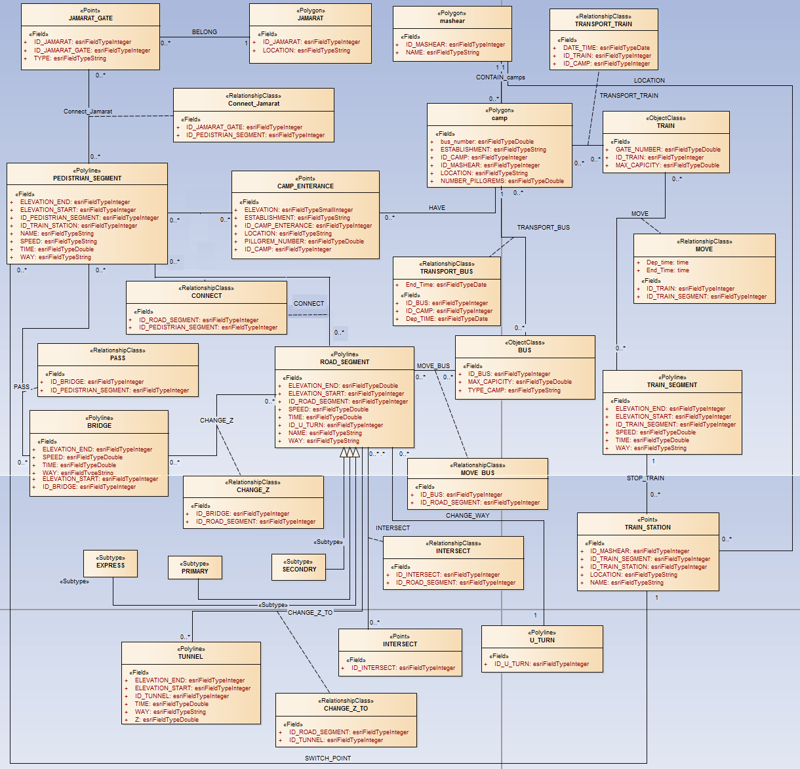

Figure 2: The CDM in UML language for the proposed Spatial Data Model

**Multi-Modal Transportation Network for Pilgrims’ movement and Transportation:**

During Hajj days, pilgrims often need to travel with more than one transportation mode (on foot, bus or train). Therefore, it is required to provide pilgrims with navigational information that consider simultaneously all these transportation modes. For this reason, the implementation of a suitable Multi-Modal Transportation Network (MMTN) is crucial. An MMTN may be defined as a transportation network where two or more different modes may be used for a single travel in which a traveller has to make a transfer (Van Nes, 2002). The figure 3.a illustrates the general concept of Multi-Modal Transportation Network.

In order to model and to implement such a network in our case, we use the CDM presented earlier in Figure 2. More specifically, we have introduced some classes that ensure the transfer between different transportation modes such as ‘Train Station’ and the relation ‘Connect’ between ‘Pedestrian Segment’ and ‘Road Segment’. In addition, for each component of the network, we introduce an elevation value (-1, 0 or 1) to model the transition of the elevation between roads or pedestrian segments in one hand, and ‘Tunnels’ and ‘Bridges’ on the other hand. Furthermore, the MMTN has to take into account other characteristics like authorized directions and Speed. The figure 3.b shows the Multi-Modal Transportation Network for supporting pilgrims’ movement and transportation during Hajj days produced based on the proposed Spatial Data Model.

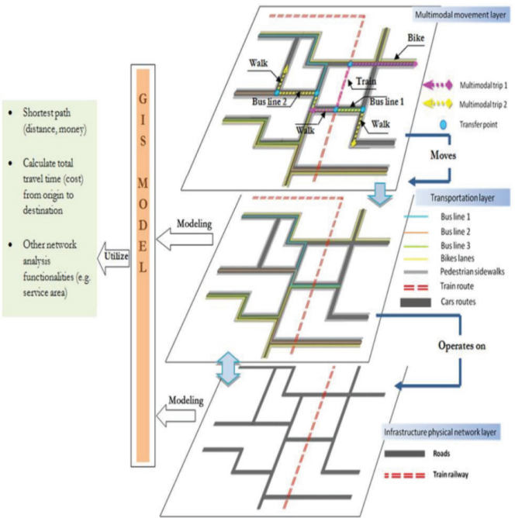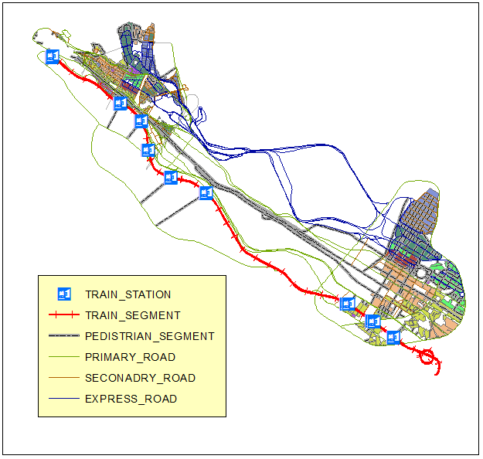

**Figure 3.a**

**Figure 3.b**

Figure 3: The concept of MMTN: a. the general concept (Mahrous, R.F. (2012)) and b. the concept for pilgrims’ movement and transportation.

**Pilgrims grouping and transportation simulation:**

In this section, we present the results of our simulation of pilgrims grouping and transportation among Holy places during Hajj days. These simulations are related to the following movements; a) from Mina’s camps to Arafah’s camps, b) from Arafah’s camps to Muzdalifah, c) from Muzdalifah to Jamarat and d) from Mina’s camps to Jamarat.

**From Mina’s camps to Arafah’s camps:**

After the sunrise of the ninth day of Dhu’l Hijja, the pilgrims move from Mina to Arafah, and they remain there until the sunset. The first step in this journey is to group the pilgrims in ‘Gathering points’ from their ‘Camps entrances’ in Mina (Figure 4.a). Then, from these gathering points, each group of pilgrims will follow a specific itinerary based on the criteria specified by Hajj authorities. In this simulation, we used the constraints of travel time in addition to the allowed directions. However, our developed SDI may take into consideration more complex restrictions such as the traffic density and the approved transportation mode assigned to each ‘Tawafah’ Institution. Figure 4.b shows the Multi-Modal aspect of the proposed itineraries from each gathering points in ‘Mina’ camps to the destination gathering points in ‘Arafah’ camps. We note that some pilgrims may take a pedestrian path, and then they take the train to Arafah station. After that, they may walk till the gathering points in ‘Arafah’ camps (figure 4.c). Finally, the pilgrims will move from the Gathering points to their camp entrances in ‘Arafah’ (figure 4.d).

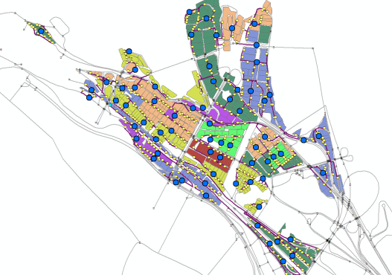

Camp entrance

Gathering point

A. from Mina Camp entrances to Gathering points

B. from Gathering points in Mina to Gathering points in Arafah

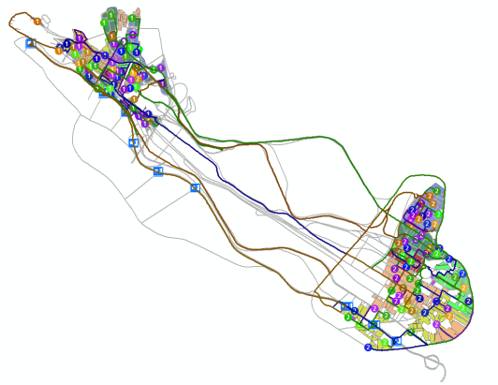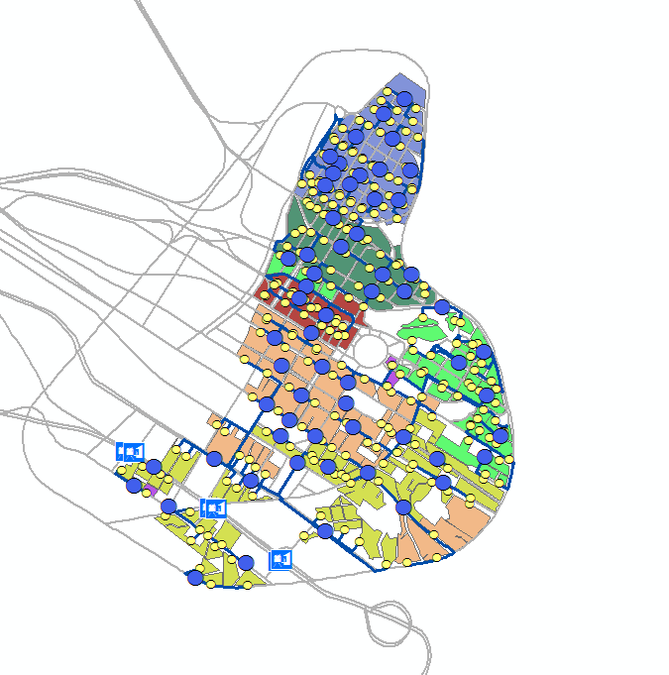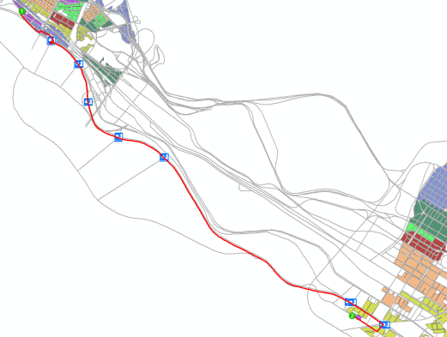

Camp entrance

Gathering point

D. from Gathering points to Arafah Camp entrances

C. Example of a Multi-Modal Itinerary: Pedestrian and Train

Mina Camps

Arafah Camps

Figure 4: The simulation of pilgrims grouping and transportation in the ninth day of Dhu’l Hijja (phases A, B, C and D).

**From Arafah’s camps to Muzdalifah:**

The second main phase is the transportation of pilgrims from Arafah Gathering Points to Muzdalifah’s Camps. Based on the developed SDI, the authorities may decide which camp will be allocated to each Tawafah institutions (Figure 5). It is also possible to calculate the best routes from Arafah’s gathering points to Muzdalifah if the camps in this latest are already allocated.

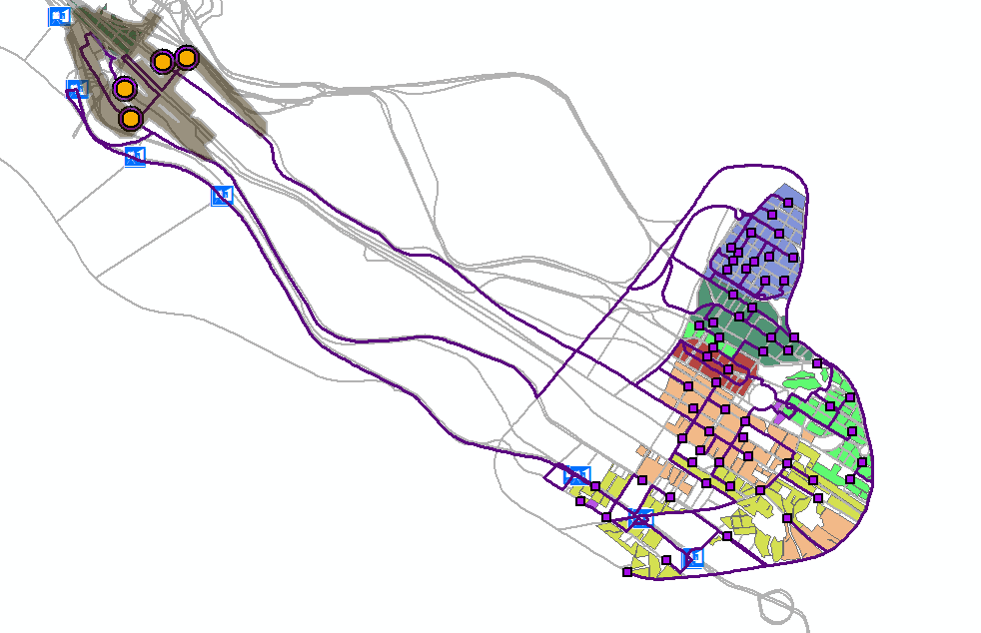

**Arafah Camps**

**Muzdalifah Camps**

Figure 5: The simulation of pilgrims grouping and transportation from Arafah to Muzdalifah.

**From Mina’s camps to Jamarat:**

In the same vein, we may generate the optimal routes from Mina’s Camp entrances to the main gates of Jamarat. Based on the developed SDI, we can either determine the appropriate Jamarat gate for each Tawafah institution (Figure 6), or we can define the best trajectories based on the decision of Hajj authorities. Note that the same procedure may be applied to the displacement from Muzdalifah’s camps to Jamarat.

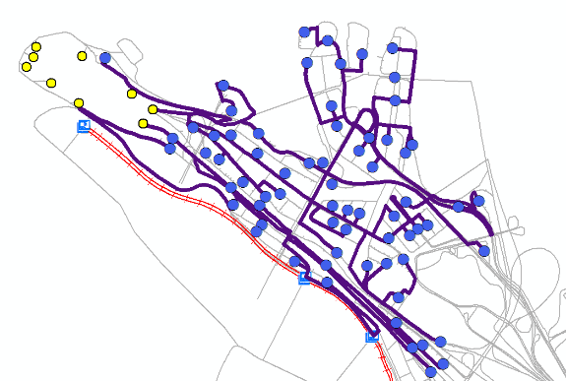

Jamarat Gate

Gathering point

Figure 6: The simulation of pilgrims’ movement from Mina’s camps to Jamarat

**Conclusion and Future Work:**

In this paper, we have developed a prototype of a Spatial Database model that supports Multi-Modal Transportation. This Spatial DB can be considered as the core of an SDI dedicated to managing pilgrims’ grouping and transportation in Holy places during Hajj days. In addition, we have presented some simulations of pilgrims’ transportation while performing Hajj rituals. The proposed itineraries can be communicated as Location Based Services (LBS) to pilgrims or Tawafah institutions, through the use of smart phones for example, in order to be aware of their assigned routes. Furthermore, the proposed solution may be very effective in assisting Hajj authorities to determine the optimal routes and transportation modes while taking into consideration the desired restrictions. We would like to mention that the designed Spatial DB must be updated at the beginning of each Hajj season in order to ensure reliable analysis and results.

As future work, we will investigate the use of Multi-Agent based modeling to simulate the behavior of pilgrims and transportation vehicles taking into consideration the Multi-Modal aspect of displacement and the restrictions imposed by Hajj authorities.

References

1. Coleman, D. J., & MCLAUGHLIN, D. (1998). Defining global geospatial data infrastructure (GGDI): components, stakeholders and interfaces. *Geomatica*,*52*(2), 129-143.
2. Erik de man, W.H. (2006). Understanding SDI; complexity and institutionalization, *International Journal of Geographical Information Science,* 20(3) : 329-343.
3. Mahrous, R.F. (2012). *Multimodal transportation systems: Modelling challenges* (M. Sc. Thesis, University of Twente, The Netherlands).
4. Rajabifard, A. Escobar, F. Williamson, I.P. 2000. Hierarchical Spatial Reasoning Applied to Spatial Data Infrastructures, *Australian Cartography Journal* 29(2) : 41-50.
5. Smith, J. Kealy, A. Mackaness, W. Williamson, I. 2004. Spatial Data Infrastructure : Requirements for Mobile Location Based Journey Planning, *Transaction in GIS* 8(1) : 23-44.
6. Van Nes, R. (2002). Design of multimodal transport networks. *Civil Engineering. Delft Technical University, Delft*, 304.