تغيرات درجات الحرارة علي مكة المكرمة والمدينة المنورة
Temperature Trend on Makkah, Saudi Arabia

Abdellatif Abdou
The Custodian of the Two Holy Mosques Institute for Research of Hajj and Umrah

الملخص :
الهدف الرئيسي من هذه الدراسة هو بحث اتجاه وتوزيع درجة الحرارة في 29 سنة للفتره من1985 الى 2013 على مكة المكرمة وفترة 36 سنة (1978-20130). يتم البحث في الحد الاقصى والادني اليومي شهريا بالاضافة الي متوسط درجة الحرارة يوميا، وقد تم الحصول على الانحرافات من الفترات المرجعية من خلال تحليل البيانات، وأظهرت النتائج علي مكة مايلي: عدد الايام الحارة نهارا وليلا ارتفعت سنويا بمعدل 1.5966/1.832 يوم بينما انخفض عدد الليالي الباردة سنويا بمعدل 0.4054 ليلة. المتوسط السنوي لمتوسط درجة حرارة الايام ارتفع ب 0.0398 درجة لكل عام بينما المتوسط السنوي لمتوسط درجة الحرارة العظمى ب 0.0552 درجة كل عام و المتوسط السنوي لدرجة الحرارة الصغرى ارتفع سنويا بمعدل 0.0398 درجة. في المقابل في المدينة المنورة كان عدد الايام الحارة نهارا وليلا ارتفعت سنويا بمعدل 0.6216 نهارا و0.6122 ليلا بينما انخفض عدد الايام والليالي الباردة سنويا بمعدل 0.1368 نهارا و 0.5275 ليلا. وهذا يعني انه خلال هذه الفتره ارتفعت عدد الايام الحارة بمعدل22.3776 وارتفع عدد الليالي الحارة بمعدل 22.0392 ليلة. من النتائج الواردة أعلاه يمكننا أن نستنتج أن مكة المكرمة و المدينة المنورة يعانون من ارتفاع درجات الحرارة، وهناك مخاطر طبية متزايدة من موجات الحرارة التي ستكون أكثر كثافة أو لفترة أطول، أو تلك التي تحدث في وقت سابق من الصيف، لذلك، يجب المطالب بتوفير طاقة اضافية للتبريد، وتوفير مصادر المياة، كما ينبغي الاستعداد الطبي من قبل صناع القرار من أجل تقليل هذه المخاطر على الحجاج الذين يتجمعوا سنويا لأداء مناسك الحج

Abstract
The main objective of this study is to investigate the trend and the distribution of temperature in 29 years period (1985 to 2013) over Makkah, Saudi Arabia, the holiest city for all Muslims. The mean monthly of daily maximum, daily minimum and daily mean temperatures are investigated, deviations from the reference period (1985–2013) were obtained. By analyzing the data, the results showed that; the number of hot days/nights increased annually by 1.5966/1.832 days while the number of cold nights decreased annually by 0.4054 nights. The annual mean of daily mean temperature increased with 0.0398°C per year while the annual mean of daily maximum temperature rose with 0.0552°C per year and the annual mean of daily minimum temperature increased with 0.0398°C. The monthly mean of mean temperature (Tmmean) of 23.98°C was found in January while a maximum mean temperature of 35.95°C in July while the monthly mean of maximum temperature (Tmmax) of 43.88°C was found in June and the a minimum of 30.54°C in January and the monthly mean of minimum temperature (Tmmin) varied between a minimum of 18.82°C in January and a maximum of 29.59°C in August. From the above findings we can conclude that Makkah is suffering from a considerable warming temperature trend and there is an increasing medical risk from heat waves that will be more intense or longer, or those occurring earlier in summer, so, specific attention towered: the energy demands for extra cooling, water resources, draughts, medical preparedness should be paid by the decision makers in order to minimize these risks over the pilgrims who gathered annually to perform hajj rituals and visitors.

Key words: extreme temperature, heat waves, human health, Makkah, Saudi Arabia

Introduction:
The Global warming is the most significant environmental problem the world experiencing today as concluded by the four IPCC Reports [1], [2], [3], [4]. Following these reports, several long-term of temperature studies have been done on different scales and there is a temperature increase globally as shown in [5], hemispherical as in [6] which showed that the rate of annual warming for global land areas over the 1901– 2000 period is 0.078°C per decade, and regionally as in [7] which showed that there an increase in the surface temperature of the Earth with 0.6°C – 0.8°C during the 20th century.
According to the satellite measurements, the lower troposphere air temperatures have increased between 0.13°C and 0.22°C per decade since 1979 [8].
Other regional studies over the south Mediterranean [9] showed that the summer temperatures have increased during the last 3 decades of the 20th century while the mean annual temperature records have a warming trend over the 1939 to 1989 period over Turkey [10] and a significant warming trend after the years 1957 and 1967 for the minimum and maximum temperatures in Jordan [11]. Also, a study over Kuwait [12] showed that the maximum yearly temperature is persistently exceeding its mean value during the last two decades and a considerable worming temperature trend and the rainfall decrease were the main reasons of the aridity in the Middle East which should be considered for rural development and water resources management in KSA [13].
Another study [14], showed that there is a statistically significant temperature increase of 0.07°C/decade over Kuwait during the period 1950-1990. The Variability of wintertime surface air temperature (SAT) of 24 observing sites in the KSA based on time series over thirty one years in length (1978-2008) [15] showed that there is a warming trend in winter time during the last 2 decades at most sites and there is significant warming trend after the year 1997 with a rate of 0.03°C/year. The extreme temperature trends over Jeddah, 70km away of Makkah, has been analyzed and studied by [16] for 40 years (1970 to 2006) and found that there is a significant increase in hot days per year and relatively smaller decrease in hot nights and confirm the increase in summer time temperatures and that the monthly and annual mean maximum temperatures have increased more than the mean and mean minimum temperatures. The surface air temperature (SAT) data of 19 meteorological stations distributed through the KSA using cumulative sum, cumulative annual mean, and the Mann–Kendall rank statistical test for the period of 1978–2010 and has showed that there is a negative temperature trend (cooling) with 0.03 °C/year for all stations during the first period (1978–1997), followed by a positive trend (warming) 0.06°C/year in the second period (1998–2010) with reference to the entire period of analysis [17].
In Makkah, the area of study, the outdoor temperature may exceed 45°C in summer. Exposes to high outdoor temperatures can result in heat exhaustion or heat stroke in many pilgrims, especially those who are not acclimatized [18].
In the current study, the behavior of the observed daily mean temperatures over Makkah has been investigated using 29 years (1985 to 2013) observation data collected from the Presidency of Meteorology and Environment is Saudi Arabia (PME) meteorological observing station.
The temperature issue in Makkah has special importance since the Hajj takes place annually once a year on the 9th to 12th of the lunar month of Dhu Al Hijjah (Figure 12) referring to the Arabic, Islamic, Hejra Calendar (The Islamic Calendar began on the year 662 AD, the year in which the Prophet Mohammed travelled to Medina.). During that annual event a drastic increase in the numbers of Pilgrims to Makkah; approximately four millions performed the Hajj in 2013. Moslems of more than 80 different nationalities, performing hajj and all of them hoping that the God will accept their devotions, bless their pilgrimage and forgive their sins[19]. So, the knowledge of the temperature trends may help the decision makers to make the right precautions in order to minimize or avoid the possible impacts of the extreme heat. Since the extreme temperatures can affect many areas of the society. It raises the power demand for air conditioning, create dangerous conditions for human health [20], [21].

Data and Site Description:
Kingdom of Saudi Arabia (KSA) occupies about 86% of the area of the Arabian Peninsula (AP)[22] and spreading throughout AP, hence the climate of KSA could be representative for the AP climate [23]. Makkah is very famous city, located around 70 km away from eastern coast of the Red Sea and the capital of Makkah Province (Figure 1). Makkah (latitude: 21.4 degree North, longitude: 39.85 degree East) and has an area of 153,128 km² [24]. It is a narrow valley at a height of 277m above sea level. Its population in 2013 was 7.7 million [24], although visitors multiple of this number every year during Hajj period held in the month of Dhu al-Hijjah, the Islamic Calendar, and proposed to increase year by year. Makkah is the birthplace of the prophet Mohammad (peace be upon him), and the place of the revelation of the Holy Quran. Makkah is regarded as the holiest city in the religion of Islam because of the obligation of Hajj since Muslims are required to visit at least once in their life-time and perform a pilgrimage. In the modern times, Makkah has seen tremendous expansion in size and infrastructure. Today, more than 15 million Muslims visit Makkah annually, including several million during the few days of the Hajj period. As a result of that, Makkah has become one of the most cosmopolitan and diverse cities in the Muslim world.
This study incorporates daily mean, maximum and minimum values of temperature in the current analysis. The standard methods have been used to check the completeness and erroneous values.
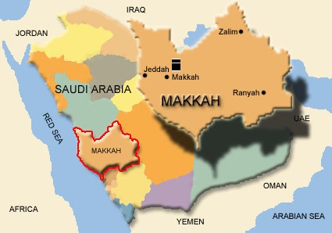
Figure 1: Location of Makkah on Saudi Arabia Map

Methodology
Using simple and known statistics, the number of hot and cold nights and days were estimated using daily maximum and minimum temperatures (Figure 2) recorded during different year.
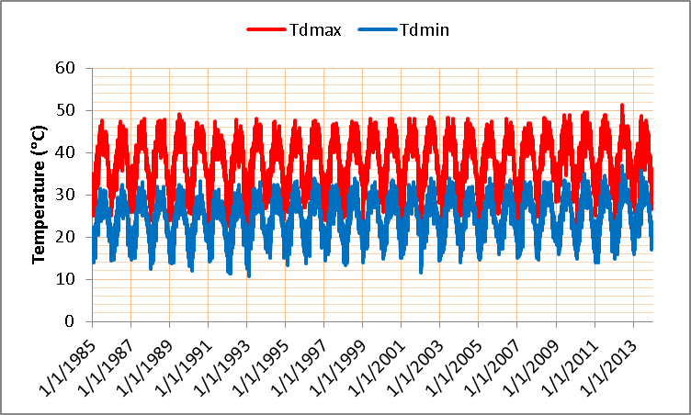
Figure 2: Daily maximum and minimum Temperatures during the period (1985-2013) over Makkah

The hot days are considered as hot if the maximum daily temperature Tdmax becomes ≥ 35°C, the hot nights are defined when daily min temperature Tdmin ≥ 20°C , the cold days are defined as cold when Tdmax ≤20°C and finally the cold nights are classified as cold when Tdmin becomes ≤15°C [16]
The monthly and annual standard deviations were calculated. The temperature range has obtained by taking the difference between the maximum and minimum temperatures of the daily mean values.
Results and Discussion
The data of daily maximum (Tdmax), daily mean (Tdmean) and daily minimum (Tdmin) values of temperature, monthly mean of maximum (Tmmax), monthly mean of daily mean (Tmmean) and monthly mean of minimum (Tmmin) values of temperatures and annual mean of maximum (Tamax), mean (Tamean) and minimum (Tamin) values of temperatures variability were studied and discussed in the coming paragraphs.
4.1 Temperature Data Summary
The overall variation of maximum, mean and minimum valued of daily maximum, daily mean and daily minimum of temperature over data reporting period (1985-2013) is summarized in Table 1. The maximum, mean and minimum of daily maximum temperature (Tdmax) were 40.67°C, 38.2°C and 35.78°C, respectively with standard deviation of 1.204°C. Similarly the maximum, mean and minimum of daily mean temperature (Tdmean) were 33.34°C, 31.64 °C and 29.86°C with standard deviation of 0.839°C and daily minimum temperature (Tdmin) varied between 22.34°C and 26.95°C while the overall mean was 26.95°C with standard deviation of 1.125°C as given in Table 1.

Table 1: Mean Temperature data Summary for Makkah during 1985-2013
Label | Max(°C) | Mean(°C) |  | Min(°C) | Std. Dev. (°C)
Tdmax | 40.67 | 38.20 |  | 35.78 | 1.204
Tdmean | 33.34 | 31.64 |  | 29.86 | 0.839
Tdmin | 26.95 | 24.80 |  | 22.34 | 1.125

4.2 Frequency of Hot/Cold Days and Nights
The number of hot days and nights and cold days and nights during the whole period were calculated and depicted in (Figure 3). It is shown that the number of hot nights and the number of hot days per year are on the increase. The regression lines of best fit show that the frequency of the hot nights has increased by 1.832 nights per year and that of hot days increased by 1.597 days each year. Also, the number of cold nights per year is on the decrease while the number of cold days is not observed. The regression lines of best fit show that the frequency of the cold nights has decreased by 0.405 nights per year.

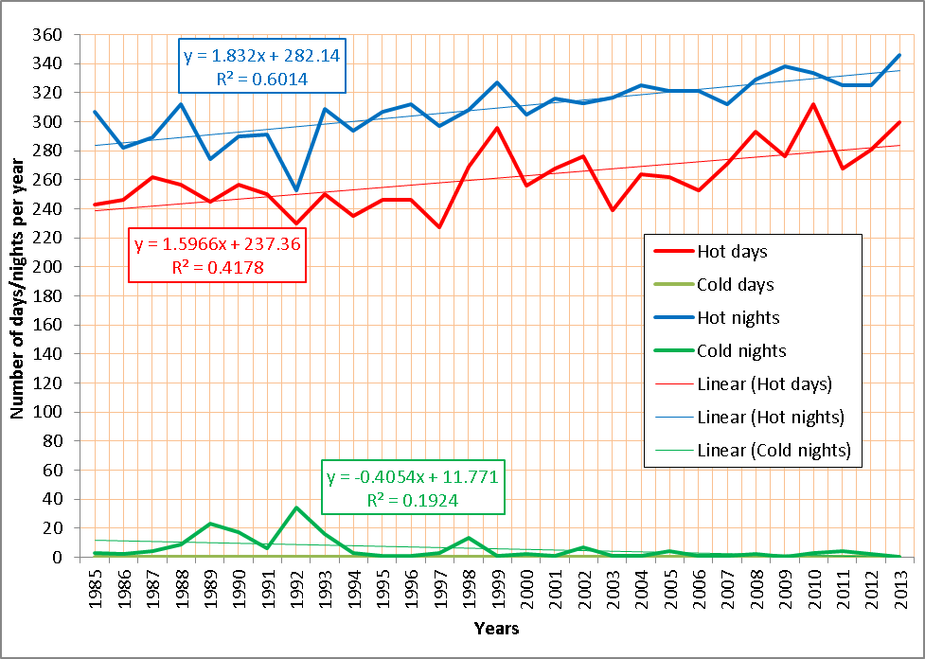
Figure 3: Annual frequency of hot days and nights and cold days and nights
Variation of Daily Mean Temperature (Tdmean)

The long term monthly mean (Tmmean) temperature were calculated using daily average values during the period 1985 to 2013 and are shown in (Figure 4). The monthly minimum and maximum of daily mean values are also displayed in this figure. The minimum mean temperature of 23.98°C was found in January while a maximum mean temperature of 35.95°C in July. This means that the ratio of hottest and coldest months was 1.499.
Higher values of mean temperature were observed from May to September, as shown in (Figure 4). The monthly maximum of 37.68°C and minimum of 20.49°C of the daily average temperatures were also observed in July and February, respectively. In this case the ratio between the hottest and cold temperature months was 1.84. Also, the same trend was followed by the monthly minimum values of the daily average temperature with hottest to coldest month’s temperature ration of 1.613.
The monthly mean temperature (Tmmean), the corresponding standard deviations, difference between the monthly maximum and minimum temperature of daily mean values (range) and the covariance are given in

Table 2.
It is found that the higher values of covariance (COV) correspond to higher standard deviations (SD) and smaller values of covariance to smaller standard deviations.
Higher values of COV and SD were observed for the winter months and the lower values for summer which is an indicative for relatively more sable temperatures in summer. COV varied between 0.19% and 8.02% corresponding to September and February during the year. This shows that the temperature in September is most stable and least in February.

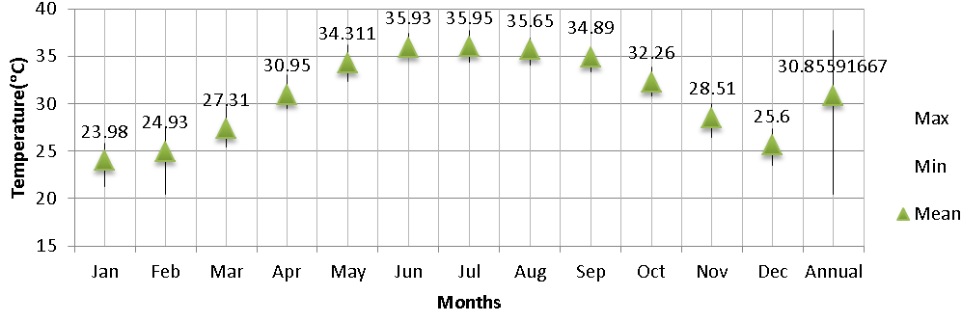
Figure 4: Variation of monthly mean, maximum and minimum temperature

Table 2: Statistical summary of monthly mean temperature of daily mean values
Month | Mean(°C) | Std. Dev. (°C) | Range (°C) | COV. (%)
Jan | 23.98 | 1.07 | 4.54 | 1.43
Feb | 24.93 | 1.68 | 7.06 | 8.02
Mar | 27.31 | 1.13 | 4.27 | 2.15
Apr | 30.95 | 0.92 | 3.58 | 2.59
May | 34.31 | 0.89 | 3.95 | 2.05
Jun | 35.93 | 0.65 | 2.58 | 3.35
Jul | 35.95 | 0.68 | 3.34 | 2.70
Aug | 35.65 | 0.63 | 2.8 | 2.49
Sep | 34.89 | 0.63 | 2.43 | 0.19
Oct | 32.26 | 0.67 | 3.07 | 3.00
Nov | 28.51 | 0.89 | 3.52 | 2.37
Dec | 25.60 | 1.03 | 3.78 | 3.06

Trend analysis of Monthly Mean of Daily Mean Temperatures (Tmmean)
The trends of monthly mean values of daily mean temperature over different years were obtained using linear regression best fit lines. The linear regression trends for all the months from January to December are shown in (Figure 5)(a-i), respectively and the corresponding best fit equations along with coefficient of determination are summarized in Table 3.

Table 3: Linear regression equation for all the months (Tmmean)
Month | Regression line | R² | Month | Regression line | R²
Jan | y = 0.0205x - 16.924 | R² = 0.0263 | Jul | y = 0.0385x - 41.041 | R² = 0.2351
Feb | y = 0.1145x - 204.01 | R² = 0.3365 | Aug | y = 0.0356x - 35.56 | R² = 0.2402
Mar | y = 0.0306x - 33.947 | R² = 0.0535 | Sep | y = 0.0027x + 29.45 | R² = 0.0013
Apr | y = 0.037x - 43.023 | R² = 0.1179 | Oct | y = 0.0429x - 53.548 | R² = 0.3017
May | y = 0.0292x - 24.123 | R² = 0.0785 | Nov | y = 0.0339x - 39.271 | R² = 0.1048
Jun | y = 0.0478x - 59.637 | R² = 0.387 | Dec | y = 0.0437x - 61.753 | R² = 0.1303

It is clear from (Figure 5) (a) to (c) that monthly mean of daily mean temperature have increased during the whole months and the annual increases were shown in (Figure 6), it is clear from this figure that the major increase occurred in February, June, December, October , July and April with annual increase of 0.1145°C, 0.0478°C, 0.0437°C , 0.0429°C , 0.0385°C and 0.0306°C, respectively, which implies that the months February, June, December, October , July and April Tmmean increased by 3.3205°C, 1.3862°C, 1.2673°C, 1.2441°C, 1.1165°C, 1.073°C during the last 29 years (Figure 7).

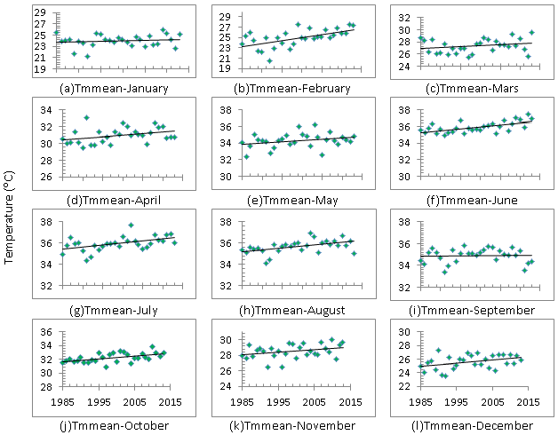
Figure 5: Linear regression trends of monthly mean of daily mean temperatures

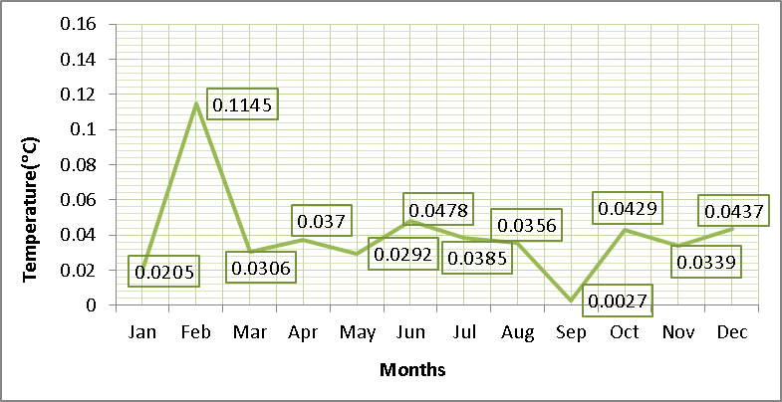
Figure 6: The annual increase in monthly mean of the daily mean temperature (Tmmean)

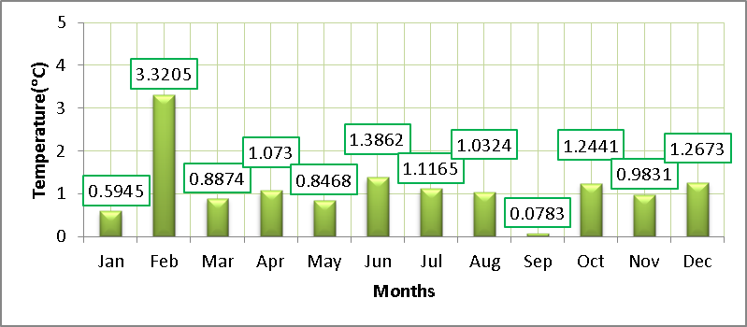
Figure 7: Tmmean total increase in the last 29 years

Trend analysis of Annual Mean of Daily Mean Temperatures (Tamean)

From (Figure 7) it is clear that the trend of the annual mean of daily mean temperature increasing with 0.0398°C per year. This implies that over the last 29 years the annual mean temperature of Makkah has increased by 1.1542°C.

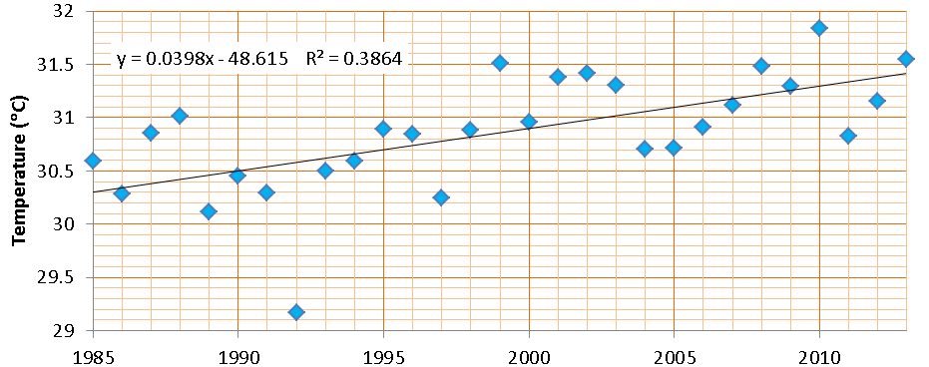

Figure 8: Trend of annual mean of daily mean temperature (Tamean)

As shown in (Figure 9) the annual deviations from overall mean temperature show increasing trends during the periods 1985 to 1986 , 1989 to 1997 and 2004 to 2005, and decreasing trends during 1998 to 2003 and 2007 to 2013.

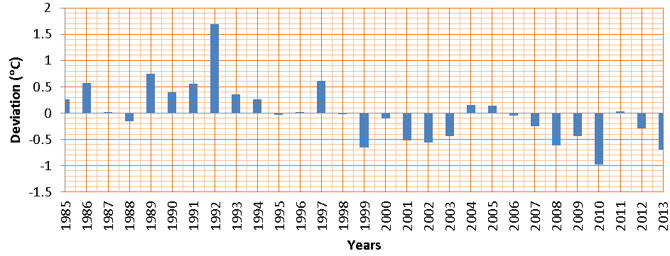
Figure 9: Trend of annual deviation from overall mean (Tamean)

Variation of Daily Maximum Temperature (Tdmax)

The long term monthly mean (Tmmax) temperatures were calculated using the daily maximum temperature values during the years 1985 to 2013. As shown in (Figure 10), the monthly minimum and maximum of the daily maximum temperature values over the entire period is also clear from the figure. The maximum value of Tmmax of 43.88°C was found in June while a minimum of 30.54°C in January. This means that the ratio between the temperatures of the hottest to coldest months was 1.436. The Tmmax was found to be greater than 30°C during the entire period and exceeds 40°C during the months May, June, July, August and September which almost the half of the year.
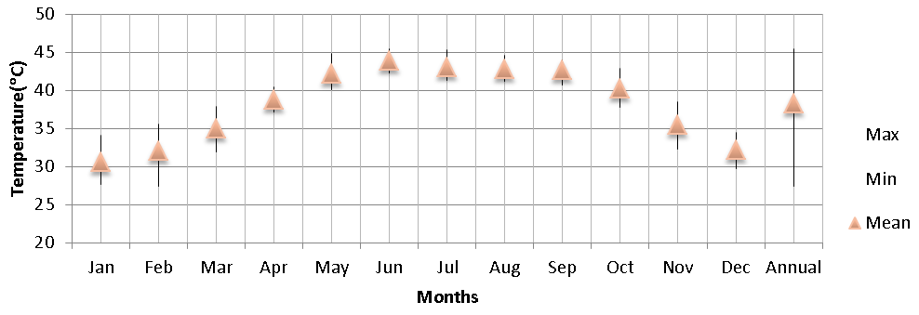
Figure 10:Variation of monthly mean, maximum and minimum temperature of daily maximum values

(Figure 11) shows the daily maximum temperatures which exceeds 44°C. The extreme (51.3°C) temperature has been recorded in 6 June 2012. There are three cases on 3 July 1989, 21 June 2010 and 7 August 2010 have recorded maximum temperatures 49.2 °C, 49.9 °C, 49.3°C, respectively. The best fit regression line show an increase of 0.0002 days of extreme temperatures per year. The extreme heat is well connected to the cause of Heat Stroke, Sun Stroke, Heat Syncope; Heat Cramps; Cardiovascular Diseases, Epilepsy, Diabetes, Breathing Disorders, Dehydration, Sunburn, Blisters, Syncope, Viral Infection, Bacterial Infections, Gastrointestinal Diseases, Respiratory Diseases, Falls-Sprains/Strains, Cuts and Abrasions, Burns, Crush Injuries, Bone Fractures [25] and exacerbates many pre-existing health conditions. The extreme heat specially with increasing humidity conditions are more stressful to human health more than isolated hot days [26, 27].
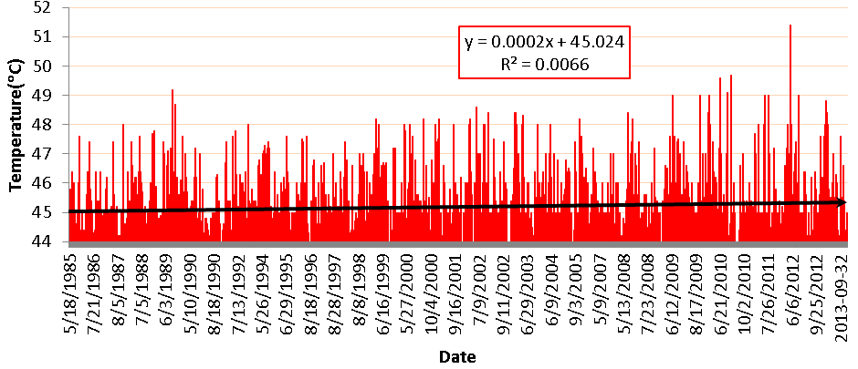
Figure 11: Daily Maximum Temperature greater the 44°C

The monthly mean temperature (Tmmax), their corresponding deviations from overall means and standard deviations and COV are given in (Table 4). Higher mean values of COV and standard deviations were observed for winter months (January, February and December) while lower for summer months (May to October). This indicated that the temperature in summer is relatively more stable.
Table 4: Statistical summary of monthly mean temperature of daily maximum values
Month | Mean ( °C ) | Std. Dev.( °C ) | Mean Dev.( °C ) | Range( °C ) | COV.(%)
Jan | 30.54 | 1.41 | -0.000517241 | 6.54 | 3.46
Feb | 32.05 | 2.02 | -2.75862E-05 | 8.18 | 9.71
Mar | 34.91 | 1.46 | -0.000931034 | 5.95 | 3.37
Apr | 38.69 | 1.09 | -0.000586207 | 3.4 | 4.09
May | 42.09 | 1.20 | 3.43021E-15 | 4.75 | 2.87
Jun | 43.89 | 0.80 | -0.000551724 | 3.21 | 2.88
Jul | 43.06 | 0.89 | -4.13793E-05 | 4.05 | 2.94
Aug | 42.77 | 0.80 | -0.000172414 | 3.38 | 1.949
Sep | 42.66 | 0.825 | -3.44828E-05 | 3.22 | 0.61
Oct | 40.18 | 1.06 | -6.89655E-05 | 5.09 | 4.16
Nov | 35.45 | 1.39 | -0.000724138 | 6.22 | 4.20
Dec | 32.15 | 1.49 | -1.10257E-15 | 4.71 | 6.16
Trend analysis of Monthly Mean of Daily Maximum Temperatures (Tmmax)

(Figure 13) (a to I) show the linear regression trends of monthly mean of daily maximum temperature from January to December, from these figures. As shown in (Figure 14), the monthly mean of daily maximum temperature have increased in all months with annual increase of, 0.0494, 0.1387, 0.0481, 0.0585, 0.041, 0.0412, 0.042, 0.0278, 0.0087, 0.0594, 0.060, 0.0619 for the months January to December respectively. This implies that the monthly mean of daily maximum temperature have increased with 1.4326°C, 4.0223°C, 1.3949°C, 1.6965°C, 1.189°C, 1.1948°C, 1.218°C, 0.8062°C, 0.2523°C, 1.7226°C, 1.74°C and 1.7951°C during the last 29 years (Figure 15).It noticed that the most significant increase was in February. The corresponding best fit equation and the determination coefficient are mentioned in (Table 5).
Figure 12: Pilgrims in Arafat during the 9th the lunar month of Dhu Al Hijjah

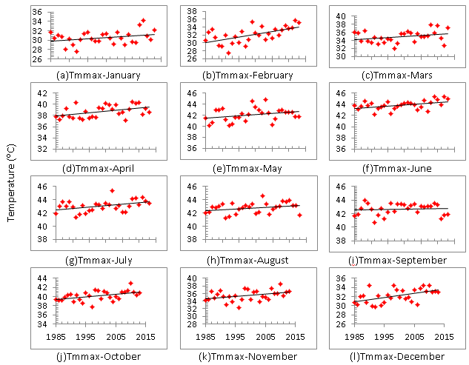
Figure 13: Linear regression trends of monthly mean of daily maximum temperature

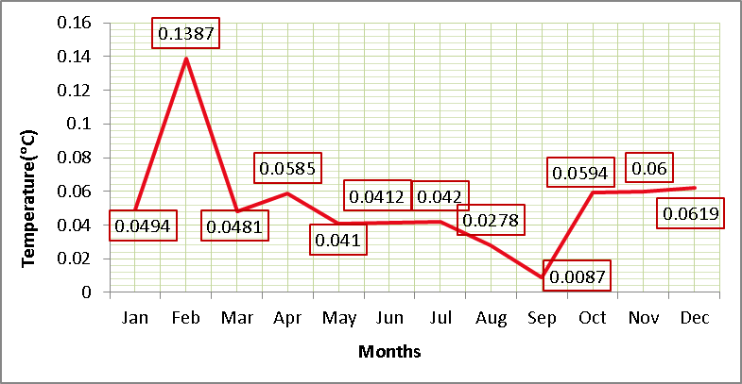
Figure 14: Annual increment in the mean of monthly mean of daily maximum temperature (Tmmax)

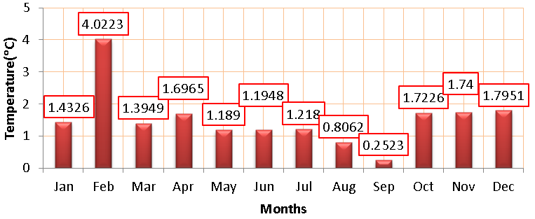
Figure 15:Tmmax total increase in the last 29 years

Table 5: Linear regression equation for all the months (Tmmax)
Month | Regression line | R² | Month | Regression line | R²
Jan | y = 0.0494x - 68.233 | R² = 0.0896 | Jul | y = 0.042x - 40.901 | R² = 0.1612
Feb | y = 0.1387x - 245.2 | R² = 0.3417 | Aug | y = 0.0278x - 12.892 | R² = 0.0875
Mar | y = 0.0481x - 61.32 | R² = 0.0785 | Sep | y = 0.0087x + 25.33 | R² = 0.008
Apr | y = 0.0585x - 78.239 | R² = 0.2091 | Oct | y = 0.0594x - 78.635 | R² = 0.2269
May | y = 0.041x - 39.908 | R² = 0.0841 | Nov | y = 0.06x - 84.39 | R² = 0.1348
Jun | y = 0.0412x - 38.476 | R² = 0.1904 | Dec | y = 0.0619x - 103.38 | R² = 0.3112
Trend analysis of Annual Mean of Daily Maximum Temperatures (Tamax)

As shown in (Figure 16), the annual mean of daily maximum temperature show an increasing trend with an annual rise of 0.0552°C, which implies that over the last 29 years the annual mean of daily maximum temperature of Makkah has increased by 1.6008°C.

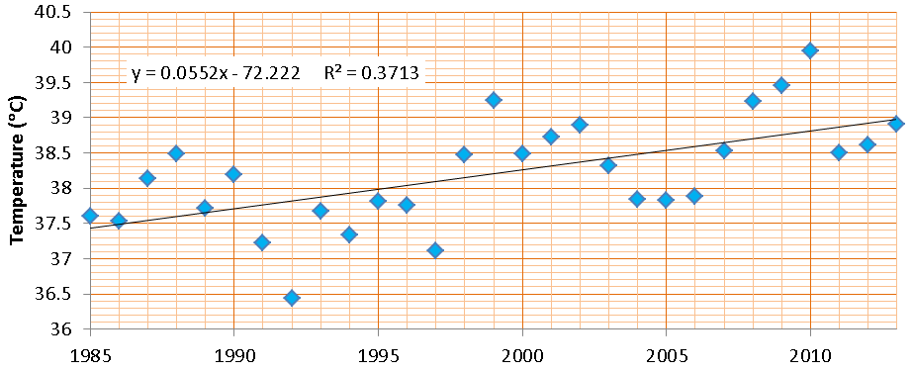
Figure 16: Trend of annual mean of daily mean temperature (Tamax)

(Figure 17) shows that the annual deviation from overall mean temperature show positive trends during the periods, 1985 to 1987 , 1989 to 1997, 2004 to 2006 and negative trends during the periods 1988, 1998 to 2003 and 2007 to 2013.
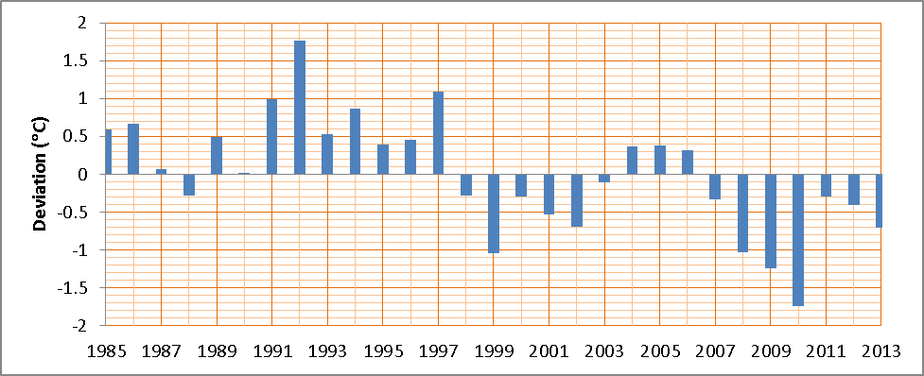
Figure 17: Trend of annual deviation from overall mean (Tamax)
Variation of Daily Minimum Temperature (Tdmin)

The monthly mean temperatures along with the monthly maximum and minimum of daily minimum (Tmmin) values during the period 1985 to 2013 are shown in (Figure 18). The Tmmin varied between a minimum of 18.82°C in January and a maximum of 29.59°C in August. This means that the ration between the hottest to the coldest Tmmin is 1.572. Tmmin is found to be greater than 20°C during the whole year except for January and February.

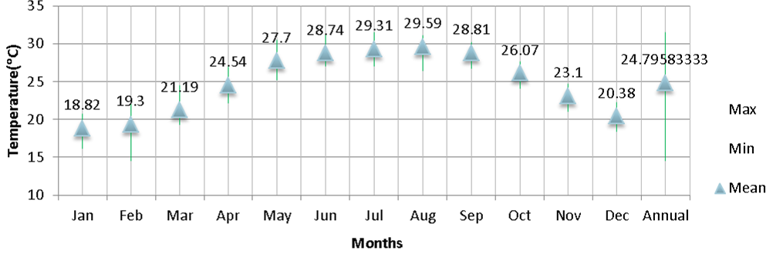
Figure 18: Variation of monthly mean, maximum and minimum temperature of daily minimum values

The monthly maximum of daily minimum temperatures (37°C) was recorded in the 2nd of June 2012 while the monthly minimum of daily minimum temperature (10.6°C) was recorded in the 8th of February 1993 as shown in (Figure 19). This means that the ration of hottest to lowest minimum temperature was 3.49.

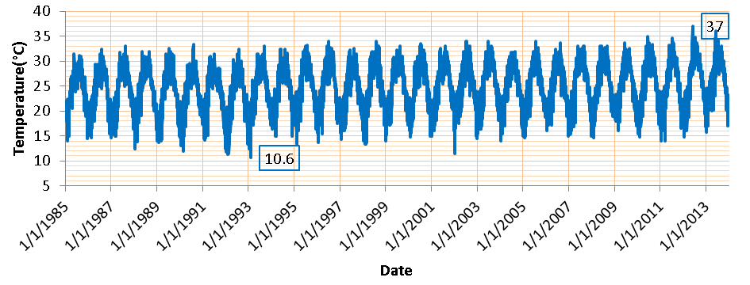
Figure 19: Variability of daily minimum temperature during the period 1985 to 2013

The monthly mean of daily minimum temperature (Tmmin), the corresponding standard deviations from overall mean, the range, and the COV are given in (Table 6). Again higher values of COV and standard deviation were observed for February.
The deviations of monthly mean temperature from overall mean show negative values for all months the highest values observed in January -0.0000586207°C and lowest in July -0.000931034°C.
The maximum range of 7.54 °C was observed for February and minimum of 3.45°C in September.

Table 6: Statistical summary of monthly mean temperature of daily minimum values
Month | Mean ( °C ) | Std. Dev. ( °C ) | Mean Dev. ( °C ) | Range ( °C ) | COV (%)
Jan | 18.82 | 1.118806432 | -5.86207E-05 | 4.6 | 3.891
Feb | 19.31 | 1.819478895 | -5.51724E-05 | 7.54 | 10.437
Mar | 21.19 | 1.156291741 | -0.000344828 | 5.13 | 4.897
Apr | 24.54 | 1.210178609 | -0.000137931 | 4.76 | 5.416
May | 27.71 | 1.162200753 | -0.000655172 | 5.33 | 4.735
Jun | 28.75 | 1.203095351 | -0.000931034 | 4.26 | 8.506
Jul | 29.31 | 1.129394319 | -9.31034E-05 | 4.47 | 7.52
Aug | 29.60 | 1.152320854 | -0.000275862 | 4.71 | 7.347
Sep | 28.82 | 0.824892738 | -0.00062069 | 3.47 | 3.214
Oct | 26.08 | 0.900352695 | -0.000241379 | 3.55 | 5.828
Nov | 23.10 | 0.887764115 | -0.000137931 | 3.62 | 4.667
Dec | 20.38 | 0.944911574 | -0.000103448 | 3.91 | 4.334

Trend analysis of Monthly Mean of Daily Minimum Temperatures (Tmmin)
The linear regression trends of monthly mean of daily minimum temperatures from January to December are shown in (Figure 20) (a to I), the corresponding best fit equations in (Table 7). The increasing trends in the values of Tmmin were observed in all months of the year with an annual increase (Figure 21), 0.0556°C, 0.1491°C, 0.07°C, 0.0774°C, 0.0677°C, 0.1215°C, 0.1075°C, 0.105°C, 0.0459°C, 0.0833°C, 0.0667°C and 0.0619°C for January to December respectively. This implies that in Makkah the Tmmin has increased during the last 27 years with 1.6124°C, 4.3239°C, 2.03°C, 2.2446°C, 1.9633°C, 3.5235°C, 3.1175°C, 3.045°C, 1.3311°C, 2.4157°C, 1.9343°C and 1.7951°C (Figure 22), for January to December respectively.

Trend analysis of Annual Mean of Daily Minimum Temperatures (Tamin)
The annual mean of daily minimum temperature, as shown in (Figure 23), showed significant increasing trend with an annual rise of 0.0398°C which implies that over the last 29 years the annual mean of daily minimum temperature of Makkah has increased by 1.1542°C. As shown in (Figure 24) the annual deviations from overall mean temperature show positive trends during the periods 1985 to 1986, 1989 to 1994, 1997, 2004 to 2005 and 2011 and then negative trends for the periods 1988, 1999 to 2003, 2006 to 2013.
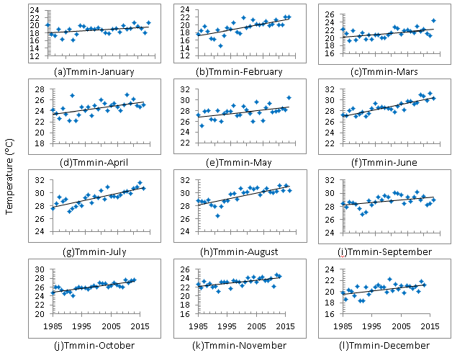
Figure 20: Linear regression trends of monthly mean of daily minimum temperature

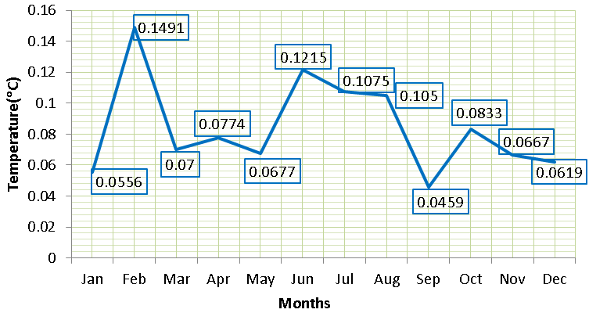
Figure 21: Annual increment in the monthly mean of daily minimum temperature (Tmmin)

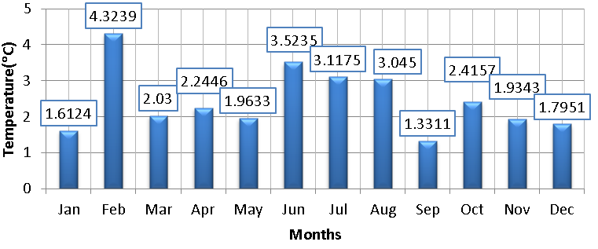
Figure 22: Tmmin total increase in the last 29 years

Table 7: Linear regression equation for all the months (Tmmin)
Month | Regression line | R² | Month | Regression line | R²
Jan | y = 0.0556x - 92.294 | R² = 0.179 | Jul | y = 0.1075x - 185.59 | R² = 0.6569
Feb | y = 0.1491x - 278.75 | R² = 0.4869 | Aug | y = 0.105x - 180.21 | R² = 0.6015
Mar | y = 0.07x - 118.65 | R² = 0.2654 | Sep | y = 0.0459x - 62.958 | R² = 0.2246
Apr | y = 0.0774x - 130.12 | R² = 0.2963 | Oct | y = 0.0833x - 140.36 | R² = 0.62
May | y = 0.0677x - 107.52 | R² = 0.2456 | Nov | y = 0.0667x - 110.18 | R² = 0.4089
Jun | y = 0.1215x - 214.17 | R² = 0.7396 | Dec | y = 0.0619x - 103.38 | R² = 0.3112

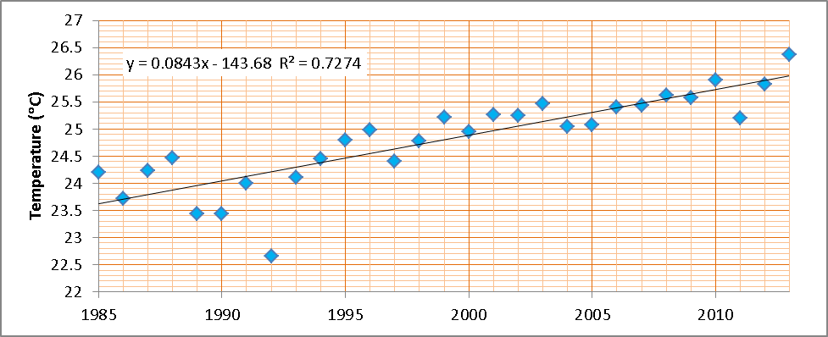
Figure 23:Trend of annual mean of daily maximum temperature (Tamin)

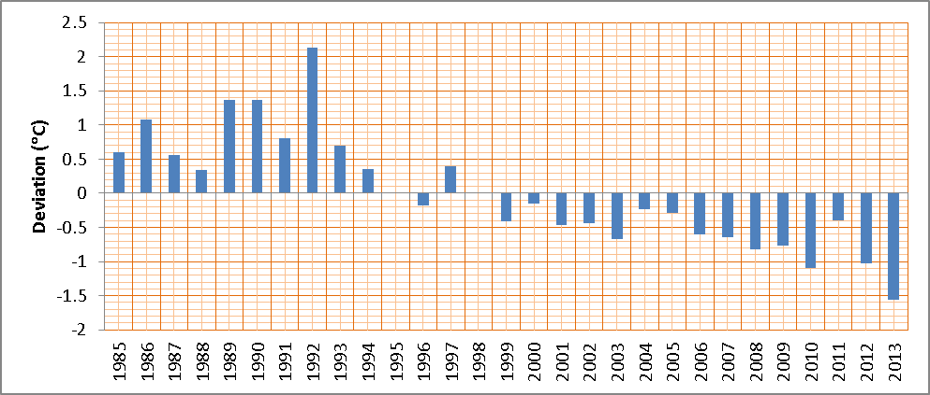
Figure 24: Trend of annual deviation from overall mean (Tamin)

Conclusion
The main findings of this study could be summarized in the following points:
The number of hot days/nights increased annually by 1.5966/1.832 days and the during the period 1985 to 2013 and during the last 29 years the hot days/nights have increased by 45.30/53.128 days
The number of cold nights decreased annually by 0.4054 which implies that the number of clod nights were decreased with 11.7566 days during the last 29 years where the number of cold days disappeared.
The regression trend analysis of monthly mean temperatures Tmmean, Tmmax and Tmmin showed worming in Makkah and the covariance values indicated stable temperature patterns.
The Tmmean minimum mean temperature of 23.98°C was found in January while a maximum mean temperature of 35.95°C in July
The monthly mean of daily mean temperature have increased during the whole months and the annual increases
Tmmean increased by 3.3205°C, 1.3862°C, 1.2673°C, 1.2441°C, 1.1165°C, 1.073°C during the last 29 years
The trend of the annual mean of daily mean temperature increasing with 0.0398°C per year, which implies that over the last 29 years the annual mean temperature of Makkah has increased by 1.1542°C
The maximum value of Tmmax of 43.88°C was found in June while a minimum of 30.54°C in January.
The number of days of recoded temperatures exceeds 44°C increased 0.0002 day annually during the period.
The monthly mean of daily maximum temperature have increased with 1.4326°C, 4.0223°C, 1.3949°C, 1.6965°C, 1.189°C, 1.1948°C, 1.218°C, 0.8062°C, 0.2523°C, 1.7226°C, 1.74°C and 1.7951°C during the last 29 years
The annual mean of daily maximum temperature show an increasing trend with an annual rise of 0.0552°C, which implies that over the last 29 years the annual mean of daily maximum temperature of Makkah has increased by 1.6008°C.
The Tmmin varied between a minimum of 18.82°C in January and a maximum of 29.59°C in August.
The monthly maximum of daily minimum temperatures (37°C) was recorded in the 2nd of June 2012 while the monthly minimum of daily minimum temperature (10.6°C) was recorded in the 8th of February 1993
The Tmmin has increased during the last 27 years with 1.6124°C, 4.3239°C, 2.03°C, 2.2446°C, 1.9633°C, 3.5235°C, 3.1175°C, 3.045°C, 1.3311°C, 2.4157°C, 1.9343°C and 1.7951°C,
Acknowledgments

The author acknowledges very much the International Center for Theoretical Physics (ICTP), Associate Program, for providing the facilities needed for performing this study. Thanks should be expressed to the Presidency of Meteorology and Environment in Saudi Arabia for providing the observation dataset. Also, the author would like to acknowledge Prof. Dr. A. H. Asghar (the dean of the Custodian of the Two Holy Mosques' Institutes for Haj and Umrah Research), Dr. Turki Habeebullah (the head of the Environment and Health Researches Department) for their support and encouragement.

Biblography
1. IPCC, Climate Change 2007: The Physical Science Basis, In: S. Solomon, D. Qin, M. Manning, Z. Chen, M. Marquis, K. B. Averyt, M. Tignor and H. L. Miller, Eds., Contribution of Working Group I to the Fourth Assess- ment Report of the Intergovernmental Panel on Climate Change (IPCC). 2007: Cambridge University Press, Cambridge, 2007.
2. IPCC, Climate Change 2007: Synthesis Report, In: R. K. Pachauri and A. Reisinger, Eds., Contribution of Working Groups I, II and III to the Fourth Assessment Report of the Intergovernmental Panel on Climate Change (IPCC), . 2007: Cambridge University Press, Cambridge, 2007.
3. IPCC, Climate Change 2007: Mitigation of Climate Change,In: B. Metz, O. R. Davidson, P. R. Bosch, R. Dave and L. A. Meyer, Eds., Contribution of Working Group III to the Fourth Assessment Report of the Inter-governmental Panel on Climate Change (IPCC), , . 2007: Cam-bridge University Press, Cambridge.
4. IPCC, Climate Change 2007: Impacts, Adaptation and Vulnerability, In: M. L. Parry, O. F. Canziani, J. P. Palutikof, P. J. van der Linden and C. E. Hanson, Eds., Contribution of Working Group II to the Fourth Assess- ment Report of the Intergovernmental Panel on Climate Change (IPCC), . 2007: Cambridge University Press, Cambridge, 2007.
5. Brohan, P., et al., Uncertainty estimates in regional and global observed temperature changes: A new data set from 1850. Journal of Geophysical Research: Atmospheres, 2006. 111(D12): p. D12106.
6. Jones, P.D. and A. Moberg, Hemispheric and Large-Scale Surface Air Temperature Variations: An Extensive Revision and an Update to 2001. Journal of Climate, 2003. 16(2): p. 206-223.
7. Soon, W., et al., Variations of solar coronal hole area and terrestrial lower tropospheric air temperature from 1979 to mid-1998: astronomical forcings of change in earth's climate? New Astronomy, 2000. 4(8): p. 563-579.
8. Vinnikov, K.Y. and N.C. Grody, Global Warming Trend of Mean Tropospheric Temperature Observed by Satellites. Science, 2003. 302(5643): p. 269-272.
9. Aesawy, A.M. and H.M. Hasanean, Annual and Seasonal Climatic Analysis of Surface Air Temperature Variations at Six Southern Mediterranean Stations. Theoretical and Applied Climatology, 1998. 61(1-2): p. 55-68.
10. LU, M.K.K., Trends in Surface Air Temperature Data over Turkey. International J. of Climatology, 1997. 17: p. 511–520
11. Smadi, M., Observed abrupt changes in minimum and maximum temperatures in Jordan in the 20th century. Am. J. Environ. Sci., 2006. 2(3): p. 114-120.
12. Al-Fahed, S., O. Al-Hawaj, and W. Chakroun, The recent air temperature rise in Kuwait. Renewable Energy, 1997. 12(1): p. 83-90.
13. ElNesr, M.N., M.M. Abu-Zreig, and Abdurrahman A. Alazba, Temperature Trends and Distribution in the Arabian Peninsula. American Journal of Environmental Sciences, 2010. 6(2): p. 191-203.
14. Nasrallah, H. and R. Balling, Jr., Impact of desertification on temperature trends in the Middle East. Environmental Monitoring and Assessment, 1995. 37(1-3): p. 265-271.
15. H. Hasanean and A. AL-Khalaf, Variability of Wintertime Surface Air Temperature over the Kingdom of Saudi Arabia. Atmospheric and Climate Sciences, 2012. 2 No.3: p. 307-321.
16. S. Rehman and L. Al-Hadhrami, Extreme Temperature Trends on the Weast Coast of Saudi Arabi. Atmospheric and Climate Science, 2012. 2 No. 3: p. 351-361.
17. Almazroui, M., et al., Detecting climate change signals in Saudi Arabia using mean annual surface air temperatures. Theoretical and Applied Climatology, 2013. 113(3-4): p. 585-598.
18. Mimish, L., Electrocardiographic findings in heat stroke and exhaustion: A study on Makkah pilgrims. Journal of the Saudi Heart Association, 2012. 24(1): p. 35-39.
19. KHOGALI, M., Epidemiology of Heat Illnesses During the Makkah Pilgrimages in Saudi Arabia. International Journal of Epidemiology, 1983. 12(3): p. 267-273.
20. C, P., Heatwave. Weatherwise, 1980. 33: p. 112-116.
21. Mearns, L.O., R.W. Katz, and S.H. Schneider, Extreme High-Temperature Events: Changes in their probabilities with Changes in Mean Temperature. Journal of Climate and Applied Meteorology, 1984. 23(12): p. 1601-1613.
22. Arabia. In Encyclopedia Britannica. From Encyclopedia Britannica, 2009; Available from: http://www.britannica.com/EBchecked/topic/31551/Arabia.
23. Abderrahman, W.A. and I.M. Al-Harazin, Assessment of climate change on water resources in the Kingdom of Saudi Arabia. Proceeding of the GCC Environment and Sustainable development Symposium, Jan. 28-30, Dhahran, Saudi Arabia, Section D-1, 2008: p. 1-13.
24. CityPopulation. Saudi Arabia. http://www.citypopulation.de/SaudiArabia.html 2013.
25. City, K.E., A study on the risks associated with the concurrently with the next pilgrimage seasons summers and propose aternatives to deal with. 2014, Knowlage Economic City. p. 88.
26. Smoyer-Tomic, K.E., and Rainham, D.G.C. Beating the heat: Development and evaluation of a Canadian hot weather-health response plan. Environmental Health Perspectives, 2001. 109: p. 1241-48.
27. Kalkstein, L.S. and K.E. Smoyer, The impact of climate change on human health: some international implications. Experientia 1993; 49: 969-79., 1993. 49: p. 969-979.

