Gigapixel Images: Towards a Novel Social Network for Hajj and Umrah
Diyaa Atiya, Rami AlMwari, Nasser AlBiqami
Custodian of the Two Holy Mosques Institute for Research of Hajj and Umrah

Abstract
Researchers from different scientific and social fields take the opportunity of Hajj and Umrah season to collect detailed information from pilgrims on the various aspects of their journeys and activities. The data collected, and the information processes, are then used to develop more detailed pictures on the strength, weaknesses, opportunities, and threats facing the organization of the Hajj season, be it on the year under investigation or for the following years. However, such research activities are severely constraint by the time limit; after all Hajj occurs only once a year, and for only a handful of days. In this paper, we propose the use of Giga Pixel technology as a means for potentially solving the "time limitation" problem and providing researchers with a medium of information they can process all year long. Also, we envisage that giga pixel images could be used as the core foundation of a new social network site where pilgrims exchange information about their experiences in Hajj and Umrah, thus providing researchers with unlimited supply of data. We have already conducted a pilot study that showed promising signs for this project, and we here report on that experience highlighting the benefits recorded and the challenges identified.

What is Gigapixel Imaging?

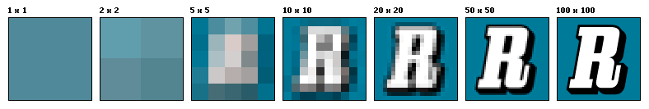
The term resolution refers to the capability of a sensor to observe or measure the smallest object clearly with distinct boundaries, and thus the resolution of an image is an indicator of the amount of details that image hold. In digital imaging, pixel count is used to describe the resolution of an image; the higher the pixel count, the higher the resolution of an image and the more details that image holds. By way of illustration, below is an example of how the same image might appear at different pixel resolutions; at a resolution of 2 pixels (=1×1), the image has hardly any details, but at a resolution of 10K pixels (=100×100), the image is quite vivid.
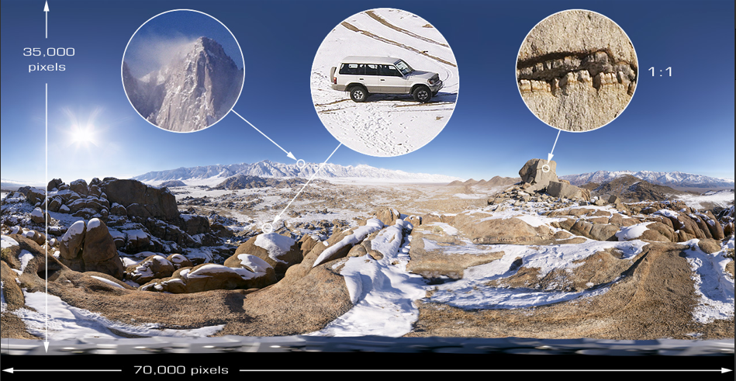
Typically, normal digital cameras will take pictures with resolutions up to megabytes of pixels; i.e. millions of pixels per image. This allows for considerable amount of details in a digital image, but what if we can take pictures with resolutions in the realms of billions of pixels per image? That is what is called a Gigapixel image. For example, compared to a digital camera typically capturing a 10 million pixels image, the following is an illustration of a 2.6 billion pixels big, i.e. 260 times larger than the picture one would shoot staying at the same Sierra Nevada vantage point. Translated into the physical world, obtaining such resolution (i.e. being able to see the white Jeep) would require a 25 meters wide image. In layman’s terms, gigapixel images allows you to capture more details in an image in unprecedented fashion.

How does it Work?

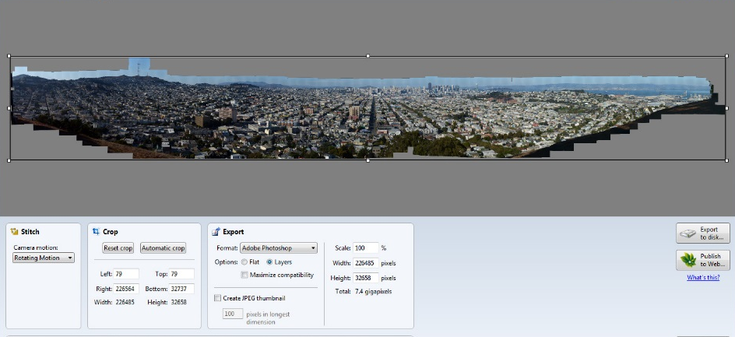
Surprisingly, to produce a gigapixel image one can use almost any consumer (compact point-and-shoot) camera, though DSLR cameras are recommended for better results. To s hoot wide-areas and long-distances, cameras –like in normal digital photography – can be supported with high lenses. The only difference between normal digital photography and gigapixel imaging is that in the latter case the camera is mounted to a special robot-motor which zigzags the camera across the target scene, capturing individual photos of smaller sections of that scene as it moves along. These individual images can then be stitched together, using a specialized software, to reconstruct the whole scene as one whole composite of a large photo sequence; same as in a puzzle.

The Importance of Gigapixel Imaging?

On commercial fronts, probably the most obvious use of gigapixel images is media. From London and Paris through Beirut and Dubai to Shanghai and Tokyo, various major cities around the world are recognizing the importance of gigapixel imaging and are keen to have 360-degree gigapixel images uploaded on the web, even competing on producing the world larges images in that domain. Major international events are now documented using this technology, the London Olymbics of 2012 and President Obama inauguration speech in 2009 are notable examples.

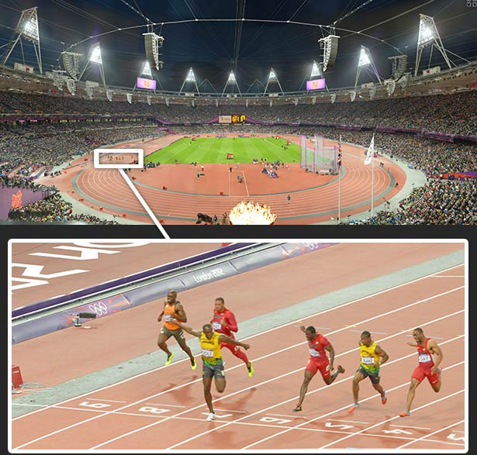 | 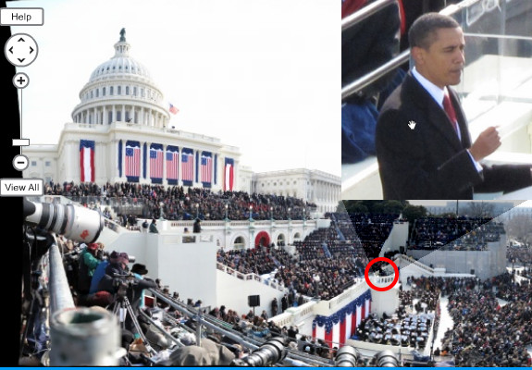
On the Research & Development fronts, perhaps the most obvious uses are in the defense and security arenas, where such capabilities of digital imaging allow for easy surveillance of large areas. Evidently, an ongoing research on producing the world’s first gigapixel camera is supported by the Defense Advanced Research Projects Agency in the USA [‎2].

Between Commerce and R&D, gigapixel imaging offers so many opportunities for other applications and scientific uses. In its June 2012 edition, for instance, the journal of Nature provides an example from an observation of swans in North Carolina’s Pocosin Lakes National Wildlife Refuge Area. A single gigapixel image of the lake allows researchers to count the exact number of swans at one time across an extremely wide area, something that would be technically impossible without such a powerful technology. On the Web front, gigapixel imaging revolutionize the concepts of Interface and Content Navigation. With gigapixel imaging, the browsing experience of users will be transformed from the linear-fashion of navigation through hyperlinks to the nonlinear fashion of zooming-in to the information we want [‎3] – exactly as one would do when flipping through the pages of a publication in a random and non-sequential fashion, which arguably may be the best way to graze information quickly and effectively.

In a nutshell, albeit quite simple a concept, gigapixel imaging essentially shifts the whole paradigm of digital photography from “where to point your camera?” to “which data you want to mine out of your image, and how?” as images now become a repertoire of knowledge rather than just a mere photograph.

How Could Gigapixel Imaging Serve Hajj And Umrah Research?

With its ability to capture gigabytes of information in a single image, gigapixel photography can help in Hajj and Umrah research in so many ways than one. For example, the documentation of, say, day of Arafat (وقفة عرفات) no longer needs to be done in a mix of fragmented picture shots, together with narration or written articles. Instead, a single gigapixel image covering the area of Arafat can be taken and saved for future reference, where users and/or researchers can navigate and inspect the slightest of details of that day; it becomes like freezing that moment of time in a single file. Also, like the above example of counting swans in North Carolina’s Pocosin Lakes National Wildlife Refuge Area, gigapixel images can be used for counting pilgrims, in various parts of Mecca and during various times of Hajj and Umrah season. This could have crucial benefit for planning purposes and/or crowd management and traffic control. Indeed, gigapixel images could also be used for traffic monitoring on the roads of, or leading to, Mecca. They can also be used for security monitoring, archeological monitoring, and disaster/crisis management. Perhapse the most important part of using gigapixel technology is overcoming the time constraints for Research during the Hajj and Umrah season. Instead of being limited to the, say, 10 days of Hajj, researchers now can use gigapixel images as a source of data they can refer back to again and again all-time long. Of all the potential applications of gigapixel technology in Hajj and Umrah, we are particularly interested in Social Media. To be precise, we propose using gigapixel images taken in Hajj and Umrah as a base for a novel social media platform, with the key word here being platform.

There is a subtle, yet very significant difference between a Website and a Web Platform. Stripping them to the bones, many websites are just digital brochures: here are the latest events, here is the map, here is the contact information, etc. The ultimate objective of a website is participation from audiences; buying a product, reading a news article, viewing a picture, etc. Platforms, by contrast, focus on collaboration from the community. In platforms, your content is incrementally enriched by participation from your users, e.g. in wiki collaborative editing. Also, your community is not just your visitors or users. Rather the community extends to application developers who use your open API (Application Program Interface) to provide more value added services, like what Facebook game developers do for Facebook users, for instance. Operating from a platform, radically and vastly increases the organization’s activity and online presence. Google operates from a platform; Facebook operates from a platform; Local Smile operates from a Platform; even Hi5, after losing the social network battle to Facebook, has repositioned itself as a platform for social gaming.

We see a great opportunity for developing a Social Network Platform, based on hosting gigapixel images Hajj photos and allowing visitors to tag people and share their own photos and experience during Hajj and Umrah activites. There so many reasons this idea could be successful.
- The idea is Novel: To our best knowledge, there is no such platform so far, though the need does exist as many people would like to share their experiences in Hajj with family and friends, and many more people would like to know firsthand information about what to expect in their Hajj journey and benefit from those who preceded them.
- The idea is Viable: The key factor to success of any social network site is to find that "killer reason" that convince users to come to your site in the first place. We believe we found that need in the form of Giga Pixel images that captures the moments and places of Hajj with unprecedented levels of details. Thus the site will attract previous pilgrims who would like to see themselves in the presence of holy places and in those unique moments of time that no individual pilgrim has the time or tools to capture while doing his religious rites. They will be able to relive the moments, identify themselves out of the crowd to their family and relatives, tag their friends and those who shared the trip with, etc.
- The idea is Sustainable: You can keep people coming back and encourage them to engage and upload their photos, stories, etc. Also, adopting the platform approach, you can open the door for applications and games that provide value added services to the visitors and the site itself. For example, an application may acquire photos of a certain place uploaded from different users, and use all these photos to generate 3D models Microsoft already applies that idea in Photosynth [‎7]. Now such an application will be useful for users as they can recall their experiences in 3D, not just 2D. Another application could use mobile GPS technology to provide location-based and time-stamped journals of pilgrims’ journey. The possibilities are endless.
- The idea is Scalable: The same above ideas we discussed for photos and applications based on Hajj Locations are also applicable for national and high profile events and locations all over the KSA, e.g. national festivals, national conferences, tourist destinations, etc. We can, for example, start "Know your Country" program where we can take Giga Pixel images from all around KSA, preferably pictures related to academic material in school History and Geography books. This way students and teachers will have a reason to go and play around with pictures, share them, add their own pictures of these locations, etc. Thus, we could potentially grow from documenting not only the history of Hajj but the history of KSA as a whole.

The benefit of the proposed social network to Hajj and Umrah research is manifold. It will act as a data bank and an encyclopedia of Hajj, tracing and documenting the time/process/activities of Hajj and Umrah over time, by acting as a central archiving and sharing hub for Hajj images. Also, with potentially millions of pilgrims viewing or adding their photographs and exchanging information and experiences of Hajj, researchers will now have an unprecedented recourse for data on pilgrims opinions and sentiment regarding their Hajj experience, things they liked, problems they faces, solutions they propose, etc. Also, researchers will have a center point they can go back to for conducting surveys and communicating with pilgrims all years long, and through very cost effective means. Finally, the social network will contribute to raising public awareness of the Hajj, and proactively guiding pilgrims on what to do, expect, or avoid during their visit to the Kingdom.

Pilot Cases and Lessons Learnt

To provide a proof-of-concept for the use of gigapixel technology in documenting Hajj and Umrah we carried three pilot project where we have taken gigapixel images for:
- The night of the 28th of Ramadan in 2013 (1434 Hijri)
- The day of Arafat in Hajj of 1434H
- The day of Mina in Hajj of 1434H
In all the three pilot projects we used the following equipment for shooting our gigapixel images:
- Canon EOS 5D Mark III 22.3 MP, Full HD video, SLR Camera, with EF 24-105mm f/4 L IS USM Lens
- Canon EF 600mm f/4 L IS II USM Lens
- RODEON VR Station Heavy Duty
- SAMSUNG Ultrabook, series 9, i5, 1.7GHz, 4GB RAM, 128GB HD, 13.3 inch screen
We also used the following equipment for stitching the individual images into the final result of the whole composite one:
- RODEON Preview version 2.0
- PTGUi Software version 9.1.9

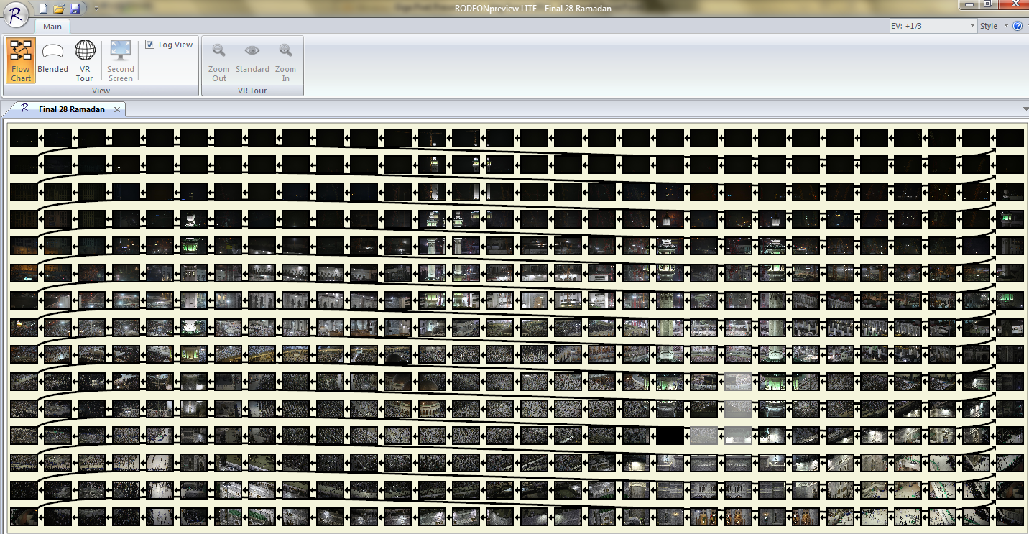
The pictures below illustrate the results of photo shooting in the night of 28th of Ramadan. The project involved the shooting of 1350 pictures (450 images, with three levels of exposures for each on), and resulted on an overall image of 26 gigapixels. We also developed a dedicated website [‎6] where we upload the gigapixel images for interactive navigation online.

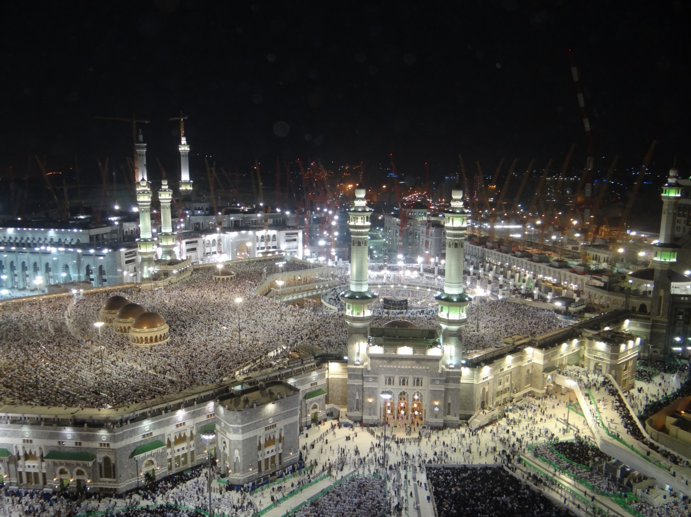
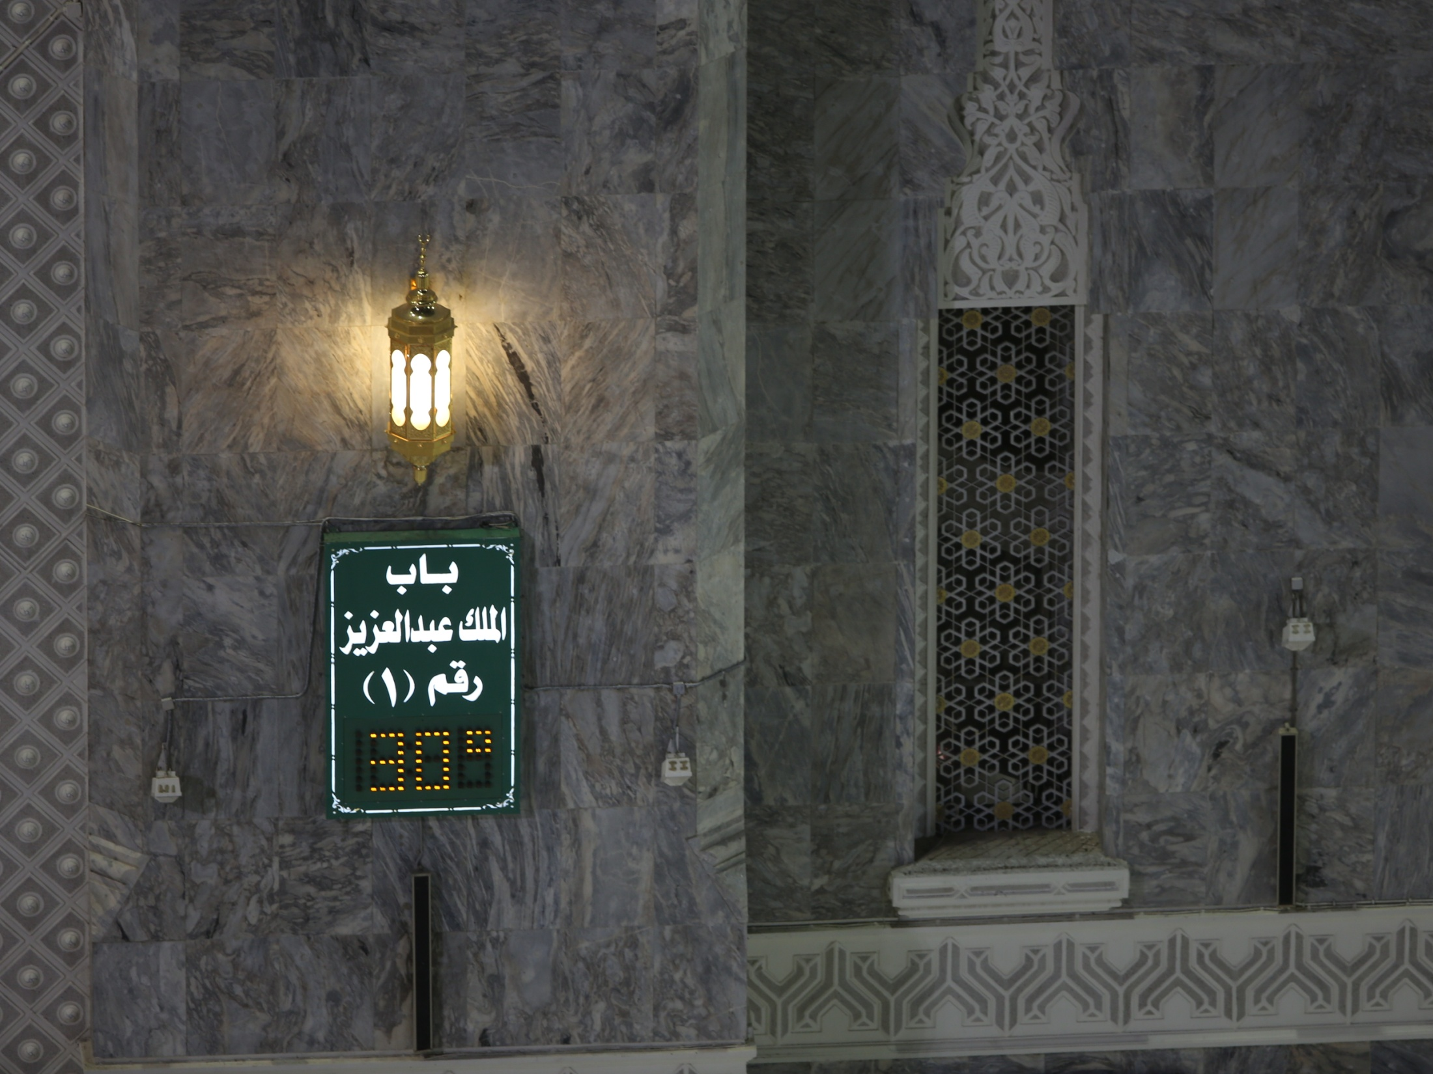

Throughout the three projects we got very encouraging results, and the experiments confirmed all the possible applications of gigapixel images that we referred to above. Even more, we realized there could be other applications for gigapixel imagines in the daily maintenance and operational of the Holy Mosque, as the images could reveal spots that needs attention of maintenance operation, e.g. a broken lamp, a tired area that needs attention, etc.

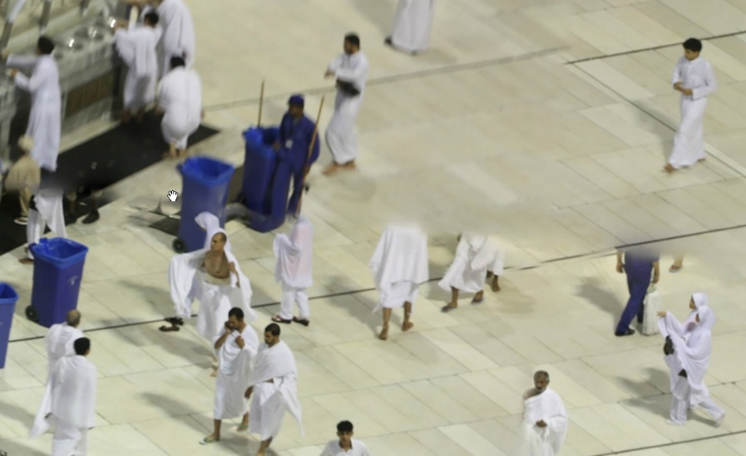
On the negative side, we had problems with the battery of the Robot and/or Camera running out of charge quite quickly and ruining some sessions. We also, had problems with the computing power of the laptop machine we used, compared to the intensive computing power required to process and generate the gigapixel images. Indeed, none of the final gigapixel images for the three projects could be generated using the laptop we used. Instead we had to revert to a dual-processor desktop machine to produce the final images. Finally, and perhaps most importantly, we had great difficulty in shooting scenes with a lot of movement therein. This has resulted in the so called ghosting problems in the final stitched image, see the picture. While this problem could be overcome using the masking feature of the PTGui software we used, where we can trace the stitches and use the original individual images to mask out any anomalies of the stitches process, this would typically consume an inconveniently large amount of time and effort. So, we believe the gigapixel images would be more suited for scenes where you can guarantee a minimum degree of movements within that scene. Also, in order to take that project to a larger scale, we would typically need some for of cluster computing or cloud computing environment.

References

- J. Bardin. New Gigapixel Camera may Revolutionize Photography, Surveillance. Los Angeles Times, 20 June 2012.
- DJ Brady, ME Gehm, RA Stack, DL Marks, DS Kittle, DR Golish, EM Vera, and SD Feller. Multiscale Gigapixel Photography. Nature, 486(7403):386-9, June 2012.
- F. Filloux. The Future of Content Navigation. The Monday Note, 8 March 2010. (http://www.mondaynote.com/2010/03/07/the-future-of-content-navigation/)
- www.gigapan.com
- www.gigapixel.com
- www.makkah360.com
- http://photosynth.net/

For sake of conciseness, we skipped over all the details involved in the shooting and stitching of the gigpixel imaging, e.g. calibrating the field of view of the camera/lens, correcting for light and exposure, graphic editing finale image for errors in the stitching process, etc. Interested readers could refer to www.gigapan.com and www.gigapixel.com for more details.
In fact President Obama inauguration speech is the most popular photo hosted on www.gigapan.com, viewed more than 15,163,303 times when this was written.

