The impact of importation of live ruminants on the epizootiology of Foot and Mouth Disease (FMD) in Saudi Arabia
Abd El-Rahim I.H.A.^{(1)*}, Asghar A.H.⁽¹⁾, Mohamed A.M. ⁽²⁾, Fat'hi S.M.⁽³⁾
(1) Department of Environmental & Health Research, the Custodian of the Two Holly Mosques Institute for Hajj & Umrah Research, Umm Al-Qura University, P.O. 6287, 21955 Makkah Al-Mukaramah, Saudi Arabia
(2) Department of Laboratory Medicine, Faculty of Applied Medical Sciences, Umm Al-Qura University, Saudi Arabia, 7607.
(3) Department of Veterinary Medicine, College of Agriculture and veterinary Medicine, Qassem University, Qassem, Saudi Arabia.

* Correspondence I.H.A Abd El-Rahim, (email:vetrahim@yahoo.com)
Summary
Millions of live ruminants are imported annually for slaughter in Saudi Arabia. The majority of these animals are imported shortly before the pilgrimage season from Sudan and horn of Africa, where Foot and Mouth Disease (FMD) is known to be enzootic. The current work intended to investigate the impact of importation of these live ruminants on the epizootiology of FMD in Saudi Arabia. A total of 480 sheep and 233 cattle from the sacrifice livestock yards of the Saudi project for utilization of Scarified animals’ meat in the Holy city of Makkah were investigated during the Pilgrimage season 1433 H (24-29 October, 2012). Investigated sheep were showing no apparent clinical evidence of FMD and included 260 from Sawakani breed (imported from Sudan) and 220 from Barbari breed (imported from horn of Africa) that were randomly selected from different houses of the yard. On the other hand, all investigated cattle were of African origin and included 58 cattle with suspected clinical evidence of FMD and 175 cattle without apparent symptoms that were selected from the contact animals of the suspected ones. Blood samples were collected from all investigated animals and separated sera were used for serological testing for FMD virus-specific antibodies using indirect enzyme linked immune sorbent assay (3ABC FMD ELISA). The results revealed an over all of 136 (28.3%) animals out of the 480 tested sheep were serologically positive for FMD. This included 17.7% among Sawakani sheep and 40.9% among Barbari ones. In cattle, 120 (51.5%) out of 233 investigated animals were positive for FMD virus antibodies. The 120 serologically positive cattle included all suspected cattle with apparent clinical symptoms and 62 (35.4%) of symptoms free-contact cattle. In conclusion, the findings of the current study denote the imminent risk of the annual importation of live ruminants from enzootic areas shortly before the Pilgrimage seasons. The risk involves the introduction of new exotic FMDV serotypes especially with the imported carrier or subclinically-infected animals. Understanding of the epidemiology of different strains and ability to track their move between geographic regions is essential for the development of efficient control strategies for the disease. Therefore, genotyping of isolated FMDV strains from imported and local animals is highly recommended and currently ongoing.
Keywords: Epidemiology - Foot and mouth disease (FMD) - Pilgrimage season - Serodiagnosis.
الملخص العربي:
تستورد المملكة العربية السعودية ملايين من مختلف أنواع الحيوانات المجترة من الأغنام والماعز والأبقار على مدار العام لاسيما قبل كل موسم حج لمواكبة الأعداد المتزايدة من حجاج بيت الله الحرام، حيث يتم الإستبراد من مناطق مختلفة تمثل دول عديدة البعض منها يعاني من توطن مرض الحمى القلاعية مثل السودان ودول القرن الأفريقي. لذا يهدف هذه البحث إلي دراسة تأثير استيراد المجترات الحية على وبائية مرض الحمى القلاعية بالمملكة العربية السعودية خلال موسم حج 1433هـ. وقد تم فحص 480 رأس من الأغنام، و 233 رأس من الأبقار بحظائر الأنعام الخاصة بمشروع المملكة العربية السعودية للإفادة من الهدي والأضاحي في مكة المكرمة خلال موسم حج 1433 هـ. وتبين عدم وجود أعراض مرضية (سريرية) واضحة لمرض الحمى القلاعية على الأغنام التي تم فحصها وكانت 260 من سلالة السواكني (المستوردة من السودان) و220 من سلالة البربري ( المستوردة من القرن الأفريقي). من ناحية أخرى، كانت جميع الأبقار التي تم فحصها أفريقية المنشأ وكان 58 رأس منها مشتبه بإصابتها بمرض الحمى القلاعية وتظهر عليها الأعراض السريرية للمرض بينما 175 رأس منها لم يلاحظ أعراض ظاهرة للمرض عليها. وتم جمع عينات الدم من جميع الحيوانات تحت الدراسة وتم فصل المصل الدموي منها للفحص السيرولوجي للكشف عن الأجسام المضادة لفيروس الحمى القلاعية باستخدام اختبار الاليزا الغير المباشرة. وكشفت النتائج أن أجمالي 136 (28.3 ٪) من 480 من الأغنام التي تم اختبارها كانت ايجابية مصليا لمرض الحمى القلاعية وكان منها 17.7 ٪ من أغنام السواكني، 40.9 ٪ من أغنام البربري . أما في الماشية كان 120 (51.5 ٪) من أصل 233 من الحيوانات التي تم اختبارها كانت إيجابية للأجسام المضادة لفيروس مرض الحمى القلاعية وكان منها 58 رأس تظهر عليها الأعراض السريرية للمرض، 62 (35.4 ٪) من الأبقار المخالطة والتي لم تظهر عليها الأعراض السريرية للمرض. وخلصت نتائج الدراسة الحالية أن استيراد الحيوانات المجترة الحية من مناطق يتوطن بها مرض الحمى القلاعية بصفة سنوية قبل مواسم الحج يمثل خطر وشيك حيث قد يؤدي إلى ادخال أنماط أو عترات مصلية جديدة من فيروس الحمى القلاعية خصوصاً مع الحيوانات الحامله للفيروس أو تلك التي تعاني من إصابة دون ظهور أعراض سريرية عليها. وأن فهم وبائية العترات المتنوعة للفيروس ودراسة وتتبع القدرة على انتقالها بين المناطق الجغرافية أمر ضروري من أجل وضع وتطوير استراتيجيات فعالة لمكافحة للمرض. لذلك فان هذا البحث ينصح بدراسة التنميط الجيني لعترات فيروس الحمى القلاعية المعزولة من الحيوانات المستوردة والمحلية.
Introduction
Economic importance and trade effect
Foot-and-mouth disease (FMD) is one of the most economically important veterinary pathogen due to its highly infectious nature, ability to cause persistent infections and long term effects on the condition and productivity of the many animal species. Recent outbreaks of FMDV demonstrated that this highly contagious viral infection of cloven hoofed animals continues to be a significant economic problem worldwide (21). Different FMDV strains were genetically grouped based on their geographic origin and thus being referred to as topotypes. An increased understanding of how FMDV strains move between geographic regions will play a pivotal role in the development of future disease control strategies (37).
FMD is highly contagious, being transmitted through multiple routes and hosts, which makes it one of the most important diseases affecting trade in livestock (14). International trade in animals and their products has been recognized as a primary determinant of the global epidemiology of transboundary diseases such as FMD. Recent dissemination of FMD virus in Europe shows that sub-clinically infected animals render trade in animals or animal products a potential risk for importing countries (54). FMD virus undoubtedly entered the UK in 2001 in illegally imported meat products, probably from south-east Asia. Some of this meat was infected with a strain of the Pan Asia serotype O topotype, which was prevalent in Asia (34).
The explosive FMD pandemic (PanAsia strain of FMDV serotype O), which occurred in Asia and extended to parts of Africa and Europe from 1998 to 2001, demonstrates the ability of newly emerging FMDV strains to spread rapidly throughout a wide region and invade countries previously free from the disease (38). FMD outbreaks in Argentina, Europe, Japan, the Republic of Korea, South Africa and Uruguay have brought to world attention the devastating effects of the disease in a naïve population and the social and economic costs of control and eradication (32). Losses of FMD arise from the direct effects of the disease on production, costs of disease control and restriction of trade. Costs of disease control, whether by stamping-out or vaccination are high (27). The economic costs of the FMD outbreak in the United Kingdom (UK) in 2001 were estimated by (56), where the losses to agriculture and the food chain amount to about £3.1 billion.
FMD in Africa
Six of the seven serotypes of FMD virus (i.e. all but Asia 1) are prevalent in Africa; however marked difference in regional distribution is evident. Three of these serotypes are unique to Africa, namely the three South African Territories (SAT) serotypes. Serotype C may also now be confined to Africa because it has not been reported elsewhere recently. Within each of the six prevalent serotypes, with the possible exception of C, there are a number of different lineages with more or less defined distributions (i.e. topotypes). Immunologically, some of these lineages are sufficiently different to require specific vaccines to ensure efficient control. This immunological diversity in prevalent serotypes and topotypes, in addition to uncontrolled animal movement in most parts of the continent, render FMD difficult to control in present circumstances. Because of this, in addition to the poorly developed intercontinental trade of animals and animal products, the control of FMD afforded low priority in most parts of the continent. As a consequence, eradication of FMD from Africa as a whole is not a prospect within the foreseeable future (58).
It was indicated that FMD diagnostic capacity in Eastern Africa is still inadequate. Hence, for the region to progress on the Progressive Control Pathway for FMD (PCP-FMD), there is a need to implement regional control measures, improve serological diagnostic test performance and laboratory capacity of the national reference laboratories (NRLs), and to establish a regional reference laboratory to enforce quality management systems (QMS) and characterization of FMD virus containing samples (45).
FMD in Asia
The distribution and movement of FMD viruses in South-East Asia is a reflection of the trade-driven movement of livestock. There is great disparity cross the region in the strength and resources of the animal health services and this has a direct impact on FMD control. Regulatory environments are not well developed and enforcement of regulations can be ineffectual. The management of animal movement is quite variable across the region and much market-driven transboundary movement of livestock is unregulated. Formal quarantine approaches are generally not supported by traders or are not available (20).
From 1997 to 2000 FMD outbreaks reported in countries of East Asia. These outbreaks were caused by pan-Asian O lineage of FMDV (50). During FMD outbreak in Japan in 2000, the disease was eradicated without resorting to vaccination, through a campaign of culling, movement control of cloven-hoofed animals in areas surrounding infected premises, and intensive clinical and serological surveillance (53).
FMD in Saudi Arabia
Saudi Arabia imports annually several millions of live ruminants for slaughter. The majority of these animals are imported from countries where FMD is enzootic. Particular emphasis has been placed on the possibility of importing either carrier animals which might act as potential source of infection or subclinically infected animals which might actively excrete FMD virus (25). Serotypes of FMDV that are not incorporated in the currently used vaccine in Saudi Arabia (e.g. SAT1 and SAT2) are prevalent in some of these exporting countries. Moreover, in some other exporting countries, the prevalent FMDV serotypes are not routinely typed (24).
Neutralizing antibodies against FMDV serotypes O, A and/or Asia 1 were detected in serum samples collected from some non-vaccinated indigenous ruminants raised in different regions of Saudi Arabia (24). Over a period of five years from July 1999 to June 2004, five outbreaks of FMD serotype O and one outbreak of FMD serotype SAT 2 were reported among livestock in Saudi Arabia. Four out of these six outbreaks were limited to cattle, while the other two outbreaks were expanded to all livestock including cattle, sheep and goats. With regard to distribution, two extensive outbreaks of FMD virus serotype O were recorded in the five regions of the country (central, eastern, western, northern and southern regions) in February-April/2001 and August/2001-November/2001, while two out of three limited outbreaks of FMDV serotype O were occurred only in the central region in October-November/1999 and in March-April/2000. The last outbreak was reported recently in the southern region (Jizan) in June/2004. Infection with FMDV serotype SAT 2 was reported for the first time in Saudi Arabia during an outbreak of FMDV serotype O in the central region (AL-Karj, Riyadh) on March-April/2000 (1).
The importance of interpreting the current epizootiological status of FMD in Saudi Arabia as a means of planning to improve national control had clearly demonstrated (22). For controlling of FMD on dairy farms in Saudi Arabia, it was recommended that emphasis should be placed on the necessity of confirming the efficacy of current animal health measures. A standard FMD vaccination programme is also obligatory. Primary vaccination at the age of four months is recommended, followed by a booster at five months of age and herd vaccination at four-month intervals (23). It was stated that FMD within Saudi Arabian dairy herds has been controlled for the past decade through vaccination. Simulations suggest that removing all infectious animals from the herd significantly reduces the per cent infected in the herd (26).
Role of small ruminants in FMD epizootiology
Small ruminants play an important role in the epidemiology and transmission of FMD. In this regard, it is considerably important that the clinical signs of FMD in adult sheep and goats are frequently mild or inapparent (16, 19, 33). Sheep have often been implicated as disseminators of FMD virus, both between and within countries. Moreover, sheep and goats may act as carriers where infected herds, which practice transhumance or are nomadic, can spread the infection to other herds long before the diagnosis of the disease is established. Shipping and trade with live sheep and goats is much more common worldwide than in other FMD susceptible species. Lack of registration of all sheep and goat herds (especially of small hobby herds) and lack of individual identifications signs (ear tags) may result in incomplete control measurements under FMD conditions (18). There have been numerous examples in the past where small ruminants have been responsible for the transboundary spread of FMD include: the type A epidemics in Morocco in 1978 and 1983 (15); the type O epidemic in Greece in 1994 (57); and the North African epidemic of 1989-1992. The epidemic started during the winter of 1989 in Tunisia and then swept westwards into Algeria and Morocco. The majority of the spread was attributed to the uncontrolled movement of large numbers of sheep, especially around the time of religious festivals when there was a surge in the demand for sheep meat (51).
Unlike animals which are carriers of FMD, sub-clinically infected animals may be highly contagious. The implications of sub-clinical infections for the control of FMD are serious because such animals are likely to disseminate the disease when in contact with susceptible livestock (54). FMD epidemic in Great Britain in 2001 was characterized by widespread dissemination of disease in sheep due to infection being present but unreported for at least three weeks before the first case was identified (52).
Control of the disease
FMD vaccination policies and trade regulation must be based on risk assessments taking these factors into consideration (54). The difficulty in making a clinical diagnosis of the disease in adult sheep and goats should encourage the development of more rapid screening tests to assist in future control programmes (33).
Vaccination against FMD might be one of the control measures used during an FMD epidemic depending on the local epidemiological situation, the status of the country, and the opinion of policy makers. A sound decision on vaccination can be made only if there is sufficient scientific knowledge on the effectiveness of vaccination in eliminating the virus from the population (46). It was shown that a commercially available, standard dose vaccine formulation can fully protect cattle against direct challenge with the virus in as little as 7 days with no carrier transmission to naïve animals (21).
The utilization of ring vaccination should be considered as an alternative to mass culling of large numbers of animals (41). Epidemiological evaluation and prediction tools have advanced particularly rapidly and can guide the choice of control policies during an outbreak. Integrated decision-support systems offer the best method of managing FMD outbreaks to minimise the cost and size of the epidemics (44).
Wealthy countries that have eradicated FMD face ongoing costs from periodic outbreaks and the costs of being prepared to rapidly detect and deal with these outbreaks via means of movement controls, culling and/or vaccination. Many countries reduce the impact of the disease with extensive ongoing or intermittent vaccination programmes, the global scale and costs associated with these programmes is vast with an estimated 2.6 billion doses administered annually (Hamond, 2011).
The use of molecular epidemiology is an important tool in understanding and consequently controlling FMDV (36). In addition, matching data on livestock movement with molecular epidemiology can enhance our fundamental understanding when reconstructing the spread of the virus between geographical regions, which is essential for the development of FMD control strategies worldwide (14).
Aim of the study
There is an evident for the possibility of recurrent occurrence of FMDV in Saudi Arabia through the imported ruminants from countries where FMD is enzootic, particularly during Hajj season. Such imported animals may be FMDV carriers or subclinical cases or showing suspected FMD lesions as recorded during the Hajj season of 1432 H (2011) (5). So that this study aims to describe the impact of the importation of live ruminant animals on the epizootiology of FMD in the kingdom of Saudi Arabia, especially in makkah, where about two millions of these imported animals are annually slaughter during the hajj season. Furthermore, prevention and control strategies of FMD in Saudi Arabia particularly in Makkah and during Hajj seasons were discussed.
Materials and Methods
Sample population:
A total number of 713 sacrifice animals (233 cattle and 480 sheep) were selected from the sacrifice livestock yards of the Saudi project for utilization of Hajj meat, in the Holy city of Makkah during the Pilgrimage season 1433 H (24-29 October, 2012). All of the investigated cattle are of African origin, 58 of them showed clinical signs of FMD and no legal certificated were associated while the rest 175 animals were selected from the contact apparently healthy ones. On the other hand, investigated sheep were randomly selected and they showed no clinical signs of FMD. Selected investigated sheep included 260 Sawakani breed (imported from Sudan) and 220 Barbari breed (imported from horn of Africa). Both Sawakani and Barbari sheep were imported shortly before Hajj season through Djibouti quarantine and Jeddah Islamic port.
Blood samples were collected from the jugular vein of all investigated animals and were used for serum separation at the same day. Produced sera were kept at -80ºC freezer till time of serological testing.

Serological surveillance of FMD among sacrifice animals
Enzyme linked immune sorbent assay 3ABC FMD ELISA (IDEXX Laboratories, Inc., USA, Part Number: FBT1139T) was used for serological testing of both bovine and ovine sera. The IDEXX FMD 3ABC Ab test detects antibodies to the nonstructural FMD protein 3ABC. The test accurately detects infection, while differentiating infected from marker vaccinated animals. The serological assay was carried out as recommended by the manufacturer at the microbiology laboratory of environmental and health research department, the custodian of the two Holly mosques institute for Hajj and Umrah research, Umm Al-Qura University, Makkah, Saudi Arabia.
Results
Epizootiological aspects
Approximately five millions of the live ruminants are imported annually into Saudi Arabia for slaughter. The majority of these animals are imported mainly from Sudan and horn of Africa, where FMD is enzootic. Importation of live ruminant animals is usually intensive shortly before Hajj season every year. Importation occurs through sea transportation from animal quarantine in Djibouti to Jeddah Islamic port.
Most of these ruminant animals are usually sheep and goats. About two millions of these animals are used as sacrifice animals for slaughtering in Makkah around the time of religious festival (Eid al-Adha) from 10th to 13th Dhu Al-Hijjah (the last month of Islamic calendar) each year. Two sheep breeds are usually imported, Sawakani breed (imported from Sudan) and Barbari breed (mainly imported from horn of Africa). The investigated sheep were of known origin and with legal certificates.
The investigated African cattle were of unknown source and no legal importation certificates are associated. They were illegally transported from the south region (Jizan region) into Makkah (the west region) shortly before the Hajj season of 1433 H. Fifty eight out of 233 (24.9%) of these cattle were showed typical FMD clinical signs. Importation of infected African cattle increases the risk of introduction of exotic FMDV serotypes into Saudi Arabia. Illegal movement of diseased cattle increases risk of the FMD virus dissemination as well as open housing of these cattle in the livestock yards of the Saudi project for utilization of Hajj meat may spread infection to all sacrifice animals (figure 1).
Clinical examination
Thorough clinical examinations revealed that about one quarter (24.9%) of the investigated cattle were showing clinical symptoms of FMD including high fever (40-41.5 °C), depression, dullness and loss of appetite. Affected cattle were weak and emaciated (figure 2). Inflammation around the nostrils was a common sign (figure 3). Some of the diseased cattle had vesicular stomatitis (figure 4) with the subsequent ropy salivation (figure 5). Vesicles in the interdigital space with the subsequent lameness were also observed. These animals were suffered from pain in standing position and reluctant to move (figure 6). No clinical signs of the disease were noticed on investigated sheep.

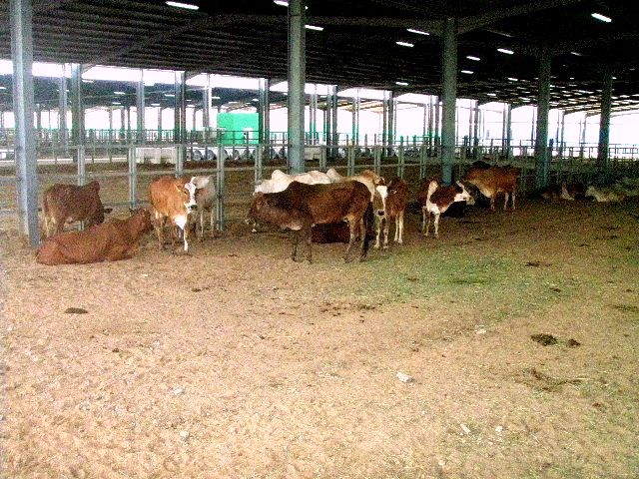
Figure 1. Open housing ease FMDV spreading
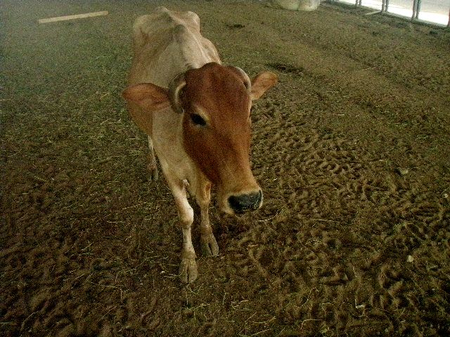
Figure 2. Weakness and emaciation of the diseased cattle

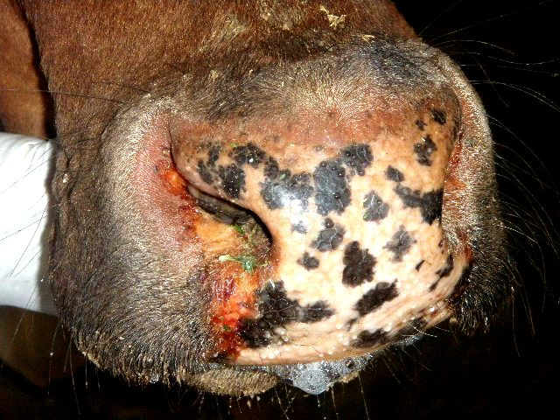
Figure 3. Inflammation around the nostrils

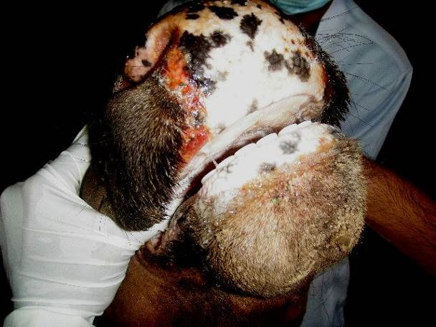  (a) | 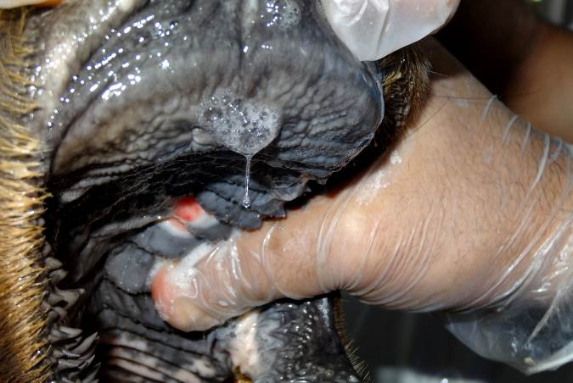  (b)
Figure 4. Ruptured vesicles on the upper gum (a) and the hard plate (b)

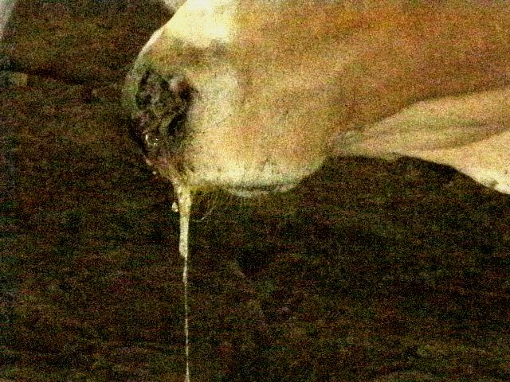 | 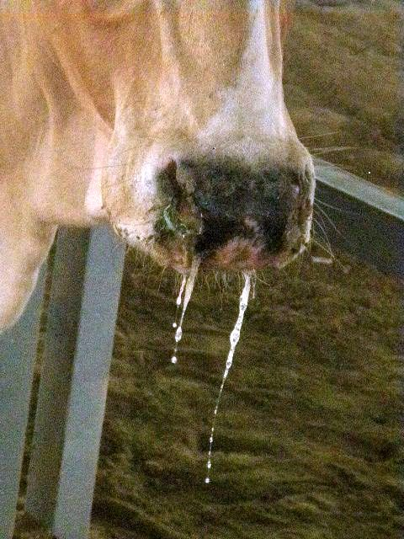
Figure 5. Ropy characteristic salivation

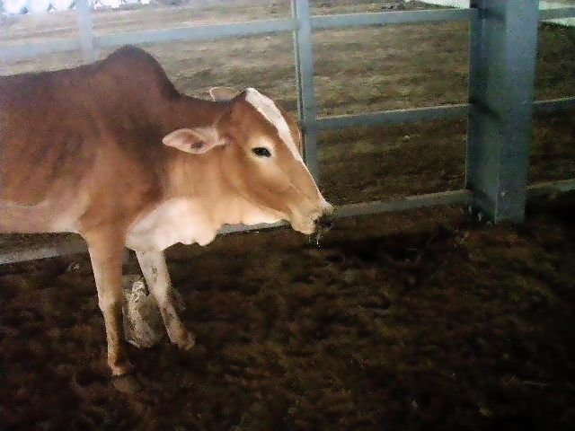
Figure 6. Pain in standing position and the animal is reluctant to move due to inflammation and vesicles in the interdigital space.

Serological prevalence of FMD among sacrifice animals:
The results of serological investigations revealed an overall serological evident of FMD infection in 256 (35.9%) out of 713 investigated sacrifice animals. This included 136 (28.3%) out of 480 sheep and 120 (51.5%) out of 233 cattle (Table 1). In sheep, 46 (17.7%) out of 260 Sawakni breed (imported from Sudan) and 90 (40.9%) out of 220 barbari breed (imported from horn of Africa) were serologically positive for FMD (Table 2). On the other hand, in cattle all investigated animals that were showing suspected clinical symptoms of FMD were serologically positive for FMDV antibodies while up to 62 (35.4%) out of 175 apparently healthy contact cattle were showing serological evidence of FMD infection (Table 3).

Table 1. Rate of FMD positive cases among imported sacrifice animals
Seropositive animals |  | no. of cases | Imported animal species
% | no
51.5 | 120 | 233 | Cattle
28.3 | 136 | 480 | Sheep
35.9 | 256 | 713 | Total

Table 2. Seropositive FMD cases among imported sheep
Seropositive animals |  | no. of cases | Source of animals
% | no.
17.7 | 46 | 260 | Sudan  (Sawakani breed)
40.9 | 90 | 220 | Horn of Africa  (Barbari breed)
28.3 | 136 | 480 | Total

Table 3. Seropositive FMD cases among imported cattle
Seropositive animals |  | no. of cases | Suspected clinical sypmtoms
% | no.
100 | 58 | 58 | Cattle with symptoms
35.4 | 62 | 175 | Cattle without symptoms
51.5 | 120 | 233 | Total

Discussion
Outbreaks of FMD are primary animal health concern worldwide as the disease is known for being highly contagious and causes productivity losses among infected animals (4). In Saudi Arabia, approximately five millions of live ruminants were imported mostly from FMD enzootic African countries. Moreover, intensified importation of at least 2 million of these animals shortly before pilgrimage season every year for scarification represents a great potential risk for the introduction of new exotic FMDV serotypes especially into the Holly city of Makkah (1) with subsequent possible outbreaks. In this context, it was reported that importation of Irish veal-calves into Netherlands via an FMD-contaminated staging point in France was the most-likely route of 2001 FMD outbreak (9). Moreover, an exotic SAT 2 FMD virus of topotype VII was characterized in Egypt as the cause behind the widespread field outbreaks during February and March 2012 (2). These newly emerged viruses were genetically closely related to strains isolated from Saudi Arabia, Sudan, Eritrea and Cameroon between 2000 and 2010, suggesting the dominant nature of this virus and underscoring the need for worldwide intensive surveillance to minimize its devastating consequences (29).
FMD in adult sheep and goats is frequently mild or unapparent with no distinct clinical signs and hence can easily be missed in diagnosis (6, 13). Several cases had been reported in the past where small ruminants were held responsible for the introduction of FMD into previously disease-free countries (33). The reasons for considering small ruminants as a risk factor that could have play an important role in the epidemiology and transmission of FMD include the fact that FMD is difficult to diagnose in these animals, as infected sheep usually do not show typical clinical symptoms or showing cardinal signs that mimicked other diseases, and also that sheep and goats are usual carriers of the disease (18). In Saudi Arabia, most of the imported live ruminants are sheep and goats, which represent the majority of the sacrifice animals in Makkah during the pilgrimage season. Most of these animals are imported from FMD-enzootic African countries with poor quarantine measurements. In the current study, all investigated sheep and goats were showing no apparent clinical symptoms of FMD. The inapparent nature of FMD in sheep and goats represents a high risk for the introduction of new exotic FMDV topotypes from Africa into Saudi Arabia. It was found that the un-recognized FMDV-infected sheep could represent a potential risk of FMD dissemination (8).
In cattle, FMD is usually clinically obvious especially in the unvaccinated herds of countries in which the disease occurs only occasionally (30). This study reported FMD in African cattle in Makkah with obvious clinical signs of the disease. Typical FMD clinical signs including inflammation around the nostrils, vesicular stomatitis, ropy salivation, vesicles in the interdigital spaces and lameness were reported. Clinical FMD infections, under certain climate and epidemiological conditions, can spread by a variety of mechanisms including the windborne spread of the disease (17). In the current study, the reported open housing system of the diseased cattle in the livestock yards in deed represent another great risk for the disease epizootiology in Makkah, with the subsequent possibility of rapid spreading of the infection not only to all sacrifice ruminant animals in Makkah, but also to all susceptible animals in west region of Saudi Arabia.
On the other hand, unlike animals which are carriers of FMD, sub-clinically infected animals may be highly contagious. In Europe, recent dissemination of FMDV shows that sub-clinically infected animals render trade in animals or animal products a potential risk for importing countries. The implications of sub-clinical infections for the control of FMD are serious because such animals are likely to disseminate the disease when in contact with susceptible livestock (54). In Saudi Arabia, illegal movement of cattle of African origin from the south region (Jizan region) into the west region (Makkah region) shortly before the Hajj season of 1433H represent a high potential risk for FMDV disseminations. Therefore control of animal movement is one of the most important measures for successful FMD eradication strategy (12).
The detection of antibody to non-structural protein's (NSPs) of FMDV can be used to identify past or present infection with any of the seven serotypes of the virus, whether or not the animal has also been vaccinated. Therefore the tests can be used to confirm suspected cases of FMD and to detect viral activity or to substantiate freedom from infection on a population basis. For certifying animals for trade, the tests have the advantage over structural protein (SP) methods that the serotype of virus does not have to be known (59). Antibody to the polyproteins 3AB or 3ABC are generally considered to be the most reliable indicators of infection (43). In the present study, the FMD 3ABC test was used for accurate detection of infection, differentiating infected from marker vaccinated animals. The detection of antibodies to NSPs of FMDV is the preferred diagnostic method to distinguish virus infected, carrier animals from vaccinated animals (7, 11, 42). Serological tests such as those for antibodies to NSPs, or specific immunoglobulin A (IgA) do provide increased security by reducing the likelihood of trading carrier animals and can be used to help define the limits of an outbreak (31). It was indicated that the 3ABC-ELISA was able to detect antibodies indicative of infection with FMDV in asymptomatic sheep in field conditions (8).
In the current study, laboratory investigations revealed an overall serological evident of FMD infection in 256 (35.9%) out of 713 investigated sacrifice animals. This included 136 (28.3%) out of 480 sheep and 120 (51.5%) out of 233 cattle. For one year and during pligrimage season of 1432 H (4-9 November, 2011) in Makkah, 14 (0.78 %) suspected cases of FMDV out of inspected 1800 cows were recorded (5). FMD serological survey among vaccinated indigenous ruminants raised in different regions of Saudi Arabia was carried out by Hafez et. al. (24). Of 5,985 sheep sera, 1,371 goat sera, 1,052 cattle sera and 694 serum samples from unspecified species of ruminants, precipitating antibodies against FMDV was detected in 1,209 (20%), 127 (9%), 172 (16%) and 38 (5%) samples, respectively. During FMD serological survey conducted by Lazarus et. al. (40) between 2009 and 2011 in Nigeria, the overall prevalence rate among 448 serum samples from cattle, sheep and goats was 64.73%.
In the present study, Forty-six (17.7%) out of 260 Sawakni sheep (imported from Sudan) and 90 (40.9%) out of 220 barbari sheep (imported from horn of Africa) were serologically positive for FMD. All of these sheep were without clinical signs of FMD. On the other hand, in cattle all investigated animals that were showing suspected clinical symptoms of FMD were serologically positive for FMDV antibodies while up to 62 (35.4%) out of 175 apparently healthy contact cattle were showing serological evidence of FMD infection. During 1999 FMD outbreak in Morocco, all the FMD clinical cases reported were cattle. The study confirmed the presence of FMDV specific antibodies in 77 clinically normal sheep (8). It was concluded that the high percentage of positive serological test results in sheep and goats in many regions of Saudi Arabia, in the absence of clinical FMD among these species, indicates the importance of these range animals in transmitting FMD virus between regions within the country (24).
It was concluded that the most appropriate approach to FMD control would be to prevent infected animals from entering the principal trading routes for susceptible animals (47). The Terrestrial Animal Health Code of the OIE (World organisation for animal health) makes recommendations for international movements of live animals and animal products because of a possible generic risk of FMD for these different commodities (55). So that the current study suggested that the recommendations of the Terrestrial Animal Health Code of the OIE for international movements of live animals should be strictly applied during importation of live animals into Saudi Arabia.
Molecular epidemiological studies on FMD in Saudi Arabia are in need. In Egypt, during FMD outbreak in 2006, the results of the molecular typing suggested a relation between strains of Egyptian and East African origin. The molecular typing confirmed only that through the trade in live cattle, an East African type A strain was introduced, which was not contained at the quarantine station. The origin of the infection was unclear, since the animals in quarantine may had acquired infection at various points during shipment, including possible contaminated pens or other animals on board the ship, at the port before loading, or in transit from Ethiopia to the port of loading (39). Therefore, isolation and genotyping of FMDV serotypes is recommended by the current study and will be considered in our future work.
Any country experiencing an outbreak of FMD can expect questions or trade restrictions from regular trading partners (10). The needs for about two millions sheep and goats for slaughtering during a very short time, within about three days, during the Hajj season every year, make Saudi Arabia to import ruminant animals from Africa, although FMD is a constant threat to animal agriculture worldwide and must always be considered when defining policies concerning the trade of live animals and animal products (28). Six of the seven serotypes of FMD virus (i.e. all but Asia 1) are prevalent in Africa (58). In addition, the FMD diagnostic capacity in Eastern Africa is still inadequate (45).
FMD control should be considered more and more in a global perspective (35, 49). FMD affects livestock all around the world particularly those in poor countries. In many places little is done to control FMD largely due to a lack of resources and a failure to recognise the benefits that control brings. FMD prevents agricultural development and reduces food security, in many countries it leads to massive losses due to control costs and in some cases by limiting export market access (48). For controlling of FMD in the Middle East and North Africa, co-ordinated epidemiological studies leading to a common control policy should be implemented and supported by international community (3). So that the present study suggests an international aids program for controlling of FMD in poor African countries that will help these countries to export live animals and subsequently will increase the development opportunities.
Conclusions
There is an evident for the possibility of introduction of exotic one or several FMDV serotypes into Saudi Arabia through the intensive importation of live ruminants from the Sudan and horn of Africa, where FMD is enzootic, particularly shortly before Hajj seasons. Such imported animals may be FMDV carriers or subclinical cases, especially sheep, where about two millions sheep are imported from Africa for slaughtering in the Holly city of Makkah within four days from 10th to 13th Dhu Al-Hijjah (the last month of Islamic calendar) annually during each Hajj season.
Recommendations
The present study suggests the following recommendations that may contribute to decrease the risk of importation of an exotic FMD serotypes into Saudi Arabia:
- Prohibition of live ruminant animals' importation from African countries, where FMD is enzootic.
- Serological screening of the live ruminant animals at Djibouti quarantine before exportation for excluding of all seropositive (infected or carrier) cases.
- Improving the import control, including quarantine, at Islamic Jeddah port.
- Vaccination of non-infected and non-carrier ruminants in the country of origin at least 3 weeks before export to Saudi Arabia, using a polyvalent vaccine incorporating FMD virus strains which can stimulate protection against Saudi field strains.
- Serological testing of random and reprehensive samples at Islamic Jeddah quarantine to ensure vaccination of the imported live animals.
- Establishment of a national project for the intensive production of sheep as an alternative to importation with a production capacity of about 1-2 million head per year.
- Application of all recommendations of the Terrestrial Animal Health Code of the OIE (World organisation for animal health) for international movements of live animals (60).
- Further studies for typing and characterization of any FMDV exotic toptypes and annual reporting of FMD molecular epidemiology in Saudi Arabia were also recommended.

References
- Abdel Baky, M.H.; Abd El-Rahim, I.H.A.; Habashi, A.R.; Mahmoud, M.M.; Al-Mujalii, D.M (2005).- Epizootiology and control measurements of foot and mouth disease (FMD) in Saudi Arabia from 1999 to 2004. Assiut Vet. Med. J., 51, 112-126.
- Ahmed H.A., Salem S.A., Habashi A.R., Arafa A.A., Aggour M.G., Salem G.H., Gaber A.S., Selem O., Abdelkader S.H., Knowles N.J., Madi M., Valdazo-González B., Wadsworth J., Hutchings G.H., Mioulet V., Hammond J.M. & King D.P. (2012).- Emergence of foot-and-mouth disease virus SAT 2 in Egypt during 2012. Transbound Emerg Dis., 59, 476-481.
- Aidaros H.A. (2002).- Regional status and approaches to control and eradication of foot and mouth disease in the Middle East and North Africa. Rev Sci Tech., 21, 451-458.
- Akashi H. (2010).- Current situation and future preventive measures of foot-and-mouth disease in Japan. Uirusu., 60, 249-255.
- Alsayeqh A.F. & Fat'hi S.M. (2012).- Recurrent appearance of foot and mouth disease virus (FMDV) in Saudi Arabia. Scientific Journal of Microbiology., 1, 63-70.
- Barnett P.V. & Cox S.J. (1999).- The role of small ruminants in the epidemiology and transmission of foot-and-mouth disease. Vet J., 158, 6-13.
- Barteling S.J. (2002).- Development and performance of inactivated vaccines against foot and mouth disease Rev. sci. tech. Off. int. Epiz., 21, 577-588.
- Blanco, E., Romero L. J., El Harrach M. & Sanchez-Vizcaino J. M. (2002).- Serological evidence of FMD subclinical infection in sheep population during the 1999 epidemic in Morocco. Vet. Microbiol., 85, 13-21.
- Bouma A., Elbers A.R., Dekker A., de Koeijer A., Bartels C., Vellema P., van der Wal P., van Rooij E.M., Pluimers F.H. & de Jong MC. (2003).- The foot-and-mouth disease epidemic in The Netherlands in 2001. Prev Vet Med., 57, 155-66.
- Brückner G.K., Vosloo W., Du Plessis B.J.A., Kloeck P.E.L.G., Connoway L., Ekron M.D., Weaver D.B., Dickason C.J., Schreuder F.J., Marais T., & Mogajane M.E. (2002).- Foot and mouth disease: the experience of South Africa. Rev. sci. tech. Off. int. Epiz., 21, 751-764
- Clavijo A, Wright P, & Kitching R.P. (2004).- Developments in diagnostic techniques for differentiating infection from vaccination in foot-and-mouth disease. Vet J., 167, :9-22.
- Correa Melo E., Saraiva V. & Astudillo V. (2002).- Review of the status of foot and mouth disease in countries of south America and approaches to control and eradication. Rev. sci. tech. Off. int. Epiz., 21, 429-436.
- Dekker A. & Terpstra C. (1999).- Foot-and-mouth disease: clinical aspects, epizootiology and diagnosis Tijdschr Diergeneeskd., 124, 74-79.
- Di Nardo A, Knowles NJ, Paton DJ. (2011).- Combining livestock trade patterns with phylogenetics to help understand the spread of foot and mouth disease in sub-Saharan Africa, the Middle East and Southeast Asia. Rev. sci. tech. Off. int. Epiz., 30, 63-85.
- Donaldson A. I. (1999).- Foot-and-mouth disease in western North Africa: an analysis of the risk for Europe. Proceedings of the Session of the Research Group of the Standing Technical Committee of the European Commission for the Control of Foot-and-Mouth Disease, Maisons- Alfort, France, 29 September to 1 October 1999, Appendix 5, p45. FAO, Rome, 1999.
- Donaldson A. I. & Sellers R. F. (2000).- Foot-and-mouth disease. Chapter in Diseases of Sheep, 3rd edition. W. B. Martin and I. D. Aitken (Editors). Blackwell science, Oxford, 1998.
- Donaldson A.I. & Alexandersen S. (2002).- Predicting the spread of foot and mouth disease by airborne virus. Rev. sci. tech. Off. int. Epiz., 21, 569-575.
- Ganter M., Graunke W.D., Steng G. & Worbes H. (2001).- Foot and mouth disease in sheep and goats. Dtsch Tierarztl Wochenschr., 108, 499-503.
- Geering W. A. (1967).- Foot and mouth disease in sheep. Australian Veterinary Journal 43, 485-489.
- Gleeson L.J. (2002).- A review of the status of foot and mouth disease in South-East Asia and approaches to control and eradication. Rev. sci. tech. Off. int. Epiz., 21, 465-475.
- Golde W. T., Pacheco J.M., Duquea H., Doel T., Penfold B., Ferman G.S., Gregg D.R. & Rodriguez L.L. (2005).- Vaccination against foot-and-mouth disease virus confers complete clinical protection in 7 days and partial protection in 4 days: Use in emergency outbreak response. Vaccine, 23, 5775–5782.
- Hafez S.M., Farag M.A., Al-Sukayran A. & al-Mujalli D.M. (1993a).- Epizootiology of foot and mouth disease in Saudi Arabia: I. Analysis of data obtained through district field veterinarians. Rev. sci. tech. Off. int. Epiz., 12, 807-816.
- Hafez S.M., Farag M.A. & Al-Sukayran A. (1993b).- Epizootiology of foot and mouth disease in Saudi Arabia: II. Current status on dairy farms and control measures in operation. Rev. sci. tech. Off. int. Epiz., 12, 817-830.
- Hafez S.M., Farag M.A., Mazloum K.S. & al-Bokmy A.M. (1994a).- Serological survey of foot and mouth disease in Saudi Arabia. Rev. sci. tech. Off. int. Epiz., 13, 711-719.
- Hafez S.M., Farag M.A. & Al-Sukayran A.M. (1994b).- The impact of live animal importation on the epizootiology of foot-and-mouth disease in Saudi Arabia. Dtsch Tierarztl Wochenschr., 101, 397-402.
- Hutber A.M., Kitching R.P. & Conway D.A. (1998).- Control of foot-and-mouth disease through vaccination and the isolation of infected animals. Trop Anim Health Prod., 30, 217-227.
- James A.D. & Rushton J. (2002).- The economics of foot and mouth disease. Rev. sci. tech. Off. int. Epiz., 21, 637-644
- Joo Y.-S., An S.-H., Kim O.-K., Lubroth J., & Sur J.-H. (2002).- Foot-and-mouth disease eradication efforts in the Republic of Korea. Can J Vet Res., 66, 122–124.
- Kandeil A., El-Shesheny R., Kayali G., Moatasim Y., Bagato O., Darwish M., Gaffar A., Younes A., Farag T., Kutkat M.A. & Ali MA. (2013).- Characterization of the recent outbreak of foot-and-mouth disease virus serotype SAT2 in Egypt. Arch Virol., 158, 619-627.
- Kitching R.P (2002a).- Clinical variation in foot and mouth disease: cattle. Rev. sci. tech. Off. int. Epiz., 21, 499-504.
- Kitching R.P. (2002b).- Identification of foot and mouth disease virus carrier and subclinically infected animals and differentiation from vaccinated animals. Rev. sci. tech. Off. int. Epiz., 21, 531-538.
- Kitching R.P. (2002c). - Future research on foot and mouth disease Rev. sci. tech. Off. int. Epiz., 21, 885-889.
- Kitching R.P. & Hughes G.j. (2002).- Clinical variation in foot and mouth disease: sheep and goats. Rev. sci. tech. Off. int. Epiz., 21, 505-512.
- Kitching R. P. (2005).- Global Epidemiology and Prospects for Control of Foot-and-Mouth Disease. CTMI, 288, 133-148.
- Kitching R.P., Hammond J., Jeggo M., Charleston B., Paton D., Rodriguez L. & Heckert R. (2007).- Global FMD control--is it an option? Vaccine, 25, 5660-5664.
- Klein J. (2009).- Understanding the molecular epidemiology of foot-and-mouth-disease virus. Infect Genet Evol., 9, 153-61.
- Knowles N.J. & Samuel A.R. (2003).- Molecular epidemiology of foot-and-mouth disease virus. Virus Res., 9, 65-80.
- Knowles N.J., Samuel A.R., Davies P.R., Midgley R.J. & Valarcher J.-F. (2005).- Pandemic Strain of Foot-and-Mouth Disease Virus Serotype O. Emerging Infectious Diseases., 11, 1887-1893.
- Knowles N.J., Wadsworth J., Reid S.M., Swabey K.G., El-Kholy A.A., Abd El-Rahman A.O., Soliman H.M., Ebert K., Ferris N.P., HutchingsG.H., Statham R.J., King D.P. & Paton D.J. (2007).- Foot-and-Mouth Disease Virus Serotype A in Egypt. Emerg Infect Dis., 13, 1593–1596.
- Lazarus D.D., Schielen W.J.G., Wungak Y., Kwange D. & Fasina F.O. (2012).- Sero-epidemiology of foot-and-mouth disease in some Border States of Nigeria. African Journal of Microbiology Research, 6, 1756-1761.
- Leforban Y. & Gerbier G. (2002).- Review of the status of foot and mouth disease and approach to control/eradication in Europe and Central Asia. Rev. sci. tech. Off. int. Epiz., 21, 477-492.
- Lu Z., Cao Y., Guo J., Qi S., Li D., Zhang Q., Ma J., Chang H., Liu Z., Liu X. & Xie Q. (2007).- Development and validation of a 3ABC indirect ELISA for differentiation of foot-and-mouth disease virus infected from vaccinated animals. Vet Microbiol., 125, 157-169.
- Mackay D.K.J, Forsyth M.A., Davies P.R., Berlinzani, A., Belsham G.J., Flint M. & RyanN M.D. (1997).- Differentiating infection from vaccination in foot-and-mouth disease using a panel of recombinant, non-structural proteins in ELISA. Vaccine, 16, 446–459.
- Morris R.S, Sanson R.L., Stern M.W., Stevenson M. & Wilesmith J.W. (2002).- Decision-support tools for foot and mouth disease control. Rev. sci. tech. Off. int. Epiz., 21, 557-567.
- Namatovu A., Wekesa S.N., Tjørnehøj K., Dhikusooka M.T., Muwanika V.B., Siegsmund H.R. & Ayebazibwe C. (2013).- Laboratory capacity for diagnosis of foot-and-mouth disease in Eastern Africa: implications for the progressive control pathway. BMC Vet Res., 24, 9:19.
- Orsel K. & Bouma A. (2009).- The effect of foot-and-mouth disease (FMD) vaccination on virus transmission and the significance for the field. Can Vet J., 50, 1059-1063.
- Perry B.D., Gleeson L.J., Khounsey S., Bounma P. & Blacksell S.D. (2002).- The dynamics and impact of foot and mouth disease in smallholder farming systems in South-East Asia: a case study in Laos. Rev. sci. tech. Off. int. Epiz., 21, 663-673.
- Rushton J. & Knight-Jones T. (2012).- The impact of foot and mouth disease. 1. Supporting document N 1. World Organisation for Animal Health (OIE)/ Food and Agriculture Organization of the United Nations (FAO), available at. http://www.oie.int/doc/ged/D11888.PDF
- Rweyemamu M.M. & Astudillo V.M. (2002).- Global perspective for foot and mouth disease control. Rev. sci. tech. Off. int. Epiz., 21, 765-773.
- Sakamoto K. & Yoshida K. (2002).- recent outbreaks of foot and mouth disease in countries of east Asia. Rev. sci. tech. Off. int. Epiz., 21, 459-463.
- Samuel A. R., Knowles N. J. &| Mackay D. K. J. (1999). Genetic analysis of type O viruses responsible for epidemics of foot-and-mouth disease in North Africa. Epidemiology and Infection, 122, 529-538.
- Scudamore J.M. & Harris D.M. (2002).- Control of foot and mouth disease: lessons from the experience of the outbreak in Great Britain in 2001. Rev. sci. tech. Off. int. Epiz., 21, 699-710
- Sugiura K., Ogura H., Ito K., Ishikawa K., Hoshino K. & Sakamoto K. (2001).- Eradication of foot and mouth disease in Japan. Rev. sci. tech. Off. int. Epiz., 20, 701-713.
- Sutmoller P. & Casas O.R. (2002).- Unapparent foot and mouth disease infection (sub-clinical infections and carriers): implications for control. Rev. sci. tech. Off. int. Epiz., 21, 519-529.
- Sutmoller P. & Casas O. R. (2003).- The risks posed by the importation of animals vaccinated against foot and mouth disease and products derived from vaccinated animals: a review. Rev. sci. tech. Off. int. Epiz., 22, 823-835.
- Thompson D., Muriel P., Russell D., Osborne P., Bromley A., Rowland M., Creigh-Tyte S. & Brown C. (2002).- Economic costs of the foot and mouth disease outbreak in the United Kingdom in 2001. Rev. sci. tech. Off. int. Epiz., 21, 675-687.
- Tsaglas E. (1995).- The recent FMD epizootic in Greece. Report of the 31st Session of the European Commission for the Control of Foot-and-Mouth Disease, 5-7 April 1995, FAO, Rome, Appendix 2, 35-40.
- Vosloo W., Bastos A.D., Sangare O., Hargreaves S.K. & Thomson G.R. (2002).- Review of the status and control of foot and mouth disease in sub-Saharan Africa. Rev. sci. tech. Off. int. Epiz., 21, 437-449.
- World Organisation for Animal Health (OIE) (2009). – Foot and Mouth Disease in Manual of Diagnostic Tests and Vaccine for Terrestrial Animals. Chapter 2.1.5. Available at: ww.oie.int/fileadmin/Home/eng/Health_standards/tahm/2.01.05_FMD.pdf.
- World Organisation for Animal Health (OIE) (2012).- Terrestrial Animal Health Code. Section 5. Trade measures, import/export procedures and veterinary certification. Available at: http://www.oie.int/index.php?id=169&L=0&htmfile=titre_1.5.htm

