Elemental composition of PM_{2.5} particles sampled in industrial and residential areas of Taif, Saudi Arabia

Abdallah A. Shaltout^{1,2,}, Dhaif-allah R. Al-Malawi¹, Zuhair F. Shehadeh¹, Hassan Alkhozahey¹

¹ Physics Department, Faculty of Science, Taif University, 21974 Taif, P.O. Box 888, Saudi Arabia
² Spectroscopy Department, Physics Division, National Research Center, El Behooth Str., 12622 Dokki, Cairo, Egypt
Abstract
Atmospheric aerosol particles PM_{2.5} were collected from two different sites (industrial and residential) in Taif during the summer of 2011. The industrial site was situated in the largest industrial area of Taif, and the residential site was situated on Television Street, which is the city’s most crowded area. PM_{2.5} samples were collected on polycarbonate filters using a cyclonic collector. Each sample was collected over a 24 hour period and new samples were collected weekly. An Energy Dispersive X-ray Fluorescence (EDXRF) spectrometer with a Mo secondary target was used to analyze the solid samples because of the relative simplicity of the technique and the widespread availability of the corresponding spectrometer. The use of a Mo secondary target is advantageous because it decreases the impact of continuum radiation from the x-ray tube and increases the signal to background ratio. Quantitative X-ray Analysis Software (PyMca) was used to perform quantitative analysis of the atmospheric aerosols. Direct analysis resulted in detected concentrations for sixteen elements; Si, S, Cl, K, Ca, Ti, Cr, Mn, Fe, Ni, Cu, Zn, Rb, Sr, Pb and Black Carbon (BC). The measured concentrations of the potentially hazardous trace elements Cu, Cr, Mn, Ni and Pb were below the limits defined by international guidelines and national standards for ambient air quality. However, further long-term research will be required to validate the quantification of trace elements in particulate matter in Taif.

عنوان البحث باللغة العربية
التركيب العنصري لحبيبات الغبار العالق (2.5 ميكرومتر) المجمعة من منطقة صناعية و أخري سكنية بمدينة الطائف
عبدالله أمين شلتوت، ضيف الله بن رحيم المعلوي، زهير فياض شحادة، حسن الخزاعي
الملخص العربي
تم تجميع ملوثات الهواء ذات الأقطار أقل من أو تساوي 2.5 ميكرومتر من موقعين أحدهما صناعي و الآخر سكني داخل بمدينة الطائف خلال صيف 2011. تم تجميع عينات ملوثات الهواء باستخدام أوراق فلاتر خاصه من ماده البولي كربونات باستخدام أجهزة خاصة لتجميع ملوثات الهواء لمدة 24 ساعة لكل عينة. تم استخدام تقنية الأشعه السينية الفلورسنسية لتشتت الطاقه و هي تتميز بالسهوله و البساطه. تم تعيين الملوثات اللغير عضوية و المتمثله في العناصر الآتيه Si, S, Cl, K, Ca, Ti, Cr, Mn, Fe, Ni, Cu, Zn, Rb, Sr, Pb بالاضافه الي عنصر الكربون. و من النتائج المتحصل عليها تبين أن تركيز العناصر المذكورة في المدي الآمن طبقا لمعايير جودة و نقاوة الهواء الدوليه. بالإضافة الي ذلك فقد تبين أن تركيز العناصر الأكثر خطرا أقل من المدي المسوح به دوليا للمعايير الدولية لجودة الهواء. و الجدير بالذكر أننا لا زلنا بحاجه لدراسة طويلة المدي للتحقق من دقة النتائج المتحصل عليها و للتعرف علي مدي تأثير التغيرات الفصليه المختلفه.

Introduction

It is important to study the chemical composition of atmospheric particulate matter because of its effects on human health (Renwick et al., 2001) and climate change (Karl et al., 1997; Cahill, 1996). In addition, such studies provide information on the origins of the particulate matter and can reveal whether it was emitted as primary or secondary particles. Smaller particles can penetrate more deeply into the lungs than larger ones and thus cause more severe harm (Schwartz and Neas, 2000). In addition, fine particulate matter affects the radiation balance of the earth (Horvath, 1998) because it scatters and absorbs much of the incident visible light from the sun. Furthermore, fine particulate matter has a long atmospheric residence time, which facilitates its transnational and even transcontinental transport over thousands of kilometers, enabling particulate emissions from one country to affect air quality in others. For all these reasons, there is great interest in determining the concentration of fine particulate matter in ambient air. The bulk of these particles originate from anthropogenic emissions (Murray et al., 2001; Ezzati et al., 2002), both as direct products of human activity and as secondary particles formed in the atmosphere from gases such as SO₂, NO_{x} and volatile organic compounds (VOC). Local emissions of fine particles can cause issues of local and regional concern because they can become highly concentrated in the vicinity of their sources. Black carbon (BC) is one of the main anthropogenic components of particulate air pollution, being produced by incomplete combustion. When it is formed, it invariably mixed with other atmospheric constituents (Liousse et al., 1993). Generally, there are two important reasons for determining the elemental content in airborne particulate matter. First, it can contain heavy elements such as Cd, Pb, As, and Sb, which are in themselves toxic to human health. It is of interest to follow the ecocycles of these metals as environmental hazards once they have been released into the atmosphere, biosphere and technosphere. The second aspect is that single elements or ratios of different elements can be used to fingerprint and monitor emissions from specific sources that may also be emitting more hazardous species that are less stable and more difficult to measure. Laws in both the USA and the European Union have established recommended limits on the concentrations of inhalable particles in ambient air (Mark, 1998).
In the present work, atmospheric aerosols from two sites (industrial and residential) in Taif were sampled on polycarbonate filters. Samples were collected over 24 hours once per week during the summer of 2011. A sampler consisting of a cyclone loaded with polycarbonate filters was installed at each sampling site. The particulate matter collected on the filters was quantitatively analyzed for trace elements by Energy Dispersive X-ray Fluorescence (EDXRF) using a spectrometer equipped with a molybdenum-based secondary target. The secondary target was used to achieve quasi-monochromatic excitation in order to minimize the background signal and improve the method’s limits of detection. The aim of the study was to evaluate trace elemental concentrations in fine particles (PM_{2.5}) and to investigate their influence on regional air quality. Fifteen trace elements (Si, S, Cl, K, Ca, Ti, Cr, Mn, Fe, Ni, Cu, Zn, Rb, Sr, and Pb) and black carbon (BC) were analyzed, and their concentrations were evaluated.

Experimental

Sampling sites
Atmospheric PM_{2.5} aerosols from the two different sites (industrial and residential) in Taif, Saudi Arabia, were collected during the summer of 2011, and analyzed. The industrial site was situated in a central location in the industrial area, 2 km away from the center of the city. The residential site was located in a highly populated area on Television Street in the southeast of the city. The map in Fig. (1) shows the locations of the two sites.

Sampling equipment
Atmospheric aerosols, PM_{2.5}, were collected on polycarbonate filters loaded inside a collection cartridge in a cyclone (CASELLA Company, UK). The cyclone creates a vortex by making the air-stream move in a cyclonic orbit in which larger particles are separated from the fine particles because their higher inertia prevents them from following the air flow. The cyclones were operated with a flow rate of 3 L min⁻¹, which was maintained by a critical orifice located between the pump and the cyclone. The polycarbonate filters had a diameter of 25 mm and a pore size of 0.4 µm; filters of this type have been used in previous studies and found to have high particle collection efficiency and to yield high purity samples (Wagner et al., 2008). Each sample was collected over a 24 h, with the filters being exchanged at 11 a.m. In order to avoid over-sampling traffic-derived pollutants, the equipment (i.e. the cyclone, flow meter, and pump) was mounted at a height of 20 m above ground level and more than 50 m from the nearest main road. Measurements were acquired simultaneously and in parallel using two individual sets of apparatus at each of the two sites.

EDXRF Setup
The Energy Dispersive X-ray Fluorescence (EDXRF) spectrometer used for the analysis of the particle samples has a three-axial arrangement built around a silver X-ray tube and uses a molybdenum secondary target that makes the beam nearly monochromatic before it reaches the sample (Boman, 1990; Chimidza, 2001). The usage of a Mo secondary target provides better sensitivity and selectivity than can be achieved with a direct excitation setup. The spectra from the EDXRF were further processed using the PyMca software package (Solé et al., 2007) and the results so obtained were converted into airborne concentrations (ng m⁻³). The EDXRF method of analyzing samples is multi-elemental, easy to use and inexpensive. It gives elemental concentrations with a typical error margin of 10%, which includes statistical counting errors due to X-ray fluorescence from the most detected element in the sample. The detection limits for the EDXRF analyses were calculated in accordance with the procedure and guidelines given by the International Union of Pure and Applied Chemistry (IUPAC, 1976) and are specified in terms of both absolute amounts and minimum airborne concentrations in Table 1. The certified reference material (CRM) sample SRM2783, which consists of airborne particulate matter trapped on a filter was used (National Institute of Standard and Technology (NIST), USA) to determine the analytical method’s limits of detection. For elements that are not present in the CRM, limits of detection were determined by interpolation based on data for the available elements.

Results and Discussion
PM_{2.5} Concentrations
Fig. (2) shows the mass concentrations of PM_{2.5} collected from the two sites in Taif on each sampling week during the summer of 2011 (June-August). A group of samples was collected for each site. The average PM_{2.5} mass concentrations measured over the entire experimental period were 46 ± 31 μg/m³ and 47 ± 15 μg/m³ for the residential and industrial sites, respectively. The PM_{2.5} concentrations in the residential site ranged from 36 - 62 μg/m³ whereas those for the industrial area ranged from 29 - 68 μg/m³. The highest measured PM_{2.5} mass concentrations at both sites are thus approximately twice as high as the upper limit specified in the ambient air quality standards published by the European commission (European Commission, 2012), which require a yearly mean of no more than 25 μg/m³. As shown in Figure 2, the lowest PM_{2.5} mass concentrations for both the industrial and residential areas were observed in August 2011, while the highest levels were observed in July 2011 for both areas. This is presumably due partly to the large dust storm that occurred in the area during July 2011, and partly to seasonal variation. In general, the measured concentrations of PM_{2.5} in the industrial and residential areas were similar over the entire measurement period with the exception of the second week of July, as shown in Fig. (2). This may be because the two sites are located in relatively close proximity to one-another. The PM_{2.5} concentrations measured in this work are comparable to those reported elsewhere in the literature (Abu-Allaban et al., 2002; Saliba et al., 2010; Abu-Allaban et al., 2007; Götschi et al., 2002; Gatari et al., 2009; Wang et al., 2005; Boman et al., 2012) for cities such as Beirut (Lebanon), Nairobi (Kenya), Athens (Greece), and Cairo (Egypt) in 2010, as shown in Table 3. However, the measured values are three times lower than those reported for industrial and residential areas in Cairo (Egypt) in 2001 and Beijing (China). Particulate matter pollution is a major problem in urban areas of Africa and Asia but is also a matter of global concern. A press release from the European Commission (European commission, 2012a) noted that 30% of Europe’s urban population is exposed to concentrations of PM_{2.5} that exceed the annual limit stipulated by the EU.

Elemental composition determined by secondary target EDXRF
Fig. (3) shows the characteristic fluorescent radiation of an empty polycarbonate filter, air particulate filters collected from the residential site during July 2011, and an air particulate filter carrying the certified reference material. Empty filters were analyzed to determine the background signal, which was subtracted from the results obtained for the sample filters. Mo scattering radiation could be recognized at photon energy higher than 16 keV. The Kα and Kβ characteristic lines were predominant for all elements other than Pb, for which the Lα and Lβ lines were predominant. Consequently, analyses were conducted using the PyMca software package based on the Kα, Kβ and Lα characteristic lines for each element. It was possible to determine the levels of fifteen elements in most (but not all) of the sample filters: Si, S, Cl, K, Ca, Ti, Cr, Mn, Fe, Ni, Cu, Zn, Rb, Sr, and Pb. Other potentially toxic heavy elements such as Cd and Sb were present below the limit of detection and so could not be measured with the apparatus used in this work due to their low ambient concentrations. Further investigations will be performed using High Resolution-Continuum Source-Graphite Furnace-Atomic Absorption Spectrometry (HR-CS-GF-AAS) to address this deficiency in the future (Boman et al., 2012). A group of single element filters (Micromatter) with known concentrations of different elements were used to establish calibration curves in order to permit the quantitative determination of trace elements trapped on the air particulate filters. The calibration curves were established by comparing the sensitivities of the elements in the standard filter group to their atomic numbers. The final concentrations of the elements in the polycarbonate filter were converted into units of ng/m³ based on the filter area and the sampled air volume. Tables 4 and 5 show the average concentrations of the measured elements in the aerosol particles collected from the industrial and residential sites during each month and over the entire sampling campaign. Black carbon (BC) levels were determined using a black smoke reflectometer. Its concentration is given in ng/m³ and each reported value represents either the average of the concentrations found for each filter in a given month or for the entire sampling period. As shown in Tables 4 and 5, it was not always possible to determine concentrations for every trace element, since some were below the method’s limit of detection in some samples. Importantly, the concentrations of the heavy elements, and especially those of Ni and Pb, were consistently below the maximum levels permitted by the European commission on air quality (European Commission, 2012a). High concentrations of Si, S, K, Ca and Fe were generally found in both the industrial and the residential locations, and the concentrations of these species did not differ between the two (Table 5). These elements presumably originate from natural sources such as mineral dust, as well as human activities such as waste burning. In addition, Taif is located in an area that is partially enclosed by the Red Sea and is surrounded by the Saharan and Arabian deserts, which are the main sources of the airborne sandy mineral dust. The concentrations of Ca and Fe in industrial and residential areas were comparable, which may be due to the relatively short distance between the residential and the industrial areas. However, the concentrations of Cu and Zn in the industrial area were substantially higher than those in the residential area. These presumably come from anthropogenic sources. On the other hand, Ti was found in higher concentrations in the residential area than in the industrial area. Other elements were present at comparable levels in both the industrial and residential locations. Table 5 shows that the average concentration of BC in the industrial area was three times higher than that in the residential area. This is probably due to the industrial activities such as blacksmithing and construction, and to increased use of internal combustion engines. Notably, the level of motorized traffic in the industrial area seemed to be heavier than that in the residential area. As such, it is not surprising to find higher levels of soot in the industrial area.

Conclusions
The present work represents the first part of an initiative to evaluate the trace element composition of atmospheric aerosols, PM_{2.5}, in two different areas (industrial and residential) of Taif city, Saudi Arabia. It can be concluded that the chosen sites are well suited for this kind of study since it was possible to identify effects due to different sources at each one. It can also be concluded that despite its location in a desert area, Taif does not suffer from more severe particulate pollution than many other urban areas in the world. Its PM_{2.5} mass concentration exceeds the European Union’s yearly mean upper limit by a factor of two, suggesting that it will be necessary to perform measurements over a longer period of time in order to obtain a more detailed picture of air pollution in the area. Fortunately, the measured concentrations of potentially hazardous trace elements were below the limits specified in international guidelines and national standards for ambient air quality. The measured elemental compositions of the samples indicate that the use of a cyclonic sampler with an EDXRF spectrometer is appropriate for studies of this type and should be suitable for related studies conducted under similar conditions. It was also demonstrated that this method can be used to identify and discriminate between natural and anthropogenic sources of airborne particulate matter in Taif.

References
Abu-Allaban, M., Gertler, A.W. and Lowenthal, D.H. (2002). A preliminary apportionment of the sources of ambient PM₁₀, PM_{2.5}, VOCs in Cairo, Atmospheric Environment 36:5549-5557.
Abu-Allaban, M., Lowenthal, D.H., Gertler, A.W. and Labib, M. (2007). Sources of PM₁₀ and PM_{2.5} in Cairo's ambient air, Environmental Monitoring Assessment 133:417-425.
Abulfaraj, W.H., Ahmed, M., Mousli, K.M. and Erturk, F. (1990). Measurement of ambient air lead concentrations in the city of Jeddah, Saudi Arabia. Environment International, 16(1):85-88.
Aburas, H.M., Zytoon, M.A. and Abdulsalam, M. I. (2011). Atmospheric Lead in PM_{2.5} after leaded gasoline phase-out in Jeddah city, Saudi Arabia, CLEAN–Soil, Air, Water 39(8):711–719.
Ahmed, K.O. and Al-Swaidan, H. M. (1993). Lead and cadmium in urban dust of Riyadh, Saudi Arabia. Science of The Total Environment, 136(1-2):205-210.
Ahmed, K.O., Al-Swaidan, H.M. and Davies, B.E. (1993). Simultaneous elemental analysis in dust of the city of Riyadh, Saudi Arabia by inductively coupled plasma-mass spectrometry (ICP/MS). Science of The Total Environment. 138(1-3):207-212.
Al-Jeelani, H. A. (2009). Air quality assessment at Al-Taneem area in the Holy Makkah City, Saudi Arabia. Environmental Monitoring and Assessment, 156(1-4):211-222.
Boman, J. (1990). Detector performance measurement techniques and computer software in an EDXRF-spectrometer applied to environmental and medical studies. PhD Thesis, Göteborg University, Göteborg, Sweden.
Boman, J., Shaltout, A.A., Abozied, A.M. and Hassan, S.K. (2012). Spectroscopic determination of the elemental composition of PM_{2.5} particles sampled in industrial and urban areas of Greater Cairo, Egypt, X-ray Spectrometry submitted 2012.
Boman, J., Welz, B., Castilho, I.N.B., Abouzied, A.M., Alashkar, E.A. and Shaltout, A.A. (2012). Elemental determination of PM_{2.5} particles sampled in industrial and urban areas of Greater Cairo, Egypt using High resolution continuum source graphite furnace atomic absorption spectrometry. Unpublished work.
Cahill, T.A. (1996) Climate forcing by anthropogenic aerosols: the role for PIXE. Nucl Instrum Methods B109-110:402–6.
Central department of statistics & information, population census 2010, Kingdom of Saudi Arabia (http://www.cdsi.gov.sa/2010-07-31-07-00-05) Accessed in 30 September 2012
Chimidza, S. (2001). Characterization and source apportionment of airborne particles in eastern Botswana. PhD Thesis, Göteborg University, Göteborg, Sweden.
European Commission, (2012a) http://ec.europa.eu/environment/air/quality/standards.htm. Visited 30 September 2012.
European Commission, (2012b) press release IP/12/1002 issued 24 September 2012. Environment: Many Europeans continue to face hazardous air pollutants.
Ezzati, M., Lopez, A.D., Rodgers, A., Hoorn, S.V. and Murray, C.J.L. (2002). Selected major risk factors and global and regional burden of disease, Lancet 360:1347-1360.
Gatari, M. J., Boman, J. and Wagner, A. (2009). Characterization of aerosol particles at an industrial background site in Nairobi, Kenya, X-Ray Spectrometry, 38:37-44.
Götschi, T., Oglesby, L., Mathys, P., Monn, C., Manalis, N., Hanninen, O., Polanska, L. and Künzli, N. (2002). Comparison of black smoke and PM2.5 levels in indoor and outdoor environments of four European cities. Environmental Science and Technology 36:1191–1197.
Heintzenberg, J. and Bussemer, M. (2000). Development and application of a spectral light absorption photometer for aerosol and hydrosol samples, Journal of Aerosol Science 31:801-812.
Horvath, H. In Atmospheric Particles, Harrison, R.M. and Van Grieken R.E. (eds). Wiley: Chichester, (1998). 543–596.
IUPAC. Pure Appl Chem 45 (1976) 99-103.
Karl, T.R., Nicholls, N. and Gregory, J. (1997). The coming climate, Sci. Am., 276:54–59.
Liousse, C., Cachier, H. and Jennings, S.G. (1993) Optical and thermal measurements of black carbon aerosol content in different environments-variation of the specific attenuation cross-section, sigma (sigma). Atmospheric Environment Part A-General Topics 27:1203-1211
Mahdy, H.M. and El-Sehrawi, M. H. (1997). Airborne bacteria in the atmosphere of El-Taif region, Saudi Arabia, Water, Air, and Soil Pollution, 98:317-324.
Mark, D. In Atmospheric Particles, R. M. Harrison, R. E. Van Grieken (eds). Wiley: Chichester, (1998). 29–94.
Murray, F., McGranahan, G., Kuylenstierna, J. (2001). Assessing health effects of air pollution in developing countries. Water Air Soil Pollut 130:1799-1804.
Reid, J.S., Koppmann, R., Eck T.F. and Eleuterio, D.P. (2005). A review of biomass burning emissions part II: intensive physical properties of biomass burning particles, Atmospheric Chemistry and Physics, 5:799-825.
Renwick, L.C., Donaldson, K. and Clouter, A. (2001). Impairment of alveolar macrophage phagocytosis by ultrafine particles. Toxicol Appl Pharmacol 172:119–127.
Sabbak, A.O. (1990). Distribution of total hydrocarbons in Jiddah atmosphere. Environment International,. 16(3):273-282.
Saliba, N.A., El Jam, F., El Tayar, G., Obeid, W. and Roumie, M. (2010). Origin and variability of particulate matter (PM₁₀ and PM_{2.5}) mass concentrations over an Eastern Mediterranean city, Atmospheric Research 97:106-114.
Schwartz, J. and Neas, L. (2000). Fine particles are more strongly associated than coarse particles with acute respiratory health effects in schoolchildren, Epidemiology 11(1):6-10.
Solé, V.A., Papillon, E., Cotte, M., Walter, Ph. And Susini, J. (2007). A multiplatform code for the analysis of energy-dispersive X-ray fluorescence spectra, Spectrochimica Acta B, 62:63-68
Wagner, A., Boman, J. and Gatari, M.J. (2008). Elemental analysis of size-fractionated particulate matter sampled in Göteborg, Sweden, Spectrochimica Acta Part B 63:1426–1431.
Wang, Y., Zhuang, G., Tang, A., Yuan, H., Sum, Y., Chen, S. and Zheng, A. (2005). The ion chemistry and the source of PM2.5 aerosol in Beijing, Atmospheric Environment 39:3771-3784.

Table 1. Limits of detection for the elements considered using EDXRF. The limits are given in ng (absolute mass) per filter, as well as in ng/m³ for the lowest detectable atmospheric mass given a flow of 3 L min⁻¹ and a collection time of 24 h.
Element | Detection Limits
Element | ng | ng/m³
S | 1000 | 230
Cl | 500 | 120
K | 110 | 25
Ca | 77 | 18
Ti | 31 | 7.1
V | 20 | 4.6
Cr | 10 | 2.3
Mn | 9.2 | 2.2
Fe | 8.5 | 2.0
Ni | 6.0 | 1.4
Cu | 4.5 | 1.0
Zn | 4.8 | 1.1
Br | 4.8 | 1.1
Rb | 4.7 | 1.1
Sr | 4.8 | 1.1
Pb | 5.6 | 1.3

Table 3. PM_{2.5} concentrations measured in this work and published data for different urban areas.
References | Industrial, μg/m³ | Residential, μg/m³ | Year | Country
Present work | 47±15 | 46±31 | 2011 | Taif, Saudi Arabia
Abu-Allaban et al. (2002) | 216.1±11.0 | 61.9±3.2 | 2001 | Cairo, Egypt
Saliba et al. (2010) | 40.95 | 38.86 | 2003 | Beirut, Lebanon
Abu-Allaban et al. (2007) | 150.3±80.2 | 78±48 | 1999, 2002 | Cairo, Egypt
Götschi et al. (2002) |  | 37.3±27.4 | 2002 | Athens, Greece
Gatari et al. (2009) | 30±9.4 |  | 2001 | Nairobi, Kenya
Wang et al. (2005) |  | 154.26±145.65 | 2001-2003 | Beijing, China
Boman et al. (2012) | 70.20±34.33 | 55.07±19.56 | 2010 | Cairo, Egypt

Table 4. Monthly average elemental concentrations of PM_{2.5} (ng/m³) collected from industrial and residential areas in Taif during summer 2011, using Mo Secondary target EDXRF. <DL denotes a measurement below the limit of detection.
 | Industrial Area, ng/m³ |  |  | Residential Area, ng/m³
 | June | July | August | June | July | August
Si | 7000 | 12000 | 4000 | 6000 | 11000 | 4000
S | 520 | 430 | 310 | 650 | 390 | 300
Cl | 180 | 200 | 130 | 140 | 180 | 150
K | 550 | 790 | 320 | 470 | 830 | 330
Ca | 3100 | 3900 | 1400 | 2900 | 4100 | 1600
Ti | 310 | 400 | 200 | 140 | 310 | 140
Cr | 5.5 | 8.8 | <DL | 2.4 | 5.8 | <DL
Mn | 55 | 79 | 26 | 32 | 67 | 32
Fe | 2200 | 3500 | 1200 | 1500 | 3200 | 1400
Ni | 3.8 | 5.5 | 0.8 | 5.8 | 7.2 | 1.1
Cu | 11 | 14 | 14 | 5.1 | 6.4 | 4.3
Zn | 46 | 42 | 30 | 18 | 20 | 23
Rb | 2.2 | 3.4 | 1.4 | 2.2 | 3.5 | 1.7
Sr | 15 | 18 | 6.9 | 13 | 18 | 7.4
Pb | 6.7 | 7.6 | 6.9 | 7.2 | 5.8 | 4.9
BC | 780 | 1300 | 470 | 360 | 540 | 61

Table 5. Average concentrations of elements including black carbon (BC) in ng/m³ at the residential and industrial sites
 | Industrial, ng/m³ |  |  | Residential, ng/m³ |  |  | QL
 | Concentration | Range | N | Concentration | Range | N | QL
Si | 7500±4000 | 3800-12000 | 11 | 7200±3300 | 4400-11000 | 11
S | 420±110 | 310-520 | 11 | 450±180 | 300-650 | 11
Cl | 170±36 | 130-200 | 11 | 150±22 | 140-180 | 11
K | 550±240 | 310-790 | 11 | 550±260 | 330-830 | 11
Ca | 2800±1200 | 1400-3800 | 11 | 2900±1300 | 1600-4100 | 11
Ti | 300±100 | 200-400 | 11 | 200±100 | 140-310 | 11
Cr | 5.1±3.9 | 1.1-8.8 | 9 | 3.4±2.0 | 2.1-5.8 | 11
Mn | 53±26 | 26-79 | 11 | 44±20 | 32-67 | 11
Fe | 2300±1100 | 1200-3500 | 11 | 2000±1000 | 1400-3200 | 11
Ni | 3.4±2.4 | 0.8-5.5 | 9 | 4.7±3.2 | 1.1-7.2 | 11 | 20
Cu | 13±1.7 | 11-14 | 11 | 5.3±1.1 | 4.3-6.4 | 11
Zn | 40±8.6 | 30-46 | 11 | 20±2.7 | 18-23 | 11
Rb | 2.3±1.0 | 1.4-3.4 | 11 | 2.5±0.9 | 1.7-3.5 | 11
Sr | 13±5.8 | 6.9-18 | 11 | 13±5.1 | 7.4-18 | 11
Pb | 7.1±0.5 | 6.7-7.6 | 11 | 6.0±1.1 | 4.9-7.2 | 11 | 500
BC | 860±440 | 470-1300 | 8 | 32±240 | 61-540 | 7

Table 6. The rotated component matrix for the principal component analysis of all samples from Taif. Elements that were present at levels below the limit of detection in more than half the samples were removed. % var is the percentage of the total variance explained by the component.
 | Component
 | Mineral dust | Anthropogenic 1 | Anthropogenic 2
Si | .959 | .200 | .144
S | .367 | .753 | -.139
Cl | .085 | .147 | .864
K | .922 | .366 | -.004
Ca | .830 | .484 | -.122
Ti | .879 | .179 | .351
Cr | .898 | .252 | .248
Mn | .915 | .248 | .304
Fe | .950 | .192 | .208
Ni | .818 | .510 | -.087
Cu | .215 | .780 | .530
Zn | .295 | .762 | .491
Rb | .962 | .251 | .032
Sr | .872 | .473 | -.018
Pb | .438 | .749 | .105
Black carbon | .200 | .780 | .526
PM_{2.5} mass | .929 | .345 | .073
% var | 72 | 13 | 6.5

Table 7. The rotated component matrix for the principal component analysis of the samples from the industrial site in Taif. Elements that were present at levels below the limit of detection in more than half the samples were removed. % var is the percentage of the total variance explained by the component.
 | Component
 | Mineral dust | Anthropogenic 1 | Anthropogenic 2
Si | .974 | .097 | .186
S | .133 | .873 | .000
Cl | .442 | .743 | .454
K | .744 | .221 | .625
Ca | .358 | .244 | .888
Ti | .960 | .212 | .049
Cr | .818 | .128 | .394
Mn | .904 | .290 | .307
Fe | .971 | .166 | .166
Ni | .482 | .417 | .749
Cu | .012 | .946 | .186
Zn | .103 | .790 | .558
Rb | .923 | .051 | .372
Sr | .629 | .354 | .678
Pb | .350 | .766 | .388
Black C | .182 | .964 | .114
Total M | .887 | .222 | .353
% | 69 | 19 | 6.4

Figure captions
Figure 1. Locations of the sites for collection of air particulate matter from industrial (I) and residential (R) areas of Taif, Saudi Arabia.
Figure 2. Variation in the mass concentration of PM_{2.5} during the period from June 2011 to August 2011.
Figure 3. EDXRF spectra of the polycarbonate filters used in this work with and without air particulates and for filters loaded with the certified reference material (CRM) SRM2873.

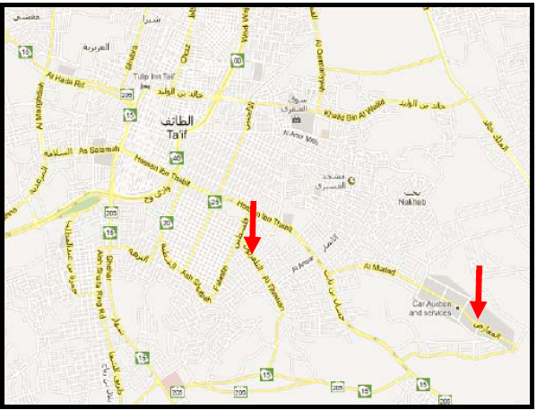
(I)
(R)

Figure 1.

Figure 2.
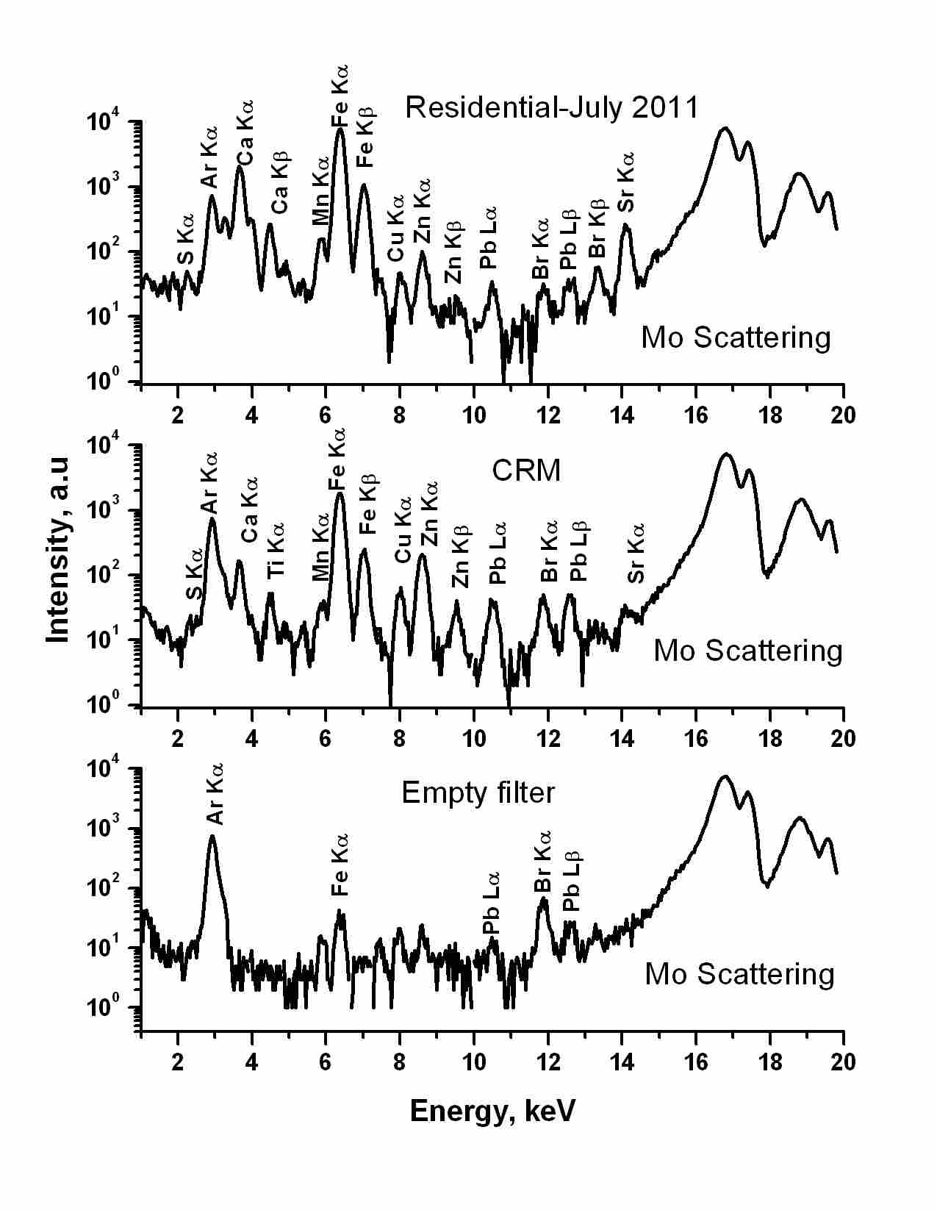

Figure 3.

* Email: shaltout_a@hotmail.com

