السوار الذكى : الجيل الثانى من سوار الحاج
د. محمد مصطفى زايد
كلية علوم و هندسة الحاسبات
جامعة طيبة – المدينة المنورة
سوار الحاج التقليدى هو عبارة عن سوار يضعه الحاج حول معصمه ومدون به بعض المعلومات المهمة مثل اسم مؤسسة الطوافة التابع لها الحاج و اسم رئيس المجموعة و تليفونه و عنوانه بمكة المكرمة و عرفة و منى. تهدف هذه الدراسة إلى تطوير السوار التقليدى الى السوار الذكى. و السوار الذكى هو سوار شبيه بالسوار التقليدى إلا انه مزودة بشريحة ذكية.
وهذه الشريحة الذكية شبيهة بفكرة الباركود (Barcode) والذى يمكن قراته عن طريق جهاز ماسح الباركود لنحصل على كل المعلومات المسجلة فى النظام لهذا الباركود إلا ان هذه الشريحة يمكن قرائتها عن بعد. والغرض من هذه الشريحة الذكية هو التعرف على جميع بيانات الحاج المسجلة بالنظام من اسمه و جنسيته و رقم جواز سفره و فصيلة دمه و مجموعة الطوافة التابع لها و اماكن الاقامة بالمدينة و مكة و منى و عرفات بمجرد مرور الشريحة على جهاز قارئ الشريحة المتصل بجهاز حاسب الى. هذا بالاضافة الى امكانية الاستدلال على موقع الحاج او الزائر فى حالة فقده للمجموعة او عدم القدرة على الوصول الى مكان سكنه.
وسوف يمكن هذا النظام رجال الامن و مراكز ارشاد الحجاج التائهين من مراقبة المكان الفعلى للحاج بناء على الرقم التعريفى الممنوح له من قبل النظام و الذى يتم قرائته عن بعد من خلال جهاز حاسب آلى مزود ببرنامج تطبيقى ملائم.
وسوف تقدم هذه الدراسة شرح تفصيلى للانواع المختلفة من طرق التعريف الأتوماتيكى الممكن استخدامها لهذا الغرض. كما تلقى الدرسة الضوء على بعض تطبيقات استخدام شرائح RFID فى الحياة العملية. بالاضافة الى شرح لكيفية استخدام شرائح RFID فى المشاعر المقدسة فى الاستدلال على موقع الحاج التائه من خلال هذه الشريحة الذكية. كما تقدم الدراسة تصور كامل لتطبيق النظام من لحظة وصول الحاج الى المملكة الى لحظة خروجه منها بإذن الله. كما توضح الدراسة بعض المجالات الاخرى (الامن و الصحة و الاحصاء و الخ) و التى يمكن ان تستفيد من مثل هذه الشرائح الذكية.
Pilgrim’s Smart Bracelet:
The second generation of the pilgrim’s traditional bracelet
Abstract
The objective of this study is to upgrade the current pilgrim’s traditional bracelet into a smart bracelet that employs a smart RFID (Radio Frequency Identification) chip. By the aid of this smart chip we will propose the design of an efficient RFID-based solution to track a lost pilgrim in the holy places (Makkah, Arafat , Mina, Jamarat, etc). The system allows security officers and lost pilgrims guiding centers to monitor the position of “tagged pilgrim” based on its RFID identifier from a large distance by implementing an application that reveals the position of a lost pilgrim anywhere in the coverage area. Moreover, the use of the smart chip will also help in many other applications (security, health, statistical, etc) as illustrated in this study.

- Introduction
Traditional pilgrim’s bracelet shown in Fig. 1. is a bracelet a pilgrim wears around the wrist containing some important information printed on the upper side of the bracelet. This information includes, the name of the raft agency (Moasaset Al-Tewafa ) that he/she belongs to, name of the chairman of the group and his phone and address in Makah, Arfa, Mina.
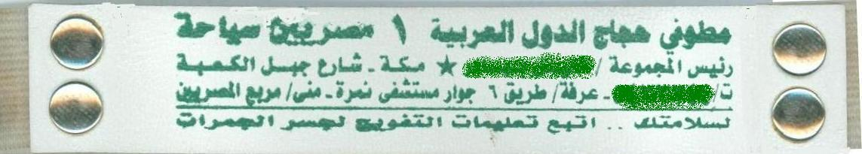
Figure. 1 Sample Traditional pilgrim’s bracelet
The aim of this study is the development of the traditional bracelet into the smart pilgrim bracelet. A smart bracelet is similar to the traditional bracelet except that it is provided with a smart chip. The idea behind this smart chip is similar to that of using the barcode that can be read through barcode scanner or reader to get all information registered in the system about this barcode except that it can be read from longer distance. The purpose of using this chip is the automatic identification of all pilgrim’s information (name, nationality, passport number, blood type, raft agency, residence place and phone numbers at Makaa, Arfa and Mina). Moreover, the possibility to track a lost pilgrim or visitor in case of misleading his group or reaching his residence place.
The rest of this study is organized as follows. In section 2, a detailed description of different automatic identification methods emphasizing the use of RFID (Radio Frequency Identification) for this scenario is presented. Section 3 shows the main components of an RFID System. Section 4 demonstrates the main categories of RFID tags highlighting the advantages and disadvantages of each. Section 5 sheds the light on some of the RFID applications in real life. Then the proposed system model is described in section 6. The significance of this study is highlighted in section 7. The conclusion is provided at section 8.
- Automatic Identification Systems Categories
Automatic Identification Systems are broadly classified into five categories [1] namely, Barcode systems, Optical Character Recognition, Biometric systems, Smart cards and RFID systems.
A barcode is a binary code comprising a field of bars and gaps arranged in a parallel configuration. They are arranged according to a predetermined pattern and represent data elements that refer to an associated symbol. The sequence, made up of wide and narrow bars and gaps, can be interpreted numerically and alphanumerically.
Optical character recognition (OCR) was first used in the 1960s. Special fonts were developed for this application that stylized characters so that they could be read both in the normal way by people and automatically by machines.
Biometry is the general term for all procedures that identify people by comparing unmistakable and individual physical characteristics. In practice, these are fingerprinting and handprinting procedures, voice identification and, less commonly, retina (or iris) identification. With Voice identification, specialized systems have become available to identify individuals using speaker verification (speaker recognition). In such systems, the user talks into a microphone linked to a computer. This equipment converts the spoken words into digital signals, which are evaluated by the identification software. The objective of speaker verification is to check the supposed identity of the person based upon their voice. This is achieved by checking the speech characteristics of the speaker against an existing reference pattern. If they correspond, then a reaction can be initiated (e.g. ‘open door’). fingerprinting procedures are used for personal identification, usually for entrance procedures, the fingertip is placed upon a special reader
A smart card is an electronic data storage system, possibly with additional computing capacity (microprocessor card), which is incorporated into a plastic card the size of a credit card. Smart cards make all services that relate to information or financial transactions simpler, safer and cheaper. Smart cards are placed in a reader, which makes a galvanic connection to the contact surfaces of the smart card using contact springs. The smart card is supplied with energy and a clock pulse from the reader via the contact surfaces. One disadvantage of contact-based smart cards is the vulnerability of the contacts to corrosion and dirt.

RFID systems are contactless wireless identification technique. Like smart card systems, data is stored on an electronic data-carrying device — the transponder. However, unlike the smart card, the power supply to the data-carrying device and the data exchange between the data-carrying device and the reader are achieved without the use of galvanic contacts, using instead magnetic or electromagnetic fields.

- Components of an RFID System
An RFID system is always made up of 3 components as shown in Fig. 2.
- The RFID tag or transponder, which is located on the object to be identified. An RFID tag is a microchip combined with an antenna in a compact package; the packaging is structured to allow the RFID tag to be attached to an object to be tracked.
- The RFID reader or interrogator, which, depending upon the design and the technology used. The reader has an antenna that emits radio waves; the tag's antenna picks up signals from an RFID reader and then returns the signal, usually with some additional data (like a unique serial number or other customized information).
- Workstation to host the Middleware and database.

Figure 2 The main components of RFID system [1]
A number of factors can affect the distance at which a tag can be read (the read range). The frequency used for identification, the antenna gain, the orientation and polarization of the reader antenna and the transponder antenna, as well as the placement of the tag on the object to be identified will all have an impact on the RFID system’s read range.

- RFID Characteristics
There are two main forms of RFID tags namely, active RFID and passive RFID [3], [4]. The primary difference between them is that active tags have their own power source (typically a battery) where as passive tags do not. This power source provides active tags with a greater and more reliable read range, as well as greater data storage and transfer capacity than their passive counterparts. Active tags however, are significantly larger than passive tags (currently the smallest active tag is approximately the size of a coin). Active tags usually operate at frequencies of 455MHz, 24.5GHz, or 5.8 GHz and have a typical read range of about 20 to 100 meters [5].
The advantages of a passive RFID tag are:
- The tag functions without a battery; these tags have a useful life of twenty years or more.
- The tag is typically much less expensive to manufacture
- The tag is much smaller (some tags are the size of a grain of rice). These tags have almost unlimited applications in consumer goods and other areas.
The major disadvantages of a passive RFID tag are:
- The tag can be read only at very short distances, typically a few feet at most. This greatly limits the device for certain applications.
- It may not be possible to include sensors that can use electricity for power.
- The tag remains readable for a very long time, even after the product to which the tag is attached has been sold and is no longer being tracked.
The major advantages of an active RFID tag are:
- It can be read at distances of one hundred feet or more, greatly improving the utility of the device
- It may have other sensors that can use electricity for power.
The disadvantages of an active RFID tag are:
- The tag cannot function without battery power, which limits the lifetime of the tag.
- The tag is typically more expensive.
- The tag is physically larger, which may limit applications.
- Battery outages in an active tag can result in expensive misreads.
- Applications of RFID
RFID based system have been used extensively in the literature, we list few of them hereafter.
5.1 Luggage tracking system
A key historical problem has been the high cost of bag losses at airports. International Air Transport Association (IATA) statistics that estimate the average cost of a lost bag is just over $100 per incident, or over $3B annually for the airline industry [6]. Exacerbating the problem is that airlines are now charging for bags. Therefore, lost bags now equate to lost revenue.

Figure 3 Luggage tracking at airports [6]
Today, most baggage tracking within airports is done with bar codes. Industry statistics suggest read rates are about 85% for bar codes, but as we speak with industry participants, we regularly hear stories of read rates that fall into the 60%-70% range. This makes sense as baggage orientation is difficult to control and can meaningfully distort read capability. It is often these low read rates, coupled with rapidly changing flight schedules and poor internal system communication that leads the industry to lose 34M bags annually.
Tests of RFID show baggage read rates in the 98%-99.9% range.

5.2 Supply chain

In a warehouse, RFID active tags can be programmed with contents and assigned locations and then placed on containers and pallets that are stored in a warehouse. Additional information can be collected and added to the RFID tags as the pallets move through the warehouse [7].
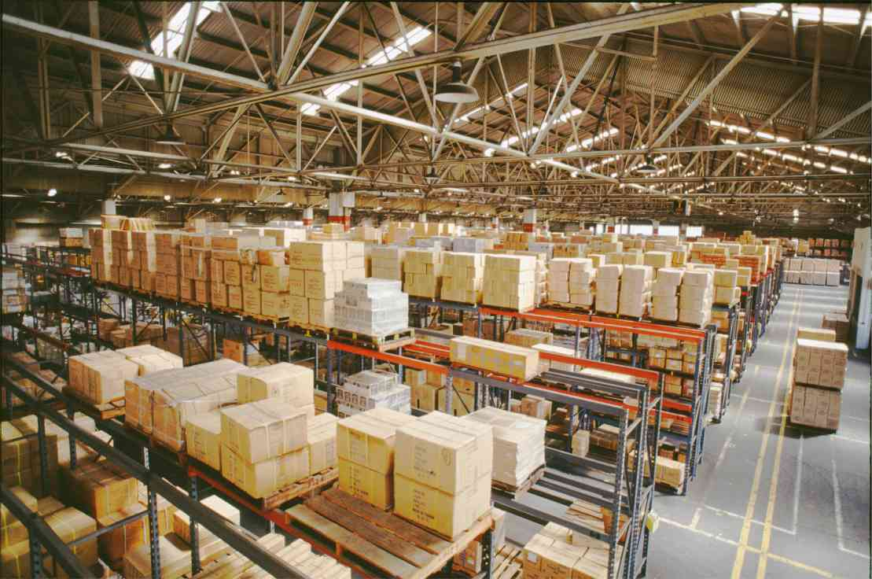
Figure 4. The use of RFID in a Warehouse [7]
RFID's automatic tracking system can identify and keep track of goods that are located anywhere in the warehouse or in any other part of the building where a RFID reader is installed. The amount of idle inventory tied up in storage can be greatly reduced through effective use of the information provided by the system.
The RFID system can also reduce theft and other forms of inventory shrinkage by immediately alerting the operations manager when a product is moved from its assigned area.

5.3 In Restaurants
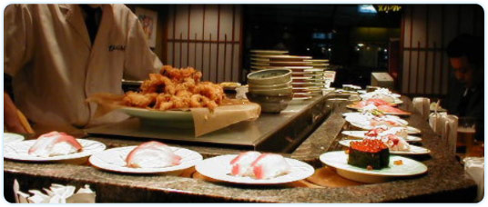
Figure 5. Plates are equipped with RFID in a Japanese Restaurant[8]

In some Japanese restaurants, RFID chips are being used to keep a watch on the duration the fish has been on the conveyor belt used to serve it to the customers. All the plates out here have been affixed with RFID chips and in case the fish has not been picked up after the standard time of thirty minutes it is replaced by fresh sushi so that the clients gets to taste only and only the best fish out of the lot. The manual work has also been considerably reduced since the staff from the kitchen only needs to do pass the RFID scanner over the plates and the technology does the rest for them.

- Proposed System Model
The proposed system is designed to track pilgrims in holy places areas such as Makkah, Mina, Arfat, Jamarat, etc. The holy places security office receives hundreds of lost pilgrims’ cases on a daily basis. Given the large area of the holy places, the security officers find it is very difficult to locate lost pilgrims. The proposed system operates by initially having each pilgrim fill an application form about his personal details such as name, nationality, passport number, age and phone number at the entry points of the kingdom (Air-ports, borders’ check points, etc). The pilgrim information is registered into the database and a unique identifier is issued to him/her. Then, a pilgrim is given a smart bracelet containing an active RFID tag to wear it through-out his stay as shown in Figure 6. By the end of the pilgrim’s stay, he/she will return back the RFID at the exit point of the kingdom.

Figure 6. A Sample RFID wrist band
To fulfill the above scenario, wireless RFID readers should be installed around the different holy places areas as well as in the pilgrims’ guiding centers. These readers are continuously transmitting the locations of all pilgrims in their surroundings. The active RFID tag of a pilgrim can be read remotely by the RFID readers deployed in the holy places area.
Once a group of pilgrim loose one of their members, one has to report it to any security station. The tag number corresponding to the lost pilgrim is retrieved from the database and the tag-readers are asked to locate the lost pilgrim. Then the location of the lost pilgrim can be tracked through the RFID readers.
Another scenario is when a pilgrim is lost and he/she tries to get back to his residence place. In such cases, a pilgrim should be directed to the closest lost pilgrims’ guiding center available in his/her area. In the center, the security officers can identify the pilgrim’s RFID tag through the RFID readers installed in the center. Once a pilgrim is identified all his residence details become available to security officers that will help him reaching his residence place.

- Significance of this study
- If a pilgrim has exposure to a health crisis anywhere in the holy places, the pilgrim can be identified. Moreover, the medical information (blood type, having allergies against any medicine, etc) registered about the pilgrim will help providing the first aid to him/her.
- In case of having a disaster (flood, collapse of a building, ) in any of the holy places areas, the system will help not only recognizing the anticipated number of victims involved in this disaster (if any), but also totally identifying them. Moreover, estimating the expected number of people who have been evacuated and the number of people who are still in need for help.
- From the security point of view, the system will help police officers in identifying the retarded or delayed visitors after performing Omra season.
- The system will help in estimating the real number of pilgrims in any selected area of the holy places based on the number of tracked RFID tags in that region.
- The RFID badge can be used as an official pilgrim’s identification method during the hajj season.

- Conclusion
A literature survey of the available automatic identification techniques has been presented. Then a discussion comparing the advantages and disadvantages of the two categories of RFID tags namely, the passive and active RFID tags has been demonstrated. Then a complete scenario of the proposed system is described from the time he/she reaches the kingdom until his safe departure Inshaa Allah.
- References
[1] Klaus Finkenzeller, “RFID Handbook, Fundamentals and Applications in Contactless Smart
Cards and Identification”, 2nd Ed., Wiley, ISBN 0-470-84402-7, 2003.
[2] http://www.technovelgy.com/ct/Technology-Article.asp?ArtNum=50
[3] Adam Trevarthen: The National Livestock Identification System: The Importance of Traceability in E-Business. JTAER 2(1): 49-62 (2007).
[4] http://www.minshawi.com/other/mohandes.htm
[5] RFID Journal (2005c). RFID Journal — the world's RFID authority [online]. Available www.rfidjournal.com/
[6] RFID Monthly, December 15th, 2009 , http://www.rfid-monthly.com/2216/bag-tagging-slow-look-to-amsterdam/
[7] RFID Solutions & Applications http://www.gaorfidassettracking.com/RFID_Asset_Tracking_Applications/RFID_Supply_Chain.php
[8] RFID weblog, http://www.rfid-weblog.com/50226711/sushi_and_rfid_makes_a_great_combo.php

