A Proposed Model for Optimizing the Flow of Pilgrims between
Holy Sites Using Traffic Congestion Control

Omar Tayan
{otayan@taibahu.edu.sa}
College of Computer Science and Engineering
Department of Computer Science
Taibah University, K.S.A.

Abstract

The use of computer simulations for modelling the behaviour of pre-existing/inaccessible products/real-life scenarios is increasing in academia and industry. The advantages of computer modelling and simulation are numerous, and include; controlled experimentation on an pre-existing/in-accessible real-life scenario without disturbing the real-life system, time- and space-compression of a real-life system and sensitivity analysis of selected key parameters. The need for such advanced computational techniques for behavioural analysis is increasing in the domain of traffic congestion and control, which has particular significance in any attempt to optimise the movement/flow of pilgrims between Holy sites during the Hajj period. The aim of this study is to model and optimise the flow/transportation of pilgrims between the various Holy sites through the use of highly sophisticated computer modelling & simulation techniques. Computer models are considered here for simulating the Makkah road network using the widely applicable concept of queuing and polling systems from computer science and engineering. In particular, this study considers a discrete-event simulator for protocol modelling, analysis and optimisation. The study compares a number of potential transport protocols suitable for the Hajj environment, before justifying the most appropriate/efficient protocol that optimises the flow of pilgrims between the various Holy sites. Key benefits would be obtained by employing a distributed protocol to traffic management, including increased efficiency of the available road network, thereby resulting with a decrease in the delays encountered and pollution emitted as a consequence of the inefficient flow of traffic.

Introduction

Significant progress in computer modelling and simulation techniques are paving the way for the widespread use of highly efficient computational techniques for modelling inaccessible artefacts/real-life scenarios and determine whether a planned change to the artefact/scenario can be implemented while producing the desired results. For instance, the use of computer simulations for modelling the behaviour of pre-existing/inaccessible products/real-life scenarios is expected to increase in academia and industry. Numerous advantages emerge through the use of modelling and simulation, including, controlled experimentation on an pre-existing/in-accessible real-life scenario without disturbing the real-life system, time- and space-compression of a real-life system and sensitivity analysis of selected key parameters.

Hence, computer modelling and simulation is an attractive option and is particularly well-suited for numerous applications that include: banks, hospitals, airports, manufacturing systems, and computer and communication systems. The importance of computer modelling & simulation is that they can be used to optimise management decisions made prior to implementing any change in a real-life scenario/artefact, thereby resulting in cost, time and resource optimisation. The need for such advanced computational techniques for behavioural analysis is increasing in the domain of traffic congestion and control, which has particular significance in any attempt to optimise the movement/flow of pilgrims between Holy sites during the Hajj period.

Motivation and Overview

A key aim of this study is to model and optimise the flow/transportation of pilgrims between the various Holy sites through the use of highly sophisticated computer modelling and simulation techniques. Computer models are considered here for simulating the Makkah road network using the widely applicable concept of queuing and polling systems from computer science and engineering. The use of such modelling techniques in this study is imperative, thereby allowing much of the relevant computer networking literature, including standard and adapted/optimised protocols, to be applied with great effect in this study. In particular, this study considers the use of discrete-event simulation for protocol modelling, analysis and optimisation. Makkah’s road network is then modelled with the application of standard/optimised and potentially novel medium access (fairness) protocols, in which multiple access points onto the road network are modelled as nodes/queues in the queuing system that compete for access to some shared resource (modelled as servers). For example, we may have several branch roads that converge into a single road/fewer roads.

The study compares a number of potential transport protocols suitable for the Hajj environment, before justifying the most appropriate/efficient protocol that optimises the flow of pilgrims between the various Holy sites. Hence, it is evident that this study is highly significant in any effort to manage the traffic flow of pilgrims and is therefore, largely relevant for application in K.S.A. Key benefits would be obtained by employing a distributed protocol to traffic management, including increased efficiency of the available road network, thereby resulting with a decrease in the delays encountered and pollution emitted as a consequence of the inefficient flow of traffic.

A number of related research-approaches have been considered for the problem of traffic management, with the most notable being the use of traffic lights with sensor devices that open the gate for incoming traffic based on some parameter value [1]. Such an approach is comparable to intermediate routing in a queuing system. On the contrary, the proposal presented here applies the concept of queuing systems in order to evaluate and compare mature and (potentially) novel distributed protocols that provide a medium access (fairness) mechanism for traffic at entry points in addition to intermediate points within the network. It is also intended that this study would compare an open-loop-traffic light system with a scenario in which a weighted factor of the open-loop timings is taken together with a queue-occupancy threshold or pre-emption signal considerations to form an adapted closed-loop feedback system for the Hajj environment. Furthermore, the study shall investigate the performance of various protocols in terms of achieving the most efficient/optimal road access/utilisation mechanism, in which performance is measured by the average waiting times of pilgrims within each queue and within the system as a whole from the point of entry to the point of exit on the road network. Hence, this study focuses on congestion awareness algorithms for Hajj traffic on the Makkah road network.

Methodology and Design

This study considers the use of queuing and polling systems in order to construct an abstract model of the traffic flow between Holy-sites in Makkah during the Hajj season. The following subsections discuss the significance of queuing and polling systems in this study.

Polling systems have been studied extensively since several decades ago, and consequently, a rich source of knowledge has emerged in the use of polling models for a variety of applications. Essentially, all polling systems consist of a single source that is shared between multiple access queues [3, 4]. Figure 1 shows a similar scenario in the study of Hajj traffic flow and congestion control, whereby many frequently used sections in the road network involve numerous roads merging into a single road as a point-of-entry into a particular site.

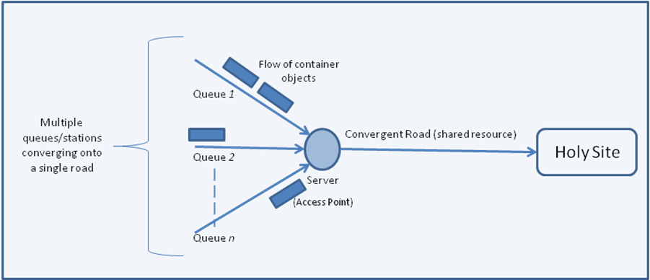
Figure 1: Overview of the Hajj Traffic Congestion Scenario

A large number of studies can be found on the use of polling systems to model a variety of applications in many disciplines. In all the relevant literature surveyed, polling systems were broadly classified according to following characteristics that include [4]; continuous- or discrete-time systems, queuing buffer capacity, queue service discipline, switchover times, symmetric or asymmetric properties, cyclic/non-cyclic service order discipline, exact or approximate analysis. The characteristics of the polling system used to model the Hajj traffic scenario is considered in more detail.

First, the polling system comprises a number of source generation processes to represent the incoming arrival traffic/pattern from numerous roads as in a multi-queue system, leading to a single/or fewer roads, considered as the shared medium that provides access to a Holy site. Figure 1 shows a server attending each of the queues as they compete for access to a shared road/medium. Pilgrim vehicles are modeled as container objects in the model, and hence, incoming traffic can be classified as discrete-time arrivals. The exhaustive (followed by the gated scheme) is the most efficient service discipline when finite queue-lengths are used (as required in this study). Polling systems are associated with server switchover times that correspond to the time interval between the service completion time at a queue, and the consequent arrival time of the free token at the next transmitting queue. In this study, the arrival rates, service time distributions, and switchover time distributions are non-uniform between queues as in an asymmetric system.
Cyclic service-order disciplines are used by the server to allow data-gathering/request packets to rotate between the competing stations (practically involving nodes in a WSN) in order to collate current queue occupancy values, rate-of-arrivals, rate-of-departures etc statistics from each station. Cyclic polling systems employ a round-robin algorithm and a single server that multiple container objects (gated or exhaustive disciplines) on each queue visit. On the other hand, a non-cyclic service-order discipline is required to serve queues randomly, based on station requests for instance. Hence, the dynamic service-order of queues can be classified as a probabilistic polling scheme employing distributed and stochastic algorithms, depending on the system state. For instance, a service policy of particular interest in this study is to observe the contents of each queue with the decision of service allocation determined based on the highest queue occupancy. An advantage of dynamic service orders are that they are sensitive to the actual system state.

An alternative approach to dynamic service orders would be to employ queue priority schemes. Queue service mechanisms permit the prioritization of queues according to key design parameters, thereby achieving improved system performance. Important design parameters in such systems include; visit order used, the frequency and duration of visits at queues and the order of packet/message service within each queue.
The operation of the proposed polling system is as follows. A data-collection/request packet circulates through the network of stations/nodes in a cyclic discipline in order to obtain the necessary statistical data representing the state of each node. The data collected describing the state of the system is then used to used to serve a particular queue based on queue-occupancy. As the circulating packet updates the state information, the system determines the most eligible queue for service on the next switchover. Notably, the stochastic service discipline employed resembles the random polling schemes used in many stochastic data-traffic computer-network models [8].

The simulation tool considered for evaluating the performance of the polling system with traffic congestion control algorithm is the OMNET++ discrete-event simulator. The OMNET++ development platform was designed for optical, wireless and other queuing networks with an overall structure that matched the requirements of this study. An advantage of using OMNET++ is evident in the flexibility it provides and its support for customised designs.

Design and Implementation

Access fairness to the road resources can be achieved by regulating traffic flow using a distributed view of the queue loadings, whereby all affected nodes are able to support/oppose required queue-flow services [5, 8]. Hence, the queuing model implementation must allow intermediate nodes to decide whether they support or oppose/reject each proposed queue-flow. The protocol would then accept or reject, the proposed queue-flow by considering its own local perception of the loading at the queue and the stance taken by each affected node. Advantageously, distributed protocols can be employed to establish queue-flow request services, thereby removing the need for a central management node. In this approach, the request structure consists of M partitions, each corresponding to one node, with the request packet circulating between the nodes as in a logical interconnection of ring nodes (Figure 1). Each partition is an N bit binary counter that counts the number of opposition-nodes encountered by each (queue/station) flow request. N is the length of each request in the request field of the packet, relative to the queuing-network size 2^{N-1}. Hence, an N-bit counter is required for each node in a 2^{(N-1)}-node ring is represented by an N-bit counter, where each subfield is initialised to the reset state (e.g. 000 for an interconnection of 4-nodes), indicating no requests waiting. Figure 2 illustrates the request-packet format that circulates between converging roads/nodes, designated using interconnected communicating wireless sensor nodes.

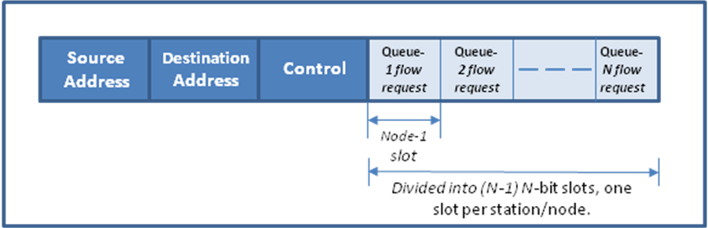
Figures 2: Packet format that circulates between converging roads/nodes

When a node transmits a connection request, it sets its subfield to a binary 100. A reset value (000) at the request field is only obtained at initialisation or when no request was sent; the reset value (000) cannot otherwise be obtained regardless of the number of rejections made. Each reject-request on a request subtracts from the correct value of the field associated with the request. Hence, the maximum number of rejections made on any request would only reduce the request subfield to 001. A clear benefit of this approach is that the cell collects more management information regarding the state of the network nodes as it circulates through the ring. Furthermore, by counting the number of rejections on each request, it has become possible to consider other factors for deciding upon flow-request acceptance or rejection at each source node/queue. For example, in a network whose access nodes are prioritised, it may be necessary that high priority nodes are able to proceed with a flow-request acceptance even after a majority of nodes have rejected the request. Such prioritisation of nodes using the request structure described here would be well suited in a master-slave system.

Anticipated Results and Conclusions

The previous section has described a sophisticated approach that provides a traffic-congestion awareness protocol, in which the number of rejections on each queue-flow request is monitored to yield a greater insight of the state of each node. Initial work on the congestion-awareness protocol shall investigate the effect of varying the number of proposed node-rejections for each queue-flow request before blocking the request, the effect of varying queue-thresholds (maximum permitted number of container objects before requesting to release traffic – 'queue-flow'), and the effect of varying the number of container objects to release following a queue-flow request acceptance. It is expected that as the queue-loadings and queue arrival-rates increase, more nodes shall propose to reject other queue-flow requests in order to prevent their queues exceeding the queue-threshold. Furthermore, it is expected that if the rejection-threshold was increased (such that more proposed rejections are required for each queue-flow in order to block the request), traffic throughput would also increase with a slight increase of the mean delay at each node/queue. An increase in the queue-length threshold was expected to yield an increase in the mean queuing delays encountered, whilst reducing the number of proposed rejections for each queue-flow request.

This study has investigated access control and fairness for Makkah's road network between Holy sites during Hajj. A fair mechanism of controlling road access and preventing node starvation, whilst limiting the delay in the network can be achieved using the proposed traffic congestion-awareness protocol.

References

1. ' Intelligent system for the management of traffic lights in Medina', K. AlAwfi, Proceedings of the Second Scientific Research Forum on Madinah Al-Munawwarrah, Madinah Al-Munawwarrah, 2008.

2. 'Ubiquitous Computing for Safe and Efficient Pilgrimage Operations ', E. Abuelela, Proceedings of the Second Scientific Research Forum on Madinah Al-Munawwarrah, Madinah Al-Munawwarrah, 2008.

3.’Teletraffic Theory and Applications’, H. Akimaru, K. Kawashima, Published by Springer 1999.

4. ’Queuing Analysis of Polling Models’, H. Takagi, Proceedings of ACM Computing Surveys, Vol. 20, No. 1, March 1988.

5.’Traffic Regulation and Control in the Manhattan Street Network’, O. Tayan, D. Harle, Proceedings of Networking 2004, Third International IFIP-TC6 Networking Conference, Athens, May 2004.

6. 'Electronic Tracking of Pilgrims' Proceedings of the Second Scientific Research Forum on Madinah Al-Munawwarrah, Madinah Al-Munawwarrah, 2008.

7. “Traffic Engineering Analysis”, chapter 6, in Kutz, M., “Handbook of Transportation Engineers”, Abdulhai, B., Kattan, L., McGraw Hill Publishing, ISBN: 0071391223, November, 2003.

8.’Waiting Time Estimates in Symmetric ATM- Oriented Rings with the Destination Release of Used Slots’, M. Zafir-Vukotic, IEEE/ACM Transactions on Networking, Volume 7, Number 2, April 1999, pp251-261.

In reality, wireless sensor networks could be employed to measure the traffic levels at access points.

